

Faculty of Engineering and Information Technology
Information Technology

“Automating PAU's Research System: From Paper to Web”

Prepared By:

Mohammed Jamel Yazan Alazzeh

Supervised By:
Dr. Mutaz Abu Sara

A graduation project is submitted to the engineering and information technology department in partial fulfillment of the requirements for the degree of the Bachelor of IT

Palestine, Bethlehem 2024 - 2025

DEDICATION

This project is dedicated to the martyrs in Gaza, whose sacrifices remind us of the value of resilience and perseverance. Their bravery and strength are an everlasting source of inspiration.

We also dedicate this work to our beloved parents, whose unwavering support and encouragement have been the foundation of our success. Their belief in our abilities has empowered us to pursue our dreams and achieve our goals.

Lastly, we extend our gratitude to our friends and mentors, especially our Supervisor Dr. Mutaz Abu Sara, for their guidance, support, and wisdom throughout this journey. Their contributions have been invaluable in making this project a reality.

ACKNOWLEDGEMENT

In the name of Allah, the Most Gracious, the Most Merciful. We extend our heartfelt gratitude to everyone who supported and guided us throughout this journey. We are deeply thankful to our supervisor, Dr. Mutaz Abu Sara, for his continuous support, patience, and insightful advice. His encouragement and feedback have been invaluable in completing this project.

We also express our sincere appreciation to our families and friends for their unwavering support and understanding during the times of intense focus and work. Their belief in us has been a constant source of motivation.

Lastly, we would like to acknowledge the sacrifices and resilience of the martyrs in Gaza. Their courage and strength inspire us to persevere and contribute to the betterment of our society. This project is dedicated to their memory.

ABSTRACT
This project aims to change the structure of the newly established services of the Scientific Research Department at PAU to electronic services as opposed to being run through a paper-based system. The new system will have the following; Accompanied Technical support examination services offering academic consultation for students and academics that include statistical analysis, translation, and linguistic review. Thus, the beneficiaries will upload the expected files (e.g. Excel files for analysis) through their web-based account. A reward system will be implemented for researchers who publish their articles in recognized journals such as Scopus and Web of Science, with rewards distributed according to the journal's classification and participation in international or local conferences. Researchers will fill out forms with their personal information and research details and attach supporting documents, like proof of publication and research follow-up. The researcher uploads their works via a template and indicates their role: either as author or co-author. The research will then be tracked from submission to publication. The approvals management represented by the Head of the Scientific Research Department and the Academic vice president will review the research and approve the issuance to the Finance Department for the Research Reward disbursement.
Notifications and reports. That is, an email update on requests and a consolidated report on the research progress and rewards due will be given to researchers. This system is going to automate all processes of the student and academics' life, making the workflow faster, more efficient, and with accuracy in it.

Table of Contents
Faculty of Engineering and Information Technology 1
DEDICATION 2
ACKNOWLEDGEMENT 3
ABSTRACT 4
CHAPTER ONE: PROJECT INTRODUCTION 9
1.1 Introduction 9
1.2 Literature Review 9
1.3 Project Scope 13
1.4 Project Statement 13
1.5 Project Objectives 14
1.6 Project Benefits 14
1.7 Project Methodology 15
1.8 Proposed Working Plan 17
1.9 Project Constraints 18
1.10 Summary 19
CHAPTER TWO: PROJECT INTRODUCTION 20
2.1 Introduction 20
2.2 Project Implementation Options 20
2.3 The Proposed System 20
2.4 System Requirements 23
2.4.1 Functional Requirements 23
2.4.2 Non-Functional requirements 25
2.5 Feasibility Study 26
2.5.1 Technical Feasibility 26
2.5.2 Economic Feasibility 28
2.5.3 Operational Feasibility 28
2.5.4 Legal Feasibility 29
2.5.5 Feasibility Scheduling 29
2.5.6 Resource Feasibility 29
2.5.7 Schedule Feasibility 29
2.5.8 Organizational Feasibility 29
2.6 Project Added Values 30
2.7 Project Management 31
2.8 Summary 31
CHAPTER THREE: SYSTEM FUNCTIONAL REQUIREMENTS ANALYSIS 32
3.1 Introduction 32
3.2 Context and Use-Case Diagrams 32
3. Use Case Diagram 33
3.3 Functional Requirement Description 34
3.4 Summary 37
CHAPTER FOUR: SYSTEM DESIGN 38
4.1 Introduction 38
4.2 Class Diagram 38
4.2.1 Users and Roles 38
4.2.2 Research & Service Management 39
4.2.3 Account & User Management 40
4.2.4 Finance & Budgeting 41
4.2.5 Technical Support 41
4.2.6 Notification & Approval Process 42
4.2.7 Rewards System 42
4.3 Sequence Diagram 43
4.4 Entity Relationship Diagram (ERD) 46
4.5 Functions Design & Activity Diagram 47
4.6 Input/Output Design: 60
4.7 Summary 62
References 63

List of Figures
Figure 1. Gantt Chart 17
Figure 2. Context Diagram 32
Figure 3. Use Case Diagram 33
Figure 4. Users and Roles Class Diagram 38
Figure 5. Research & Service Management Class Diagram 39
Figure 6. Account & User Management Class Diagram 40
Figure 7. Finance & Budgeting Class Diagram 41
Figure 8. Technical Support Class Diagram 42
Figure 9. Notification & Approval Process Class Diagram 43
Figure 10. Rewards System 43
Figure 11. Service Request Sequence Diagram 45
Figure 12. Reward System Sequence Diagram 46
Figure 13. Consultation Request Sequence Diagram 47
Figure 14. Publication Submission Sequence Diagram 47
Figure 15. Entity Relationship Diagram (ERD) 48
Figure 16. User Registration Activity Diagram 50
Figure 17. Service Request Activity Diagram 51
Figure 18. Reward Application Activity Diagram 52
Figure 19. Consultation Booking Activity Diagram 53
Figure 20. Account Management Activity Diagram 54
Figure 21. Notification System Activity Diagram 55
Figure 22. Research Submission Activity Diagram 56
Figure 23. Admin Dashboard Activity Diagram 57
Figure 24. Researcher Profile Activity Diagram 58
Figure 25. Approval Process Activity Diagram 59
Figure 26. Research Tracking Activity Diagram 60
Figure 27. Service Feedback Activity Diagram 61

LIST OF TABLES

Table 1. Literature Review 12
Table 2 . Technical Feasibility Study 29
Table 3. Required Resources & Costs 31
Table 4. Schedule Feasibility 32
Table 5. Functional Requirement Description: Submit Research 36
Table 6. Functional Requirement Description: Request Technical Support 36
Table 7. Functional Requirement Apply for Reward 37
Table 8. Functional Requirement Description: Track Research Status 37
Table 9. Functional Requirement Description: Manage Research Submissions 37
Table 10. Functional Requirement Description: Approve/Reject Research 38
Table 11. Functional Requirement Description: Notify Researcher 38
Table 12. Functional Requirement Description: Approve Research for Rewards 39
Table 13. Functional Requirement Description: Process Research Rewards 39

CHAPTER ONE: PROJECT INTRODUCTION

1.1 Introduction

Today, with the rapid development in technology, universities and academic institutions are in dire need to rely on electronic systems instead of the traditional paper-based methods, because frankly, paper has become slow and complicated and has problems such as delay, difficulty in following up, and sometimes loss of papers. PAU University has a scientific research department that provides many services to students and academics such as consultations, statistical analysis, translation and proofreading. Unfortunately, the current system is still paper-based and takes a long time to complete procedures.
The project we are working on aims to convert this system from paper to electronic system to make things easier for everyone. This means that the student or academic no longer needs to go to the department's office in person, or waste time filling out manual forms. Through the new website, the user will be able to submit a request for the service he needs, whether it is consultation, statistical analysis or others, with ease while sitting in his office or home. Also, there will be an option to upload files directly, for example, if user want a statistical analysis, user upload the required file directly to the website and the department receives it and responds to user.
Moreover, the system will also provide a new mechanism for applying for the rewards that the university gives for published research. The researcher can enter all the details of the research, upload the required documents such as proof of publication, choose the classification of the journal in which it was published, and all of this is done in an organized and easy way. The researcher can also follow up on his application directly and see where it has reached, whether it was accepted, rejected, or needs to be modified, meaning there is no need to keep waiting or visit the office more than once. The goal of the project is to facilitate the process of communication and dealing with the Scientific Research Department, reduce errors, and save time and effort for all parties. The suggested system will also make everything clear and transparent, and give the department the ability to follow up on all the research published by academics and students accurately and quickly.

1.2 Literature Review

A literature review is an academic writing piece of work that should demonstrate knowledge and understanding of literature on a particular topic and is placed in context.

Related Studies
At Local Level,

Birzeit University - Scientific Research Research and Projects, (2015) [1]

Birzeit University launched its electronic platform in 2015 with the aim of enabling the scientific research process with more ease and enhancing the management of technical support requests submitted to researchers. This portal allows students and researchers to request technical support services such as translation, statistical analysis, and all other support services needed by academic researchers. There are challenges that the platform faces, which include the fact that some of the processes at these academic departments remain paper-based, obstructing efficient service delivery. The platform also faces challenges in integrating with other university systems; this impedes the seamless flow of data across systems.

An-Najah National University- Deanship of Scientific Research (2017) [2]

In 2017, An-Najah national university set up a completely electronic platform that was put in place to enhance and improve submission processes related to awards application on the published research. This platform provides a digital setting where researchers can send in awards applications and collaborate with academic systems. One of the characteristic features of the platform is its integration with Scopus and Web of Science global academic databases for the correct assessment of research. At the same time, even in the presence of these advantages, partial difficulties in full integration with these global databases sometimes affect the accuracy of the evaluations.

Palestine Technical University - Khadouri (2018) [3]

Palestine Technical University has issued an electronic platform in 2018 that would ease the methodology of dealing with scientific research in all its aspects. Among these services, it provides for submitting requests regarding technical support like translation and linguistic review, in addition to following up on the research work. The platform does face some challenges in communicating between different systems in the university and hinders integration in the workflow between different departments.

At the Level of the Arab World,

King Saud University - Deanship of Scientific Research (2016) [4]

In 2016, King Saud University in the Kingdom of Saudi Arabia came up with a digital platform to manage scientific research. It contains many features including submitting research requests, organizing awards, and tracking up on published research. However, it suffers from hindrances while integrating with some of the university's internal academic systems, leading to delays while providing services.

Cairo University- Research Awards (2014) [5]

Cairo University has initiated, since 2014, an electronic platform that aims to develop and upgrade the process of managing scientific researches and distributing the published prizes. It is featured with multi-service characteristics: technical support, organizing financial prizes, in addition to distributing academic certificates for the successful researches. The main limitation facing the application is that it needs integration with other academic systems, which also require their updates.

United Arab Emirates University - Research and Innovation (2019) [6]

The United Arab Emirates University, in 2019, designed a website to increase the efficiency of research management and give academic awards. The platform has many services incorporated into it, including the submission of research for awards, and it is integrated with international databases such as Scopus and Web of Science. However, some of the challenges the website faces involve continuous data processing, coupled with the rapid updating of global databases, thus slowing the processes of evaluation.

Globally,

Harvard University - Research Data Management, (2012) [7]

Harvard University built its digital platform in 2012 with the aim of transforming all scientific research services into digital systems that use artificial intelligence. The platform offers a lot of services, such as making requests for research, following up on the progress of work, and analyzing data by using advanced techniques of artificial intelligence. On the other hand, despite the huge technological development given to them through the platform, some students seem to find it very difficult to use because the technology used in this platform is highly complex and it requires many other guidance and training.

Cambridge University - Research, (2015) [8]

In 2015, the University of Cambridge established its digital platform on digitizing scientific research and offering a flexible environment for academics. The use of artificial intelligence to analyze research and present various awards is one of the major distinctive features of the digital platform. The key challenges that face the platform on its establishment in the university relate to the integration of various university systems, which create delays in service delivery to researchers.

Stanford University - Research Technology | Stanford Data Science Resources (2014) [9]

Stanford University initiated its platform in 2014 aimed at availing all services related to scientific research through one electronic system. These include application requests for research, follow-up, and allocation of grants, among others, in addition to its integration with worldwide databases. Despite the several advantages that the platform has, some drawbacks that it faces including the updating of data continuously; hence, the accuracy of the information provided.

Table 1 summarizes the previously mentioned related works at all levels.

Table 1. Literature Review
Institution | Year | Disadvantages
Birzeit University | 2015 | Integration issues with other university systems
An-Najah National University | 2017 | Slower process for international collaborations
Palestine Technical University | 2018 | Hindered integration between departments
King Saud University | 2016 | Integration issues with internal university systems
Cairo University | 2014 | Needs integration with other academic systems, which also require updates
United Arab Emirates University | 2019 | Challenges with data processing, slowing evaluations due to rapid updates of global databases
Harvard University | 2012 | Complex technology makes it difficult for students to use, requires guidance and training
University of Cambridge | 2015 | Integration issues between university systems create delays in service delivery
Stanford University | 2014 | Continuous data updates affect the accuracy of information provided

1.3 Project Scope

This project focuses on digitizing research department processes in PAU to enable them to move fully from paper-based to a full digital platform. This system will be able to cater to the needs of this department by offering technical support services, submission of service requests, and rewards for published research. Besides this, the system will also include some administrative functionalities for research activity management that would make the job of the head of the department quite easy. The system shall include process automation, friendly users' interfaces, and a dashboard to track the requests and manage the rewards. This scope will cover everything, starting from the submission of requests to final approval, ensuring seamless, efficient, and secure processing for staff and researchers.

Thus, the key focus of the project will be on:
- Service Requests: A fully integrated system for users to request technical support and consultation.
- Reward Applications: Interface that allows the researcher to claim rewards against published work and to track their applications.
- Admin Tools: Administration dashboard for the head of the department to keep track of all the service requests, rewards, and other operational tasks.
- Automation of Workflows: Minimize the process of working manually through automation, improving efficiency and productivity.
- Security and Reporting: With ensured data security, provide insightful reports that allow tracking research activities and distributing rewards accordingly.

1.4 Project Statement

The project focuses on the conversion of all manual and paper-based processes in the Scientific Research and Technical Support Department into an electronic beverage system in Palestine Ahliya University. Conventional preventive measures pose a wide range of challenges for management and administrators related to technical support requests, research follow-up, and research publication activities and coordination between different departments.

We will try to answer these challenges by providing the following facilities:
- The Electronics Management System: This system allows scientists to request technical support-translation and proofreading-with ease and speed.
- Digital Rewards System: It enables academics to submit requests for scientific publishing rewards while linking research to global databases for better design accuracy.
- Control Panel: It enables managers and administrators to use the system's services and suggest the required production of their units easily in a faster and more effective way.
This generally means enhancing the effectiveness of process management and speed of delivery of service in scientific research at the university.

1.5 Project Objectives
The project targets a set of main objectives that will contribute to enhancing the efficiency of the operations done in the Scientific Research and Technical Support Department at Palestine Ahliya University. Among these major objectives are the following:
- Enhancing the management of technical support requests: enabling the researchers to submit and follow up their requests digitally, hence accelerating the process and reducing reliance on papers.
- Improved Scientific Publication Rewards System: It should be able to offer an e-system for submission of requests for publication rewards. This needs to be integrated with international academic databases for better evaluation.
- Improved inter-departmental communication: There should be a development and improvement in the link between the various university departments through a central system that facilitates smooth passage of information and data.
- Advanced reports and analytics: single click access to integrated administrator dashboards in order to review performance and progress reports on several operations.
- Data security: building high security to protect research and user confidentiality of data throughout the phases of digital processing.

1.6 Project Benefits

The “Digital Transformation of the Scientific Research Department” project will provide many benefits that contribute to improving administrative and academic performance within the university. Here are ten main benefits with a more detailed explanation:
- Speeding up administrative processes: The transition from a paper-based system to a digital system will contribute to accelerating the processing of requests and responses for researchers and students, reducing delays and ensuring that procedures are completed faster and more efficiently.
- Improving user experience: Under the same platform, researchers and academics can submit technical support requests or actively join in academic activities, which is definitely easier and organized in contrast with traditional procedures.
- Saving time and effort: Replacing paper transactions into digital processes will reduce the efforts made by humans in communication; users will get the services without having to move around in various sections.
- Instant reports and analysis: The digital system will allow for the extraction of accurate reports on researchers’ performance, project progress, and the number of submitted requests, facilitating the process of making data-based decisions.
- Supporting communication between departments: Thanks to the integration between the various systems within the university, the ability of academic and administrative departments to communicate and exchange information quickly and effectively will improve.
- Improving the quality of services: The system will provide integrated services such as translation, linguistic review, and statistical analysis, which will improve the quality of services provided to researchers.
- Providing centralized data management: The digital system will collect all data related to scientific research and academic support in one place, making it easy to access and follow up effectively.
- Automating complex processes: Some processes such as managing rewards and research evaluations will be automated, which will help reduce human errors and improve the accuracy of processes.
- Enhancing transparency: The system will allow researchers to clearly follow up on their requests and know the status of each request in detail, which will enhance transparency in dealing between researchers and management.
- Data security: The digital system will ensure better protection of sensitive data related to research and academic requests, thanks to the electronic security measures that will be implemented.

1.7 Project Methodology

Methodology refers to the techniques and stages that would be pursued so as to successfully bring about the implementation of the project. To this end, the Agile Software Development methodology will be applied in order to ensure flexibility in the efficient and effective actualization of the project objectives. It is based on the principle of breaking the work down into tiny stages, known as "iterations," and continuous review and interaction with users and stakeholders in order to ensure that their requirements are precisely met.

Definition of Agile Software Development
“Agile - denoting " The Scrum one the quality of being agile, readiness for motion, nimbleness, activity, dexterity in motion" - software development methods are attempting to offer an answer to the eager business community asking for lighter weight along with faster and nimbler software development processes. This is especially the case with the rapidly growing and volatile Internet software industry as well as for the emerging mobile application environment. The new agile methods have evoked substantial amount of literature and debates. However, academic research on the subject is still scarce, as most of existing publications are written by practitioners or consultants. The aim of this publication is to begin filling this gap by systematically reviewing the existing literature on agile software development methodologies. This publication has three purposes. First, it proposes a definition and a classification of agile software development approaches. Second, it analyses ten software development methods that can be characterized as being "agile" against the defined criterion. Third, it compares these methods and highlights their similarities and differences. Based on this analysis, future research needs are identified and discussed.” [10]

Key principles of Agile include:

- Individuals and interactions over processes and tools
- Working software over comprehensive documentation
- Customer collaboration over contract negotiation
- Responding to change over following a plan
- This methodology is ideal for the research department system, where flexibility and user feedback are essential.
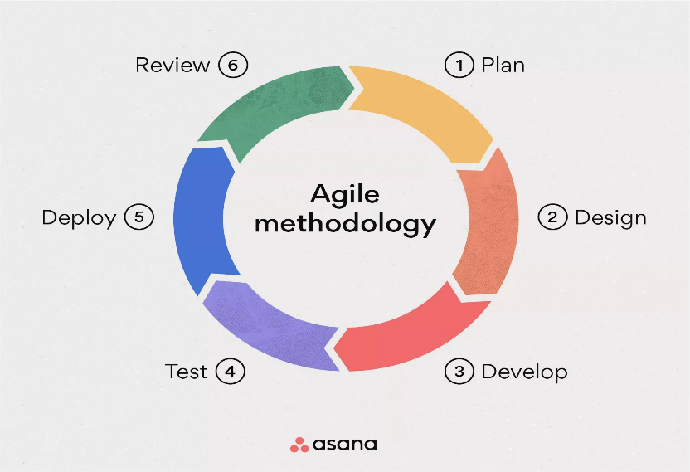
Figure 1. Agile Methodology

Following are steps to constitute the project methodology:

Requirements Analysis:
During this phase, major requirements of the system will be elicited from its stakeholders, who are the researchers and academics, with the support of the technical support team. All the processes to be automated will be identified, including the processes of submitting requests for support or rewards, in addition to the reports and analysis requirements.

System Design:
It will be followed by the system design based on the requirements analysis of both the user interface and the database. During this phase, one decides on how users will interact with the system and how data will be stored and processed. Effort shall be made in the design to meet the needs of the users and make the process of managing scientific research and related services easier.

System Development:
In this stage, writing codes takes place to actually build the digital system. Of course, there is certain technology, such as HTML and CSS for developing interfaces, complemented by other languages ​​like PHP for the development of the platform. It will split the development into small modules so that each part may be tested before going on to another.

Testing and Quality Assurance:
At each stage of the development of the system, there will be testing on whether any error exists. Performance, usability, and compliance with specified requirements will be tested. First of all, there will be initial tests within the development team, then within a small circle of users from the university and the test will be on localhost.

Implementation and Deployment:
The system developed and tested will be deployed into the university environment. During this stage, the support team is meant to be trained in how the system should be used effectively, and to have a trial run period by the users to ensure that things go on smoothly.

Continuous Monitoring and Evaluation:
It will also be continuously monitored upon deployment for seamless operation and resolving hitches that may show up. User feedback will be sought and analyzed for the continued development and improvement of the system. This methodology will keep the project flexible in implementation, reach the aimed goals with continuous care about the quality of the final product, and it will be in step with the users' expectation.

1.8 Proposed Working Plan

The proposed working plan allows for an orderly overview of how the project is supposed to be executed.
It is a group project, and each of the team members is responsible for completing a part. Usually, at the university, weekly meetings with the instructor are held for 12 hours a week, and the work on specific sections is developed and finalized. In addition, Sunday and Thursday are selected for periodic meetings with the supervisor, each lasting 1.5 hours per week, in order to review progress and discuss completed tasks, with further insights and ideas welcomed.

The following Gantt Chart represents the working plan for the project.

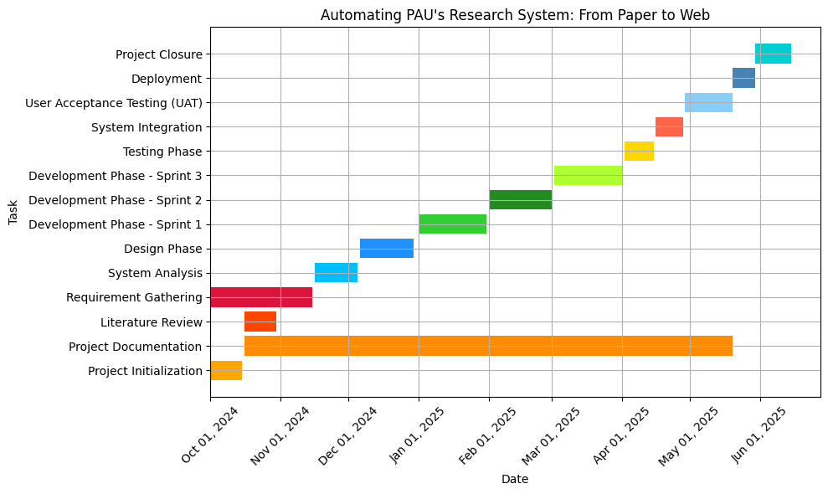
Figure 2. Gantt Chart

1.9 Project Constraints

Though intended to provide major boosts in efficiency and effectiveness to the Scientific Research Department at Palestine Ahliya University, the "Automating PAU's Research System: From Paper to Web" project has many constraints that need to be considered while developing and implementing the project. A few of these are:

Technical Limitations:
The design and functionality of the system will be limited to the infrastructure at the university. These include server capacity, the level of connectivity to the internet, and the compatibility level with other operating systems that may be in place. This may also involve additional resources and expertise, which ensure smooth integration with other university systems and third-party databases, such as Scopus and Web of Science.

User Adoption:
This might be the most difficult-hitting factor, turning a completely paper-based system into a fully electronic system. Not all users, especially the ones accustomed with traditional methodologies of work, like staff and researchers, would be comfortable taking the switch to full electronic systems. A plan for training and support will need to be developed to ensure users can utilize this new system to their fullest capabilities.

Data Privacy and Security:
The level of information handled would be academic research and personal data; thus, it needs stringent levels of security with a view to protecting such information. This would need to cater to local and international regulations on data privacy that may further constrain design and implementation.

Budget and Resources:
It will be well-developed by having good budgeting with adequate resources. Largely, the scope would be limited because the budget would inversely affect the use of software tools, hardware infrastructure, and even the hiring of more technical experts in places where needed.

Timeline:
The project is proposed to be done within the academic year, and this may mean that not as much time could be spent on testing and refining. Any form of delay in any phase will result in cascading effects on the final delivery of the system.

System Maintenance:
Bug fixing, system updating, and solving user problems within the system after the go-live will be an ongoing need. A plan needs to be developed that gives attention to the long-term sustainability of the systems by focusing resources toward continuous improvement and enhancement of the systems.

Extrinsic Dependencies:
As the integrations are to be made on the external platforms themselves, like Scopus and Web of Science, development of the system depends on the cooperation between the platforms and also on the availability of APIs from those platforms. Any changes or limitations introduced within those third-party systems affect the efficiency and functionality of this system.

1.10 Summary

It was an introductory chapter that outlined the background, objectives, scope, and methodology of the project. The project aims at digitizing from paper to digital the Scientific Research and Technical Support Department of Palestine Ahliya University. It presents how a digital system would improve efficiency, communication, and maintaining the data of the technical support request, research follow-up, and application for rewards through an online platform. Agile is the methodology followed for the project to make sure the project maintains flexibility for continuous improvement. The system will allow smoother processing, enhanced quality of services, and better security with more transparency.

CHAPTER TWO: SYSTEM ANALYSIS

2.1 Introduction

The chapter on system analysis will look at and assess important elements vital to the implementation of a digital platform for the Scientific Research Department at PAU. This chapter discusses in detail important aspects regarding the strategies for project implementation, the proposed system design, system requirements (functional and non-functional), feasibility studies, added value that the project brings about, and management of the project. It helps the chapter to develop a comprehensive understanding of what would be required to realize the desired results of the system transformation through this analysis.

2.2 Project Implementation Options
Options For the Construction of The Proposed system the implementation options for Proposed system mainly concern the decision about how best to develop and deploy the platform for the Scientific Research Department. Upon consideration of such various options, we have opted to develop a web-based application. The following are justifications for that decision:

Availability: Students, researchers, and administrators can use the web-based platform easily on any device through a browser. No special software need be installed. That's how easy it is to access from anywhere.

Device Independence: The application can be operated efficiently across all different devices and browsers; access could easily be from desktops, laptops, tablets, or other smartphones.

Easy Updates: Any upgrades or changes concerning the platform can be immediately implemented without users downloading. That way, all users are always using the newest version of the application, without any downtimes.

SHR Development: It is far less expensive to create a single cross-platform web application than to create local applications for each of the operating systems. Thus development costs remain low, and feature richness is still ensured.

It can develop faster now with web technologies, but implementation happens faster and iterating using a feedback loop from the user happens much faster than it used to be.

Expandable; this design will also include the expandable one according to what would probably be any demand in case of increased users, submissions, and service requests.

Entry Barrier Reduction: Users will not install software or applications to interact with the platform, which will enhance accessibility and further reduce entry friction for new users-a critical factor in user adoption.

Advanced web security: The platform can be fitted with advanced safety measures to safeguard the most sensitive information, such as research data, user credentials, and reward processing.

Data Analyzing Capabilities: The web platform will allow the attaching of data trackers to record usage type, requests, and movements by the user. The data will result in insights that can be utilized to further optimize the system and the performance.

2.3 The Proposed System

- Digital Submission of Research Papers: The system will be able to allow researchers to submit their research papers through a user-friendly online portal. This eliminates physical paperwork and, as such, makes both the work of the researcher and that of the administrator easier. These can be uploaded in Word format, PDFs, Excel, among other formats, and automatically get in-process through the system itself. An efficient digital submission system, by the integration of such a system, makes the entire submission process streamlined, mistakes associated with paper submissions reduced, and delays avoided, as usually associated with managing physical documents. In addition, this process will enable researchers to trace where their submissions are in the status of review in near "real time," greatly fostering transparency and efficiency in the process.

- Upload Supporting Document for Verification: The system allows uploading supporting documents, such as proof of publication in known journals or a conference participation certificate or other relevant documentation with regard to the research and its dissemination. This helps the verification process because the system verifies that indeed a document is attached before submitting, which gives the system the opportunity to ensure that the researchers are qualified for the grant. The system automatically flags incomplete or invalid submissions; the researchers are forced to address these issues before they are able to complete their application. This reduces administrative burdens significantly and cuts the processing cycle of the reward.

- Workflow Automation: The workflow is automated for approvals that might ensure the research submissions have gone through the proper channels and that some action has been sought in this regard. Every time a research paper comes along, it goes automatically into the heads of different departments for approval, including, most relevantly, the Head of Research, Finance Department, etc. The system gives a faster route and approval for the same, hence reviewing the papers in the fastest possible time. It notifies all the parties involved on completion of any task or any attention needed to be paid to a step so that no step may get left behind. The automated approval system minimizes manual intervention and improves transparency to fasten up the entire process and improve the institution's research management efficiency.

- Comprehensive Rewards System: This platform shall have an inbuilt Rewarding Scheme, which focuses on providing incentives to the researchers for their quality works and academic contributions. Researchers publishing at a recognized journal, such as Scopus and Web of Science, or conference participants would get the reward after identifying predetermined criteria, such as classification in journals or place the researcher holds in the said publication. Besides, the researchers will be able to view the detailed breakdown of their reward calculation, and the system itself will update the rewards after verification of publication or attendance at conferences is completed. It will encourage the researchers to strive for better publications and incentivize continuous contributions being made to academia.

- Real-Time Notification Capabilities: The system shall notify the researchers at every critical point the process has reached in the submission to its eventual approval. This may be in the areas such as, but not limited to: Successful submissions, movement to next stage in the review, or approval for a certain reward. These instantaneous notifications will keep the researcher posted about the latest happenings on their submissions and would cause researchers to take required action at the right time. This feature will improve internal communication on the platform, lessen the use of follow-up e-mails, and reduce the chances of missing out on deadlines or vital updates.

- User-Friendly and Intuitive Interface: The platform will be designed in an easy-to-use and accessible fashion. This, in turn, means a user-friendly interface that the most minimally technically orientated researcher can easily employ for what needs to be done. It finally means that researchers can basically accomplish just about anything they want with the platform, from submission and tracking processes regarding approval or awarding, with minimal hassle. The system will then be friendlier for the users, who will have to invest less time in learning how it works and will let researchers actually do their job. It needs to be optimized for desktop and mobile devices for any-time-anywhere access.

- Research Submission Template: The system shall provide pre-designed and customizable templates to the researchers for standardization in research submission. These templates will guide the researcher through the steps involved in formatting consistency and minimal submission errors. The researcher will be able to fill in the important details, such as their role, type of research, and related documents. In this way, all required information is gathered in the right format, which will speed up the approval and review process. These templates can easily be adapted by researchers to suit any particular submission guidelines with a very successful chance of through. Tracking Research Participation and Status: The platform allows the researcher to indicate whether he/she is an author or co-author in submitting the research and further track from the initial to the final stages of their submissions.

- They will then have an overview of where their submission lies in the approval chain, whether it is with reviewers, awaiting review by department heads, or has been approved for a reward. Researchers may, therefore, have full view over their submissions, hence eliminating or reducing anxiety over the status of their works. It will store historical data on the submission history, which helps to compare the progress of their works with past research over time. It supports the following research types: journal articles, conference papers, collaborative research work, and so on.

- This will allow researchers to identify the type of research for submission and customize the system when submitting. For example, if a collaborative paper, the system can offer an opportunity for co-authors to add their name and keep track of his/her contributions. For conference presentations, if it is a research work, the system can also ask to upload a certificate of conference participation. With such versatility, any form of academic work can be maintained on one single and uniform system. View detailed reports and metrics on the said granular activities tracking performance for various aspects of a researcher's academics.

- The reports will further include information on submissions made, rewards received, publications to accredited journals, and attendance to conferences. Allowing insight into their academic development, the researchers will then use these reports to review and analyze their performance for setting objectives and determining areas that need improvement. The system shall, therefore, make such reports available to the researcher for download for further analysis or addition to their personal records to allow them to track long-term academic contributions. Integration with university systems: The system is designed to be integrated into university systems, such as the student management, finance, and academic administration platforms.

- This will ensure consistency in data across systems, thus reducing redundancy and increasing overall administrative efficiencies. For instance, once a reward has been approved, the system will automatically send a notification to the finance department for disbursement. Such integration will make the working of different departments coordinate effectively in order to enhance workflow and minimize errors. Scalability and Flexibility: The system is to be designed with considerations of scalability in order to let it grow together with the research community of the university.

- It should also be able to handle any extra load that may arise due to an increase in the number of researchers, publications, and submissions. Equally, it should be agile enough to accommodate added functionality, enhancing the currently existing functionality or adjusting to meet the ever-changing needs of academics and administration. This will ensure the system can grow with university needs, adding value in a long-term way for researchers and administrators.

2.4 System Requirements

2.4.1 Functional Requirements

- User Registration and Authentication
Users will get registered by giving necessary information regarding their name and email. So, after registering, users should log in using their provided credentials to access the systems securely based on their levels. The system will contain the recovery of passwords besides this to make the system accessible without compromising security.

- Submitting Research
The researchers will submit their research through the filling of a form capturing necessary details like the research title, authors, and published or not. They will be able to carry supporting documents like proof of publication among others ensuring completeness in submission.

- Rewards and Recognition System
Researchers are rewarded based on the importance of the publication. The system will monitor and automate rewarding, linking the submissions to the corresponding reward. Researchers will provide their details and upload proof of publication to qualify for rewards.

- Approval Workflow
The research submitted will undergo an approval process, where the administrators will review and approve the research. After approval, the research will be forwarded to the Finance Department for the distribution of rewards, making the flow of work easy.

- Notification System
The users will be notified through email regarding any updates on their research, whether an approval or an action required. These notifications will keep the researchers updated on time regarding the status of their submissions.

- Research Tracking
Researchers can track the developments regarding their research work right from submission to publication. It gives a dashboard for monitoring of status and due actions which will enhance transparency and hence efficiency.

- Reporting and Analytics
The system will generate various reports on research submissions, rewards, and department performances. These reports will thereby enable administrators to analyze the trends for informed decision-making from the data collected.

- User Roles and Permissions
The system will have varied users' roles, which include the researchers, administrators, and finance officers. Each of these roles will have certain permissions while ensuring that users access only areas they are authorized to interact with within the system.

- Document Management
The system will let users upload, manage, and download documents related to their research. It would support different file types, store them securely, and thus be easily accessible when required.

- Search and Filtering
A search function will allow users to find research papers or other relevant documents using specific criteria like title, author, or publication date. This will improve efficiency and reduce time spent searching for specific information.
- Secure Data and Privacy
Thus, the adage goes, "from cradle to grave." In today's time, most of the parents are really concerned about the education of children and are trying to provide the best possible education to their children, no matter how far they have to go to get it. The system will integrate security features like encryptions and secure authentication protocols such that sensitive information will be adequately safe. It shall be compliant with the data privacy laws such that no user's data will fall under the wrong hands

- Admin Dashboard and Management Tools
The admin dashboard will keep the administrator in a position where he or she can see the entire research process from submission through approval to reward. It shall consist of a management tool through which the research tasks will be taken care of and the system run efficiently.

2.4.2 Non-Functional requirements

- Scalability
It should be noted that the system is a scalable one that will have to deal with more and more users, research submissions, and data. The system must be keeping up its optimal performance during increasing submission and user numbers without any substantial delays or downtimes.

- Performance
The system has to be able to respond to a huge number of users in parallel without any lag whatsoever. For quality user experience, action submission, approval, and notification should happen with minimal time consumption.

- Availability
The system should be available round the clock and throughout the year except during minimal downtime. Maintenance schedules should take care of updates and other maintenance work so that it does not affect heavy usage. High availability therefore means the user always has the opportunity to access the system when needed.

- Usability
The system should be very easy to navigate, quite intuitive, and just simply throw up windows or pop-ups where the user has to proceed variable measures of the process: submission, follow-up, and rewards. Clear navigation, clear instructions, and responsiveness would then make it easy to enhance the user experiences.

- Security
To protect sensitive user data, the system must include encryption and secure communications protocols. It should also prevent unauthorized leakage and data breaches as personal as well as research information must remain confidential.

- Backup and Recovery
Automated backup of all user data and research submission will be performed regularly to avert the possibility of data loss. The system should have a recovery plan so that data can be restored when the system crashes in order to ensure continuity and reliability.

- Compliance
The system must comply with regulations such as data protection regulations and privacy regulations to manage user data responsibly (for example, GDPR). Of course, such regulations will increase the system's credibility and trustworthiness.

- Maintainability
The system must guarantee easy maintainability with low effort in making system improvement, because ideally, the code should be modular, documented properly, and allow developers to quickly fix errors, put in improvements, or adapt the system for new requirements without affecting overall functionality.

2.5 Feasibility Study

Feasibility study forms one of the important parts of project planning; it involves the critical study of the work to be undertaken with respect to technical, economic, and operational viability. It will be aimed at ensuring that the project is successfully executed within given constraints like time, budget, and availability of resources. The feasibility study for our project is given below:

2.5.1 Technical Feasibility

This aspect looks at the sufficiency of the existing technology and resources for developing and implementing the system. The proposed system will be a web-based application using modern web technologies: HTML, CSS, JavaScript, and backend technologies like PHP with MySQL or PostgreSQL. Because of the technical competency level required in web development from the team and frameworks supporting the same for rapid development, technical feasibility is high. Furthermore, cloud hosting services shall ensure that there is scalability and flexibility.
Considering that, we also have made a table of the “Automating PAU's Research System: From Paper to Web” Team skills to determine if the team has the skills needed for such a project as shown in table 2.

Table 2 . Technical Feasibility Study
Skill | Description | Required for | Team Member
Project Management | Ability to plan, execute, and manage the project timeline and tasks. | Overall project coordination and deadlines. | Project Manager/Lead Developer
Web Development | Knowledge of HTML, CSS, JavaScript, PHP, and frameworks (React, Angular, etc.). | Frontend and backend development. | Frontend Developer/Backend Developer
Database Management | Knowledge of relational databases (SQL, MySQL, PostgreSQL) and NoSQL. | Database design, data storage, and queries. | Database Administrator/Developer
UI/UX Design | Expertise in creating user-friendly interfaces and experiences. | Website interface design and user flow. | UI/UX Designer
Security Best Practices | Knowledge of securing web applications (encryption, authentication, etc.). | Protecting user data and securing platform. | Security Specialist/Backend Developer
API Development & Integration | Ability to design, develop, and integrate APIs for communication between services. | Service interactions, external API integrations. | Backend Developer/API Specialist
Quality Assurance | Knowledge of testing methodologies (unit, integration, system tests). | Ensuring system reliability and bug-free operation. | QA Tester
Mobile App Development | Knowledge of mobile app development (if applicable) for research tracking. | Developing mobile interfaces for access. | Mobile Developer
System Architecture | Ability to design scalable and robust system architectures. | Structuring the project’s technology stack and infrastructure. | System Architect
Cloud Computing | Familiarity with cloud services (AWS, Azure, Google Cloud). | Hosting, scaling, and managing the project infrastructure. | Cloud Specialist
Version Control | Proficiency in Git for code versioning and collaboration. | Collaborating on code and managing changes. | All Developers
Data Analysis and Reporting | Ability to design and implement data analysis tools (e.g., dashboards). | Admin and user analytics, research tracking. | Data Analyst/Backend Developer
Communication Skills | Ability to convey information clearly to both technical and non-technical stakeholders. | Project updates, troubleshooting, and coordination. | Project Manager/All Team Members
Customer Support | Knowledge of handling customer queries and feedback. | Managing feedback and user support. | Support Specialist/Customer Support

2.5.2 Economic Feasibility

The processes which go into considering a system include determining whether economic costs can bear development and maintenance. Some significant ones would involve software development costs, hosting costs, periodic ongoing maintenance costs, and associated support costs. A web-based platform will cut down on the cost of development and maintenance since the system is web-based and can be accessed with any device, hence reducing the need for mobile applications. The return on investment shall be witnessed in terms of efficiency, ease of research processes, and reduced paper work. This option of economic feasibility indicates the cost-effectiveness of the system in the long term; it promises increased efficiency while diminishing administration overhead.

2.5.3 Operational Feasibility

Operational feasibility determines the degree to which the system fits into an operational use within the organization. Its specific aims include the automation of operations currently being done manually; for example, research submissions and reward tracking, among many more, with technical support from a professional. The proposed system would be in line with the university's strategic plan of making all administrative work electronic and, therefore, more efficient. This system is user-friendly, hence easy to use by students and academic staff, and, with proper training, they will master the use of the system very fast. Operational feasibility is affirmative since the system enhances the entire research management process without any major disruption.

2.5.4 Legal Feasibility

The system must comply with the set legal and regulatory standards, especially in respect to data privacy and security. Since the platform will handle sensitive user data such as research content and personal information, it is very necessary that regulations like GDPR and the protection of data be taken into consideration. For that, the development phase needs to consider legal experts on the panel to ensure all legal requirements are met. The project, in that sense, is legally viable at this initial stage, provided all data protection measures are duly considered.

2.5.5 Feasibility Scheduling

This study justifies whether the project can be successfully completed within the estimated time. The projected date for the completion of the project is from October 2024 to May 2025. For easier handling, the development phases-requirement gathering, design, development, and testing-are divided into stages with clearly defined deadlines. With proper planning and allocation of resources, the system shall be developed and implemented within the given timeline. Schedule feasibility is high, since the team feels very confident that the capability of milestones and deadlines shall be met.

2.5.6 Resource Feasibility

This aspect concerns the availability of resources: the development team, hardware, software, and infrastructure. The development team is composed of professionals with vast experience in web development, database management, and system design. The infrastructure comprising cloud hosting and development tools is available at low cost. Thus, the resource feasibility is high, and the required resources are at hand for the successful completion of the project.

Table 3. Required Resources & Costs
Total Cost (USD) | Cost (USD) | Quantity | Item | Resource Category
$0 | $0 (Student) | 1 | Project Manager/Lead Developer | Development Team
$0 | $0 (Student) | 1 | Frontend Developer
$0 | $0 (Student) | 1 | Backend Developer
$0 | $0 (Student) | 1 | Database Administrator
$0 | $0 (Student) | 1 | UI/UX Designer
$0 | $0 (Free) | 1 | XAMPP (Local Development) | Software & Tools
$0 | $0 (Free) | 1 | Visual Studio Code
$0 | $0 (Free) | 1 | Git Version Control
$0 | $0 (Free) | 1 | Postman (API Testing)
$0 | $0 (Open Source) | 1 | Selenium WebDriver
$0 | $0 (Open Source) | 1 | Apache JMeter
$0 | $0 (Open Source) | 1 | Nikto Scanner
$0 | $0 (Personal) | 1 | Development Laptops | Hardware
$0 | $0 (XAMPP) | 1 | Testing Server (Local)
$0 | $0 (Free/Student) | 1 | Microsoft Office/Google Docs | Documentation
$0 | $0 (Free) | 1 | Draw.io (Diagrams)
$50 | $50 | 1 Year | Web Hosting Service | Hosting (Future)
$15 | $15 | 1 Year | Domain Name
$0 | $0 (Internal) | - | Documentation & User Guides | Training & Support
$0 | $0 (Internal) | 3 Sessions | System Training Sessions
$0 | $0 (University) | 8 Months | Internet & Utilities | Miscellaneous
$20 | $20 | - | Project Stationery
$85 |  |  |  | TOTAL

2.5.7 Schedule Feasibility
Table 4. Schedule Feasibility
Status | Resources Required | Duration (Weeks) | End Date | Start Date | Task | Phase
Completed | Project Manager | 1 | Oct 7, 2024 | Oct 1, 2024 | Project Initiation | Phase 1:  Planning
Completed | All Team Members | 2 | Oct 21, 2024 | Oct 8, 2024 | Requirements Gathering
Completed | Research Team | 2 | Oct 28, 2024 | Oct 15, 2024 | Literature Review
Completed | System Analyst | 2 | Nov 11, 2024 | Oct 29, 2024 | System Analysis | Phase 2:  Analysis
Completed | Project Manager | 2 | Nov 18, 2024 | Nov 5, 2024 | Feasibility Study
Completed | System Analyst | 2 | Nov 25, 2024 | Nov 12, 2024 | Use Case Development
Completed | System Architect | 2 | Dec 9, 2024 | Nov 26, 2024 | System Architecture | Phase 3:  Design
Completed | Database Designer | 2 | Dec 16, 2024 | Dec 3, 2024 | Database Design
Completed | UI/UX Designer | 2 | Dec 23, 2024 | Dec 10, 2024 | UI/UX Design
In Progress | Frontend Developer | 6 | Feb 3, 2025 | Dec 24, 2024 | Frontend Development | Phase 4: Development
In Progress | Backend Developer | 6 | Feb 17, 2025 | Jan 7, 2025 | Backend Development
In Progress | Database Developer | 4 | Feb 10, 2025 | Jan 14, 2025 | Database Implementation
Planned | All Developers | 2 | Feb 17, 2025 | Feb 4, 2025 | Unit Testing | Phase 5:  Testing
Planned | QA Team | 2 | Mar 3, 2025 | Feb 18, 2025 | Integration Testing
Planned | QA Team | 2 | Mar 17, 2025 | Mar 4, 2025 | System Testing
Planned | End Users | 1 | Mar 24, 2025 | Mar 18, 2025 | User Acceptance Testing
Planned | Technical Team | 1 | Mar 31, 2025 | Mar 25, 2025 | System Deployment | Phase 6: Implementation
Planned | Training Team | 1 | Apr 7, 2025 | Apr 1, 2025 | User Training
Planned | All Team | 1 | Apr 14, 2025 | Apr 8, 2025 | System Launch
Planned | Documentation Team | 3 | May 5, 2025 | Apr 15, 2025 | Documentation Finalization | Phase 7:  Closure
Planned | Project Manager | 2 | May 19, 2025 | May 6, 2025 | Project Evaluation
Planned | All Team | 1 | May 26, 2025 | May 20, 2025 | Final Presentation
85% Complete |  | 34 Weeks | May 26, 2025 | Oct 1, 2024 |  | TOTAL PROJECT DURATION

2.5.8 Organizational Feasibility

Organizational feasibility evaluates whether organization necessary structure, resource, expertise successfully implements manage proposed system. project feasibility factor includes:
- Staffing: team required expertise web development, database management, project management execute project effectively. additionally, support staff trained handling new system.
- Technology: organization access required technology stack, including web development tool, database, server infrastructure.
- Management: project aligns organization 's goal, management team committed providing necessary resource, oversight, support project 's success.
- Resource: project access sufficient resource, including budget, hardware, software license, support development operational phase.

Organizational feasibility ensures project well - positioned successful completion integration within existing organizational framework.
In conclusion, the feasibility test shows that technically, economically, and operationally for the project is doable. Needed resources, budgets, and timeline are available to develop and deploy it successfully. Since there is a good chance that efficiency and streamlining of research management might be enhanced within PAU, the viability of this project goes hand-in-hand with the university's strategic imperatives.

2.6 Project Added Values

- Increases Efficiency: Automation of research submission and reward tracking as well as requests for support should hasten workflows and take on some of the manual paperwork.
- Improved Access: A web-based platform offers users the opportunity to avail services from any device anywhere anytime thus increasing flexibility among researchers and students.
- Tracking Precision: Updates applied in real-time to research approvals, rewards, and technical support requests will be part of the system and will increase transparency.

- Going Paperless: It promotes a paperless office/working environment as it reduces paper processes thus environmentally friendly and cost saving in administration.

- Improved Communication: A more efficient communication network would allow instant notification to researchers and their staff as soon as there is a status change on any of their requests.

- Centralization: As part of the centralized system, all documents, research, and requests will be stored is very easy to access and manage data.

2.7 Project Management

From the very first initiation of the project, a close and regular collaboration among the team members was going on. We had regular meetings in the university and also spent some evenings in homes. Most task coordination and continuous progress becomes realized through daily communication by WhatsApp and GitHub and Discord. The team continues discussing issues, sharing updates, and refining its endeavors toward project objectives.

2.8 Summary

In this chapter, the that has been given an extensive examination is the system that will be used in this project. It started with the exploration of the different ways of project implementation and explained the choice of a web application. The system under consideration is robustly interrogated for the primary components and functionalities. The different requirements of the system are specified: functional requirements and non-functional requirements; a detail description follows for each. There was also a feasibility study conducted to determine how viable the project would be, as well as the additional value additions. Additional emphasis that lay at this final chapter was on effective project management, stressing the efforts of the team in sustaining a collaborative approach in the project.

CHAPTER THREE: SYSTEM FUNCTIONAL REQUIREMENTS ANALYSIS

3.1 Introduction

This chapter outlines the functional requirements of the system. These requirements are derived from the inputs the system receives and the operations it performs. The objective is to streamline and articulate these requirements, facilitating a lucid comprehension of the roles and responsibilities of all individuals engaged in the system.

3.2 Context and Use-Case Diagrams
Context Diagrams: “Context diagrams serve as a foundational tool, helping designers and stakeholders grasp the scope and boundaries of a system under consideration. These diagrams provide a high-level view, illustrating how the system interacts with external entities and the environment. This article explores the significance of context diagrams in system design, their key components, and how to create them.” [11]

Use-Case Diagrams: “A Use Case Diagram in Unified Modeling Language (UML) [12] is a visual representation that illustrates the interactions between users (actors) and a system. It captures the functional requirements of a system, showing how different users engage with various use cases, or specific functionalities, within the system. Use case diagrams provide a high-level overview of a system’s behavior, making them useful for stakeholders, developers, and analysts to understand how a system is intended to operate from the user’s perspective, and how different processes relate to one another. They are crucial for defining system scope and requirements.” [13]
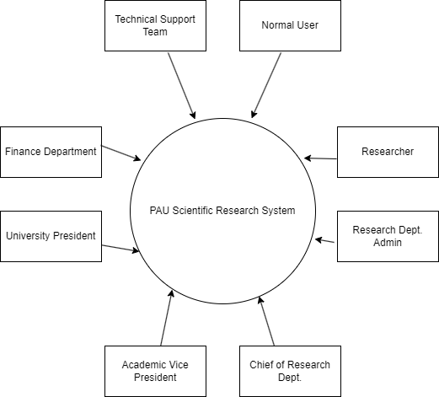
Figure 3. Context Diagram
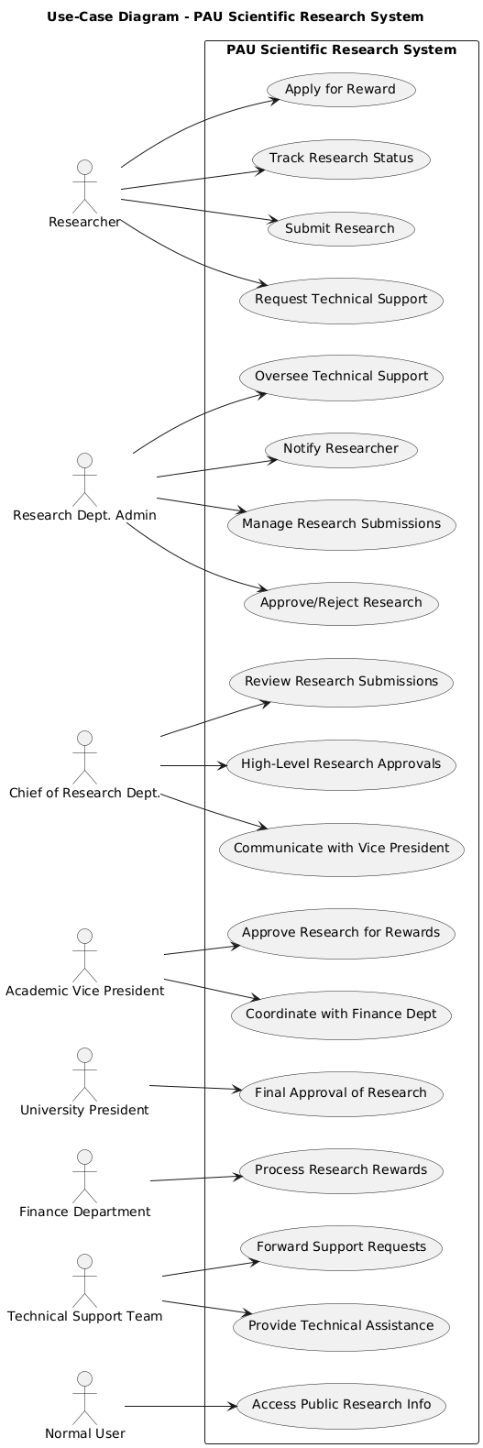
Figure 4. Use Case Diagram

3.3 Functional Requirement Description

Depending on the functional requirements mentioned in chapter 2, the following describes the functional requirements in more detail.

- Submit Research

Table 5. Functional Requirement Description: Submit Research
Actor | Researcher
Description | A researcher submits their research through the system to be reviewed and tracked.
Preconditions | The researcher must have an account and be logged in.
Basic processes | 1. The researcher logs into the system.  2. Selects the 'Submit Research' option.  3. Fills in research details and uploads the required documents.  4. Submits the research for review.
The exceptional | If the researcher fails to upload the required documents, an error message will prompt them to upload the necessary files.

- Request Technical Support

Table 6. Functional Requirement Description: Request Technical Support
Actor | Researcher
Description | The researcher requests technical support for issues such as statistical analysis or translation.
Preconditions | The researcher must be logged in and have a valid request for support.
Basic processes | 1. Researcher logs in.  2. Selects 'Request Technical Support' from the menu.  3. Fills in the request form with details about the required support.  4. Submits the request.
The exceptional | If no support options match the request, a notification will be sent asking the researcher to provide additional details.

3. Apply for Reward
Table 7. Functional Requirement Apply for Reward
Actor | Researcher
Description | The researcher applies for rewards based on published research in recognized journals.
Preconditions | The researcher must have a published research article in a recognized journal.
Basic processes | 1. Researcher logs in.  2. Selects 'Apply for Reward' option.  3. Fills in the form with details of the research and proof of publication.  4. Submits the application.
The exceptional | If the proof of publication is missing or invalid, the researcher will be notified to submit the correct documentation.

4. Track Research Status
Table 8. Functional Requirement Description: Track Research Status
Actor | Researcher
Description | The researcher tracks the status of their submitted research.
Preconditions | The researcher must have submitted research through the system.
Basic processes | 1. Researcher logs in.  2. Selects 'Track Research Status' from the dashboard.  3. The system displays the current status of the research (e.g., under review, approved, published).
The exceptional | If no research has been submitted, the researcher will be prompted to submit research.

5. Manage Research Submissions

Table 9. Functional Requirement Description: Manage Research Submissions
Actor | Admin (Research Dept.)
Description | The admin manages research submissions, reviews them, and decides whether to approve or reject.
Preconditions | Admin must be logged in and have the authority to manage submissions.
Basic processes | 1. Admin logs into the system.  2. Views the list of submitted research.  3. Reviews the research details.  4. Approves or rejects the submission.
The exceptional | If the research does not meet the required standards, the admin will send feedback to the researcher for revision.

6. Approve/Reject Research
Table 10. Functional Requirement Description: Approve/Reject Research
Actor | President of Research Dept.
Description | The President approves or rejects research based on its quality and relevance.
Preconditions | The research must have been submitted for review by the admin.
Basic processes | 1. President logs into the system.  2. Reviews the submitted research.  3. Approves or rejects the research.
The exceptional | If the research is incomplete or fails to meet criteria, the President will provide feedback for revision.
7. Notify Researcher
Table 11. Functional Requirement Description: Notify Researcher
Actor | Admin, President
Description | Notify researchers about updates on their submissions (e.g., approved, rejected, requires revision).
Preconditions | The research must be reviewed by the admin or President.
Basic processes | 1. Admin or President reviews the research.  2. Sends a notification to the researcher about the approval/rejection status.
The exceptional | If the notification fails, a backup email is sent to the researcher.
8. Approve Research for Rewards

Table 12. Functional Requirement Description: Approve Research for Rewards
Actor | Vice President, President
Description | The Vice President or President approves research for rewards based on journal classification and publication.
Preconditions | The research must meet reward criteria (published in recognized journals).
Basic processes | 1. The Vice President or President logs in.  2. Reviews the submitted research.  3. Approves the research for rewards.
The exceptional | If the research does not meet reward criteria, it will not be approved, and the researcher will be notified.

9. Process Research Rewards

Table 13. Functional Requirement Description: Process Research Rewards
Actor | Finance Dept.
Description | The Finance Department processes the rewards for researchers.
Preconditions | The research must be approved for reward by the Vice President or President.
Basic processes | 1. Finance logs into the system.  2. Views the list of approved research for rewards.  3. Processes payments or rewards.
The exceptional | If there is a discrepancy in the reward amount, the Finance Dept. will notify the President or Vice President for clarification.

3.4 Summary

This chapter covered system models and system representations through the proposed management system for research departments. It has included context and use-case diagrams which represent how different users-researchers, administrative staff, finance personnel, and system administrators-interact. Using these models, a flow of activities and the essential processes through which the department's services need to be converted from a paper-based system to a fully digital one was shown.
Functional requirements, in turn, have been specified in well-structured tables, which describe the actors, processes, and conditions involved in each feature so that every role and interaction in the system will be fully covered through this structured approach. Such structured information helps to ensure that the system will be fully understood with respect to behavior, interactions, and capabilities. This, therefore, creates a solid foundation for the project's implementation and future extension.

CHAPTER FOUR: SYSTEM DESIGN

4.1 Introduction

This chapter focuses on the design aspects of the research department management system, detailing how the system 's components and functionalities will be developed and structured. The design phase is crucial in transforming the system’ s requirements, outlined in previous chapters, into an implementable blueprint. It includes the architectural design, database schema, user interface design, and algorithms that will be used to ensure the system meets its functional and non-functional requirements.

4.2 Class Diagram
Class Diagram:
In software engineering, a class diagram in the Unified Modeling Language (UML)is a type of static structure diagram that describes the structure of a system by showing the system's classes, their attributes, operations (or methods), and the relationships among objects. [14]
Due to class diagram being very complex and very hard to read, we therefore decided to split it in 6 categories:

4.2.1 Users and Roles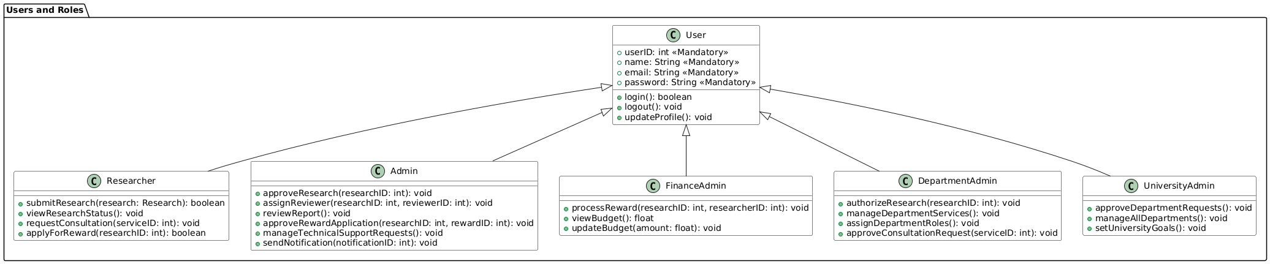
Figure 5. Users and Roles Class Diagram

4.2.2 Research & Service Management
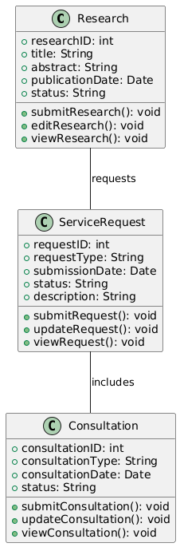
Figure 6. Research & Service Management Class Diagram

4.2.3 Account & User Management
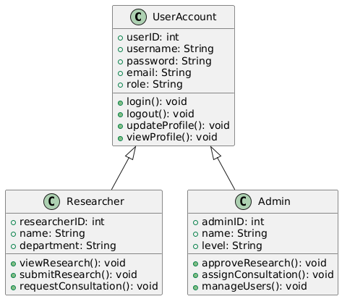
Figure 7. Account & User Management Class Diagram

4.2.4 Finance & Budgeting
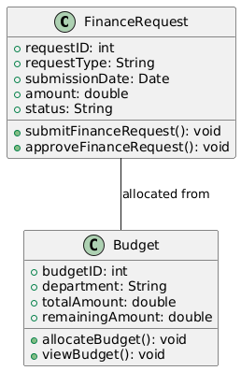
Figure 8. Finance & Budgeting Class Diagram

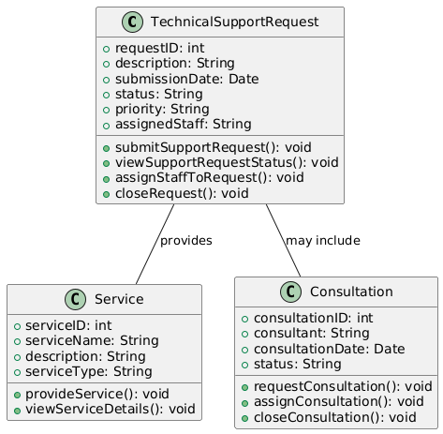
4.2.5 Technical Support
Figure 9. Technical Support Class Diagram

4.2.6 Notification & Approval Process
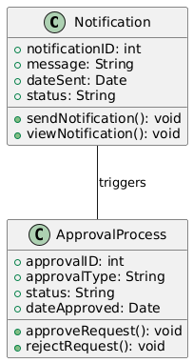
Figure 10. Notification & Approval Process Class Diagram

4.2.7 Rewards System
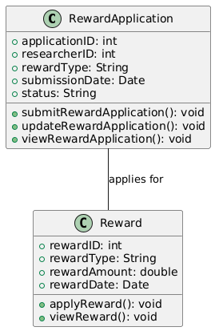
Figure 11. Rewards System

4.3 Sequence Diagram

In software engineering, a sequence diagram shows process interactions arranged in time sequence. This diagram depicts the processes and objects involved and the sequence of messages exchanged as needed to carry out the functionality. Sequence diagrams are typically associated with use case realizations in the 4+1 architectural view model of the system under development. Sequence diagrams are sometimes called event diagrams or event scenarios.

There are two kinds of sequence diagrams:

Sequence Diagram (SD): A regular version of sequence diagram describes how the system operates, and every object within a system is described specifically.
System Sequence Diagram (SSD): All systems are treated as a black box, where all classes owned by the system are not depicted. Instead, only an object named System is depicted.

Key elements of sequence diagrams
A sequence diagram shows, as parallel vertical lines (lifelines), different processes or objects that live simultaneously, and, as horizontal arrows, the messages exchanged between them in the order in which they occur. This allows for the graphical specification of simple runtime scenarios.

A system sequence diagram should specify and show the following:

- External actors
- Messages (methods) invoked by these actors
- Return values (if any) associated with previous messages
- Indication of any loops or iteration area
[15]
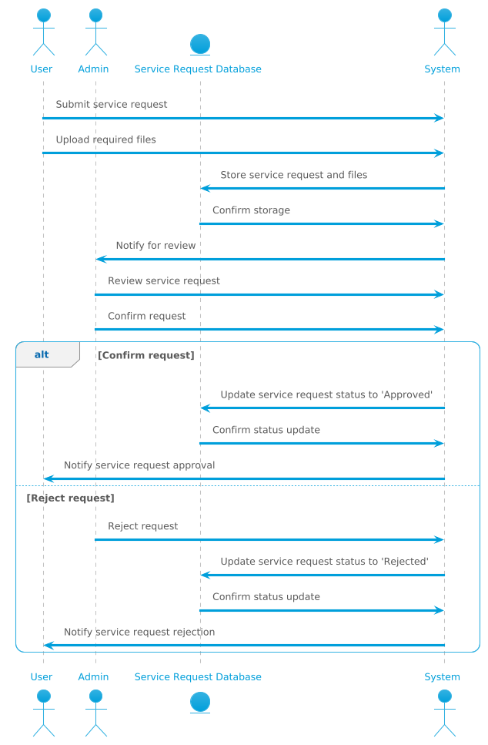
Figure 12. Service Request Sequence Diagram

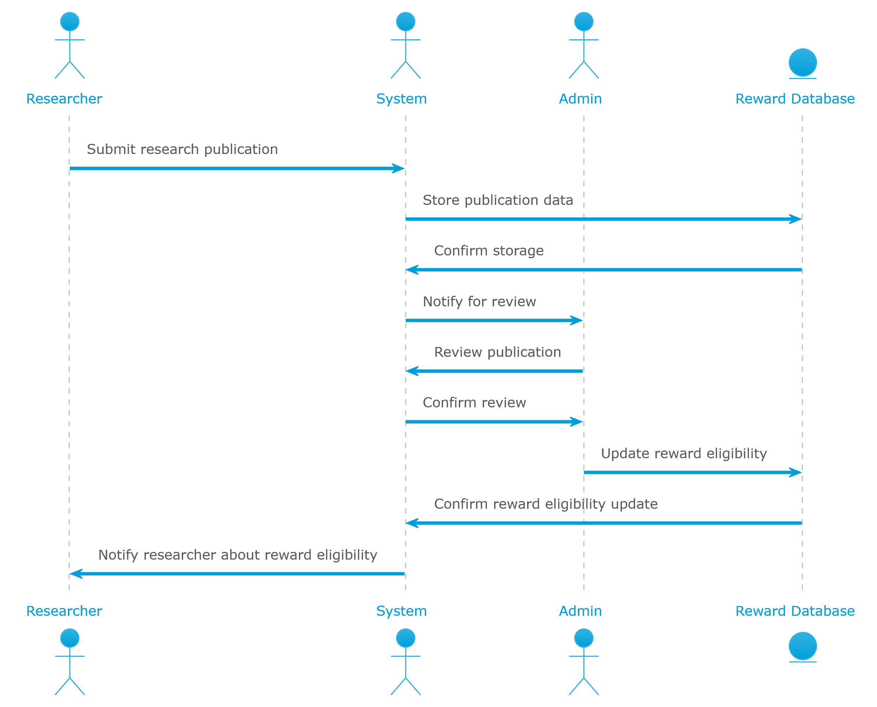
Figure 13. Reward System Sequence Diagram

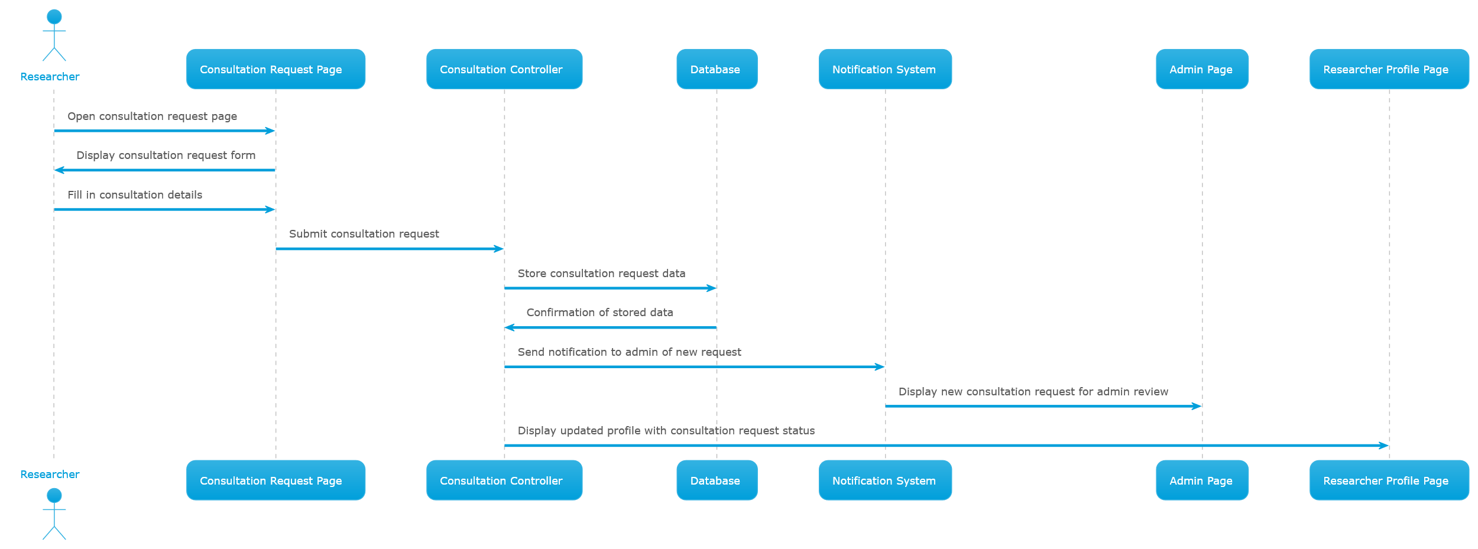
Figure 14. Consultation Request Sequence Diagram

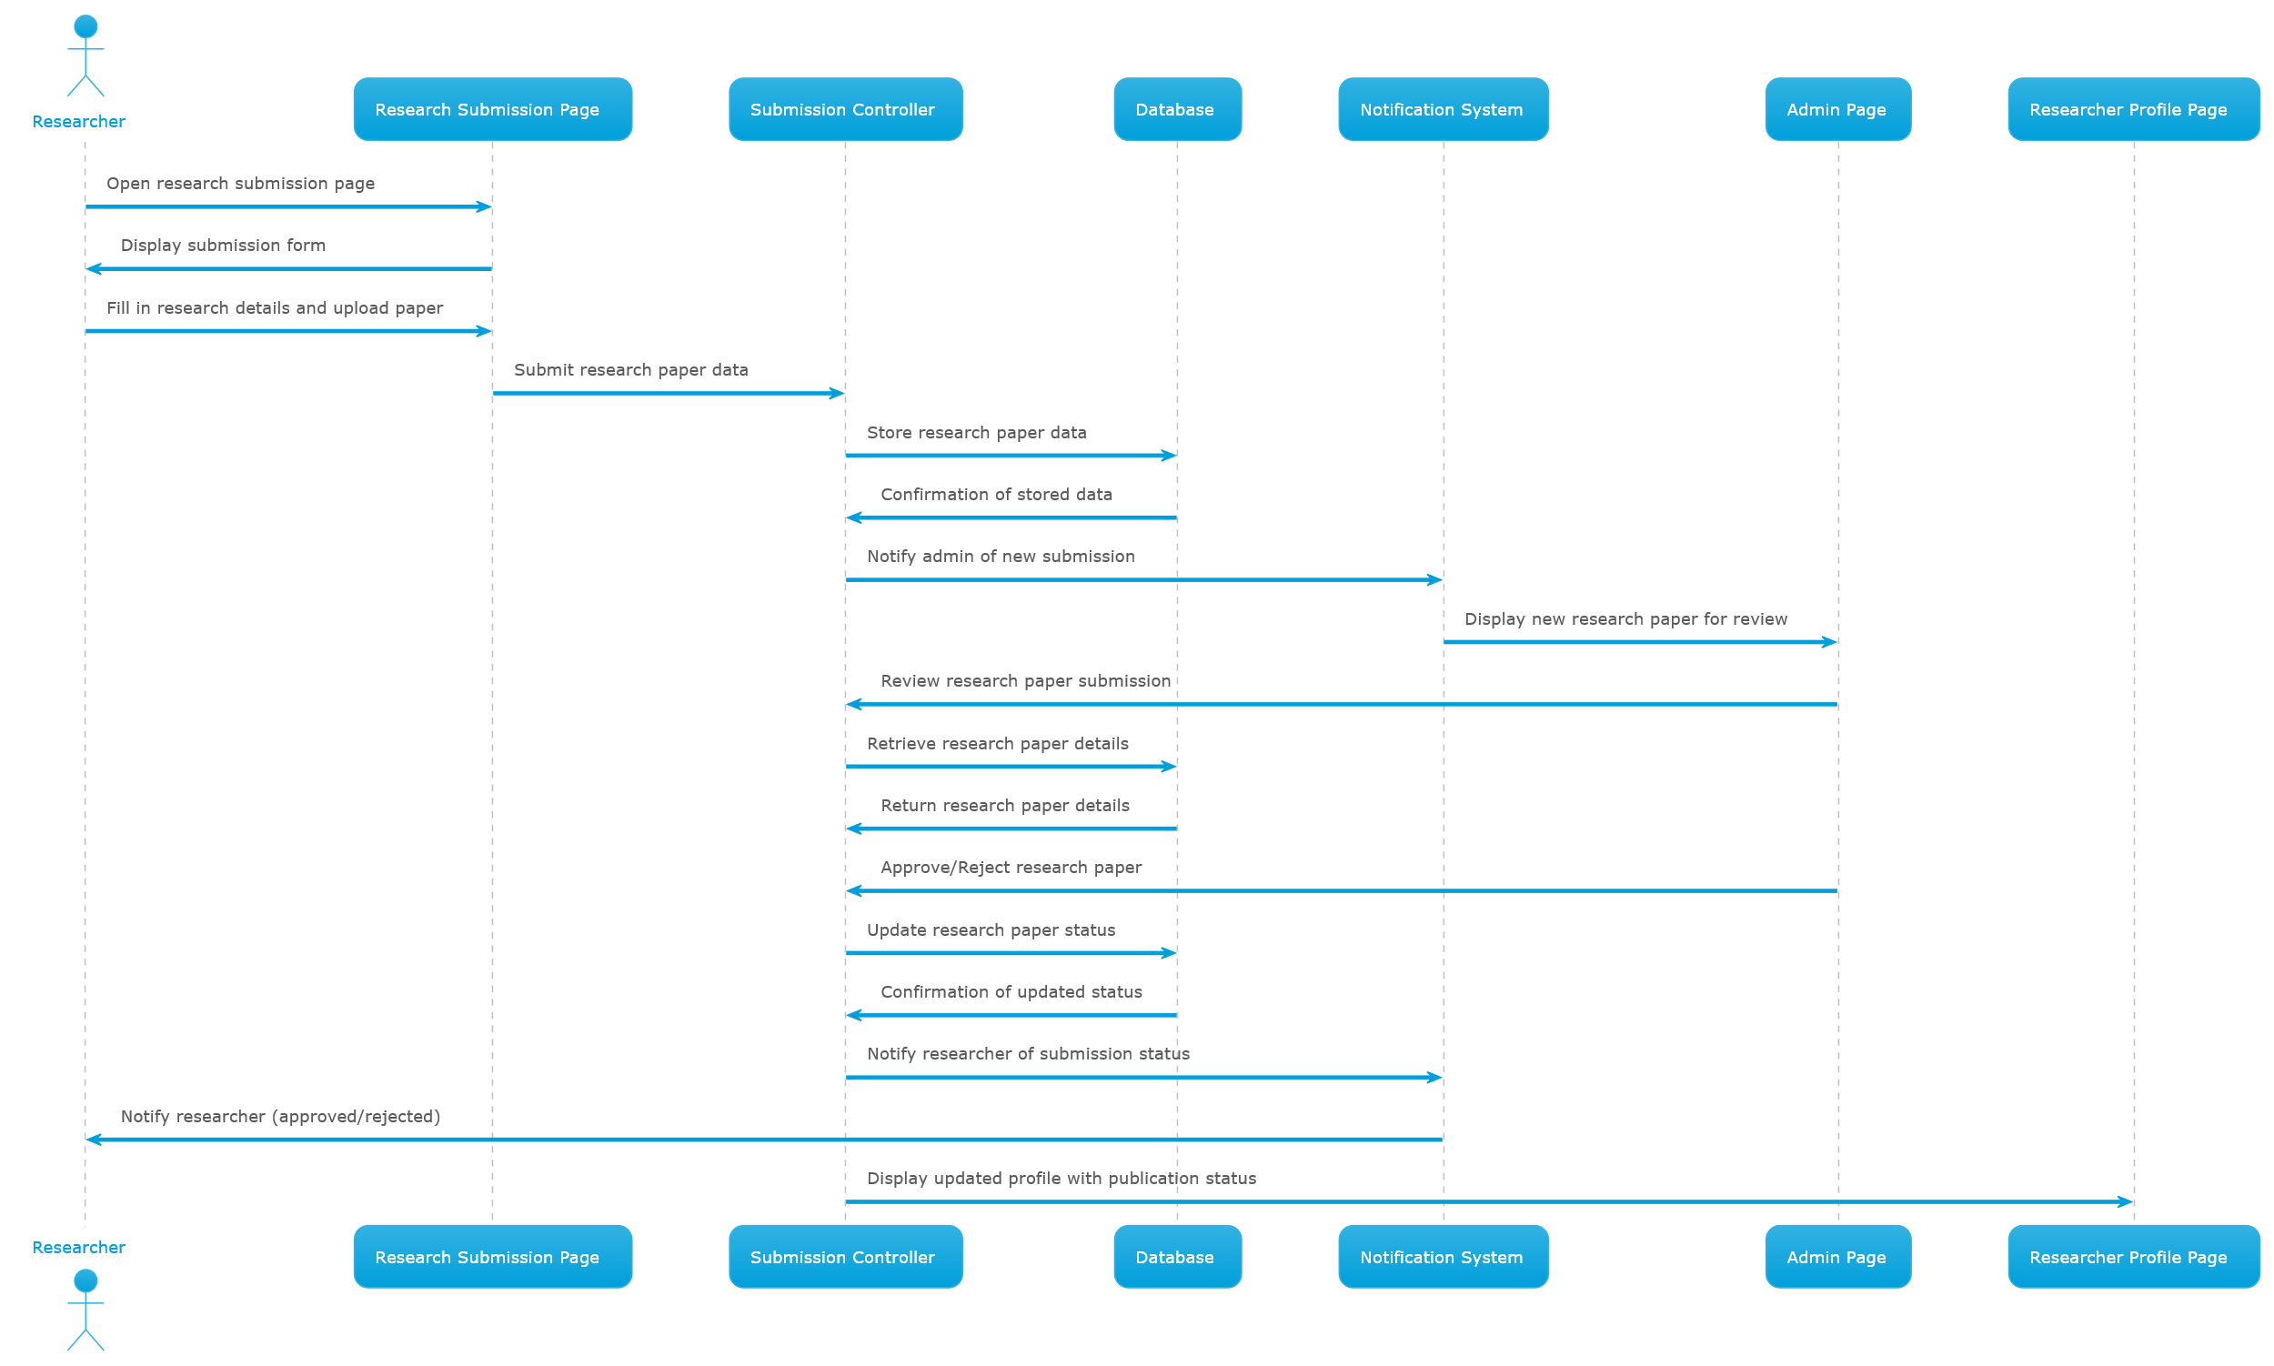
Figure 15. Publication Submission Sequence Diagram

4.4 Entity Relationship Diagram (ERD)
Entity-Relationship Diagram (ERD): An Entity-Relationship Diagram (ERD) is a semantic data modeling technique used to represent the relationships between data entities within a database system. It visually defines how data is structured and how various entities interact with one another. ERDs are used in data management to ensure the accurate representation of real-world resources, events, and concepts within a database. The ERD is a crucial tool in the design and development of database systems, allowing for the planning, building, and evaluation of shared databases and integration of existing ones. [16]

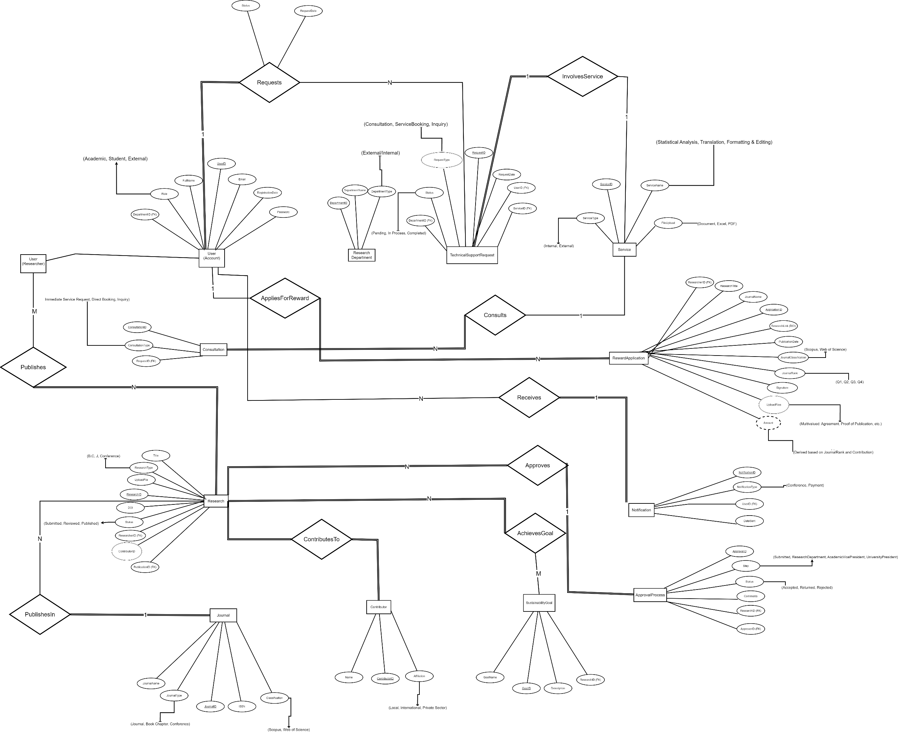
Figure 16. Entity Relationship Diagram (ERD)

4.5 Functions Design & Activity Diagram

Activity Diagrams: Activity diagrams are an essential part of the Unified Modeling Language (UML) that help visualize workflows, processes, or activities within a system. They depict how different actions are connected and how a system moves from one state to another. By offering a clear picture of both simple and complex workflows, activity diagrams make it easier for developers and stakeholders to understand how various elements interact in a system. [17]

Functions Design:

- User Registration
- Service Request
- Reward Application
- Consultation Booking
- Account Management
- Notification System
- Research Submission
- Admin Dashboard
- Researcher Profile
- Approval Process
- Research Tracking
- Service Feedback
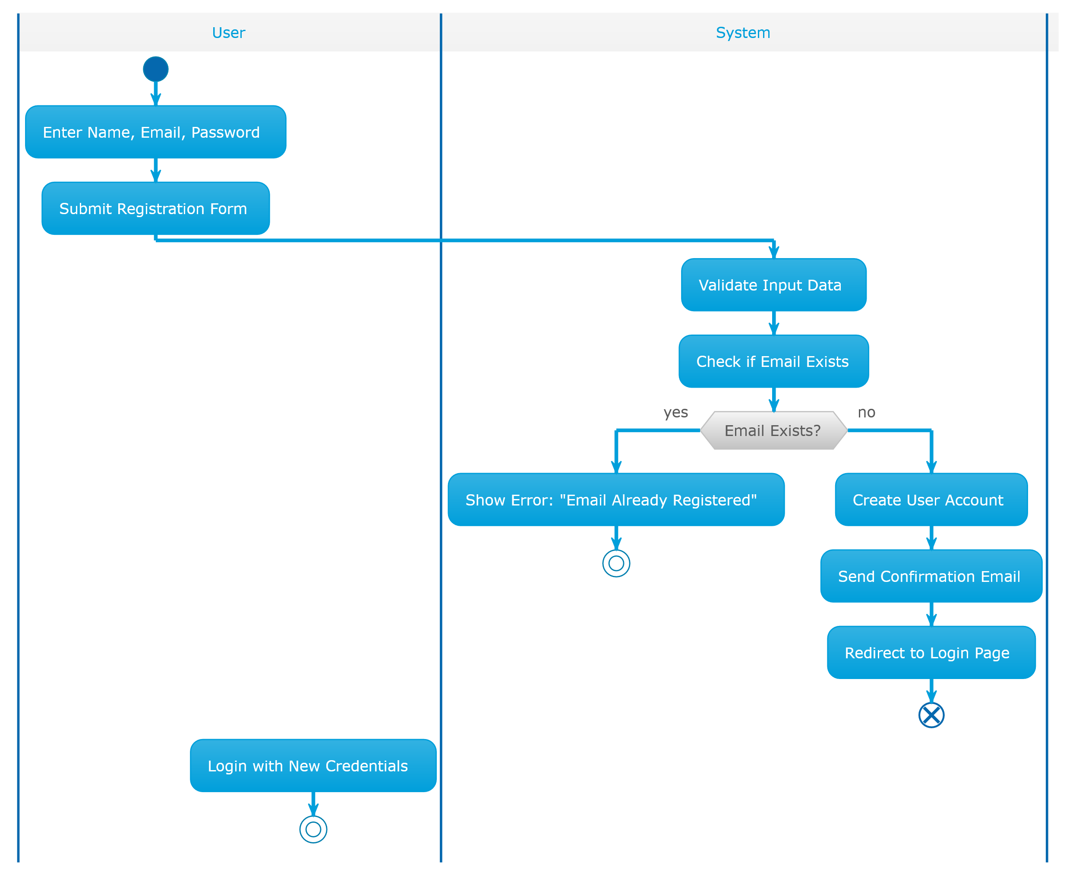
Figure 17. User Registration Activity Diagram

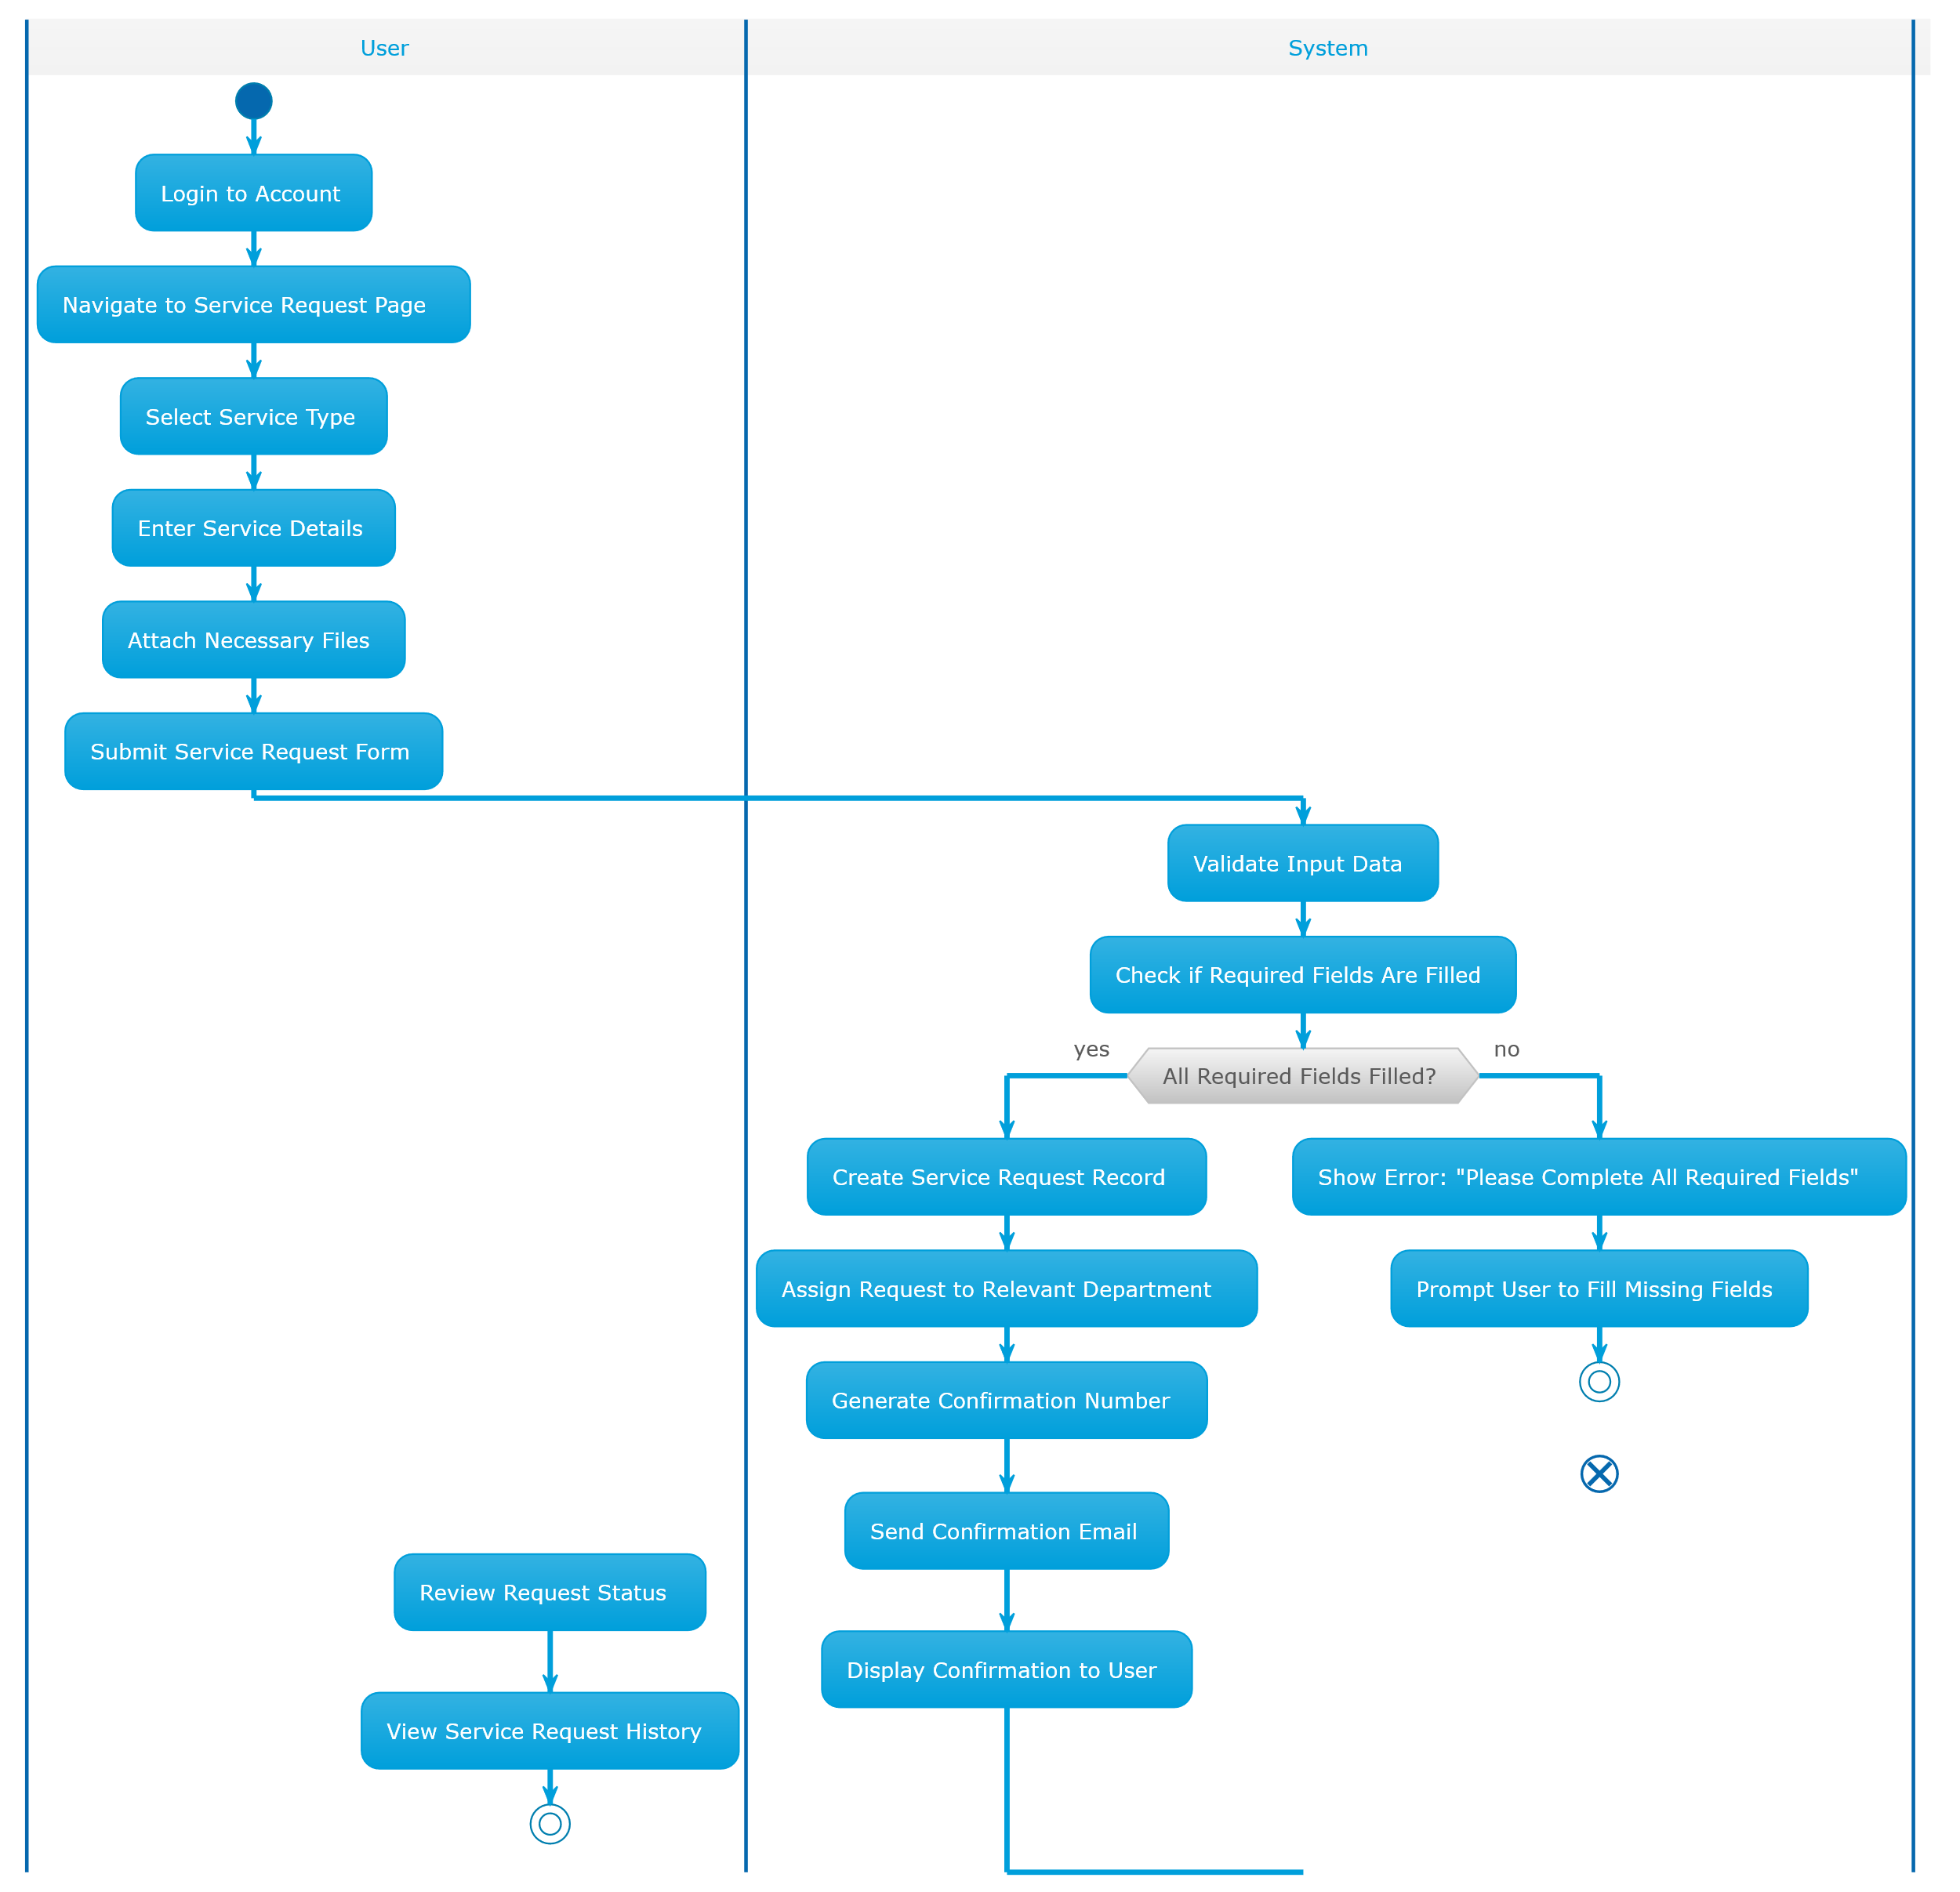
Figure 18. Service Request Activity Diagram

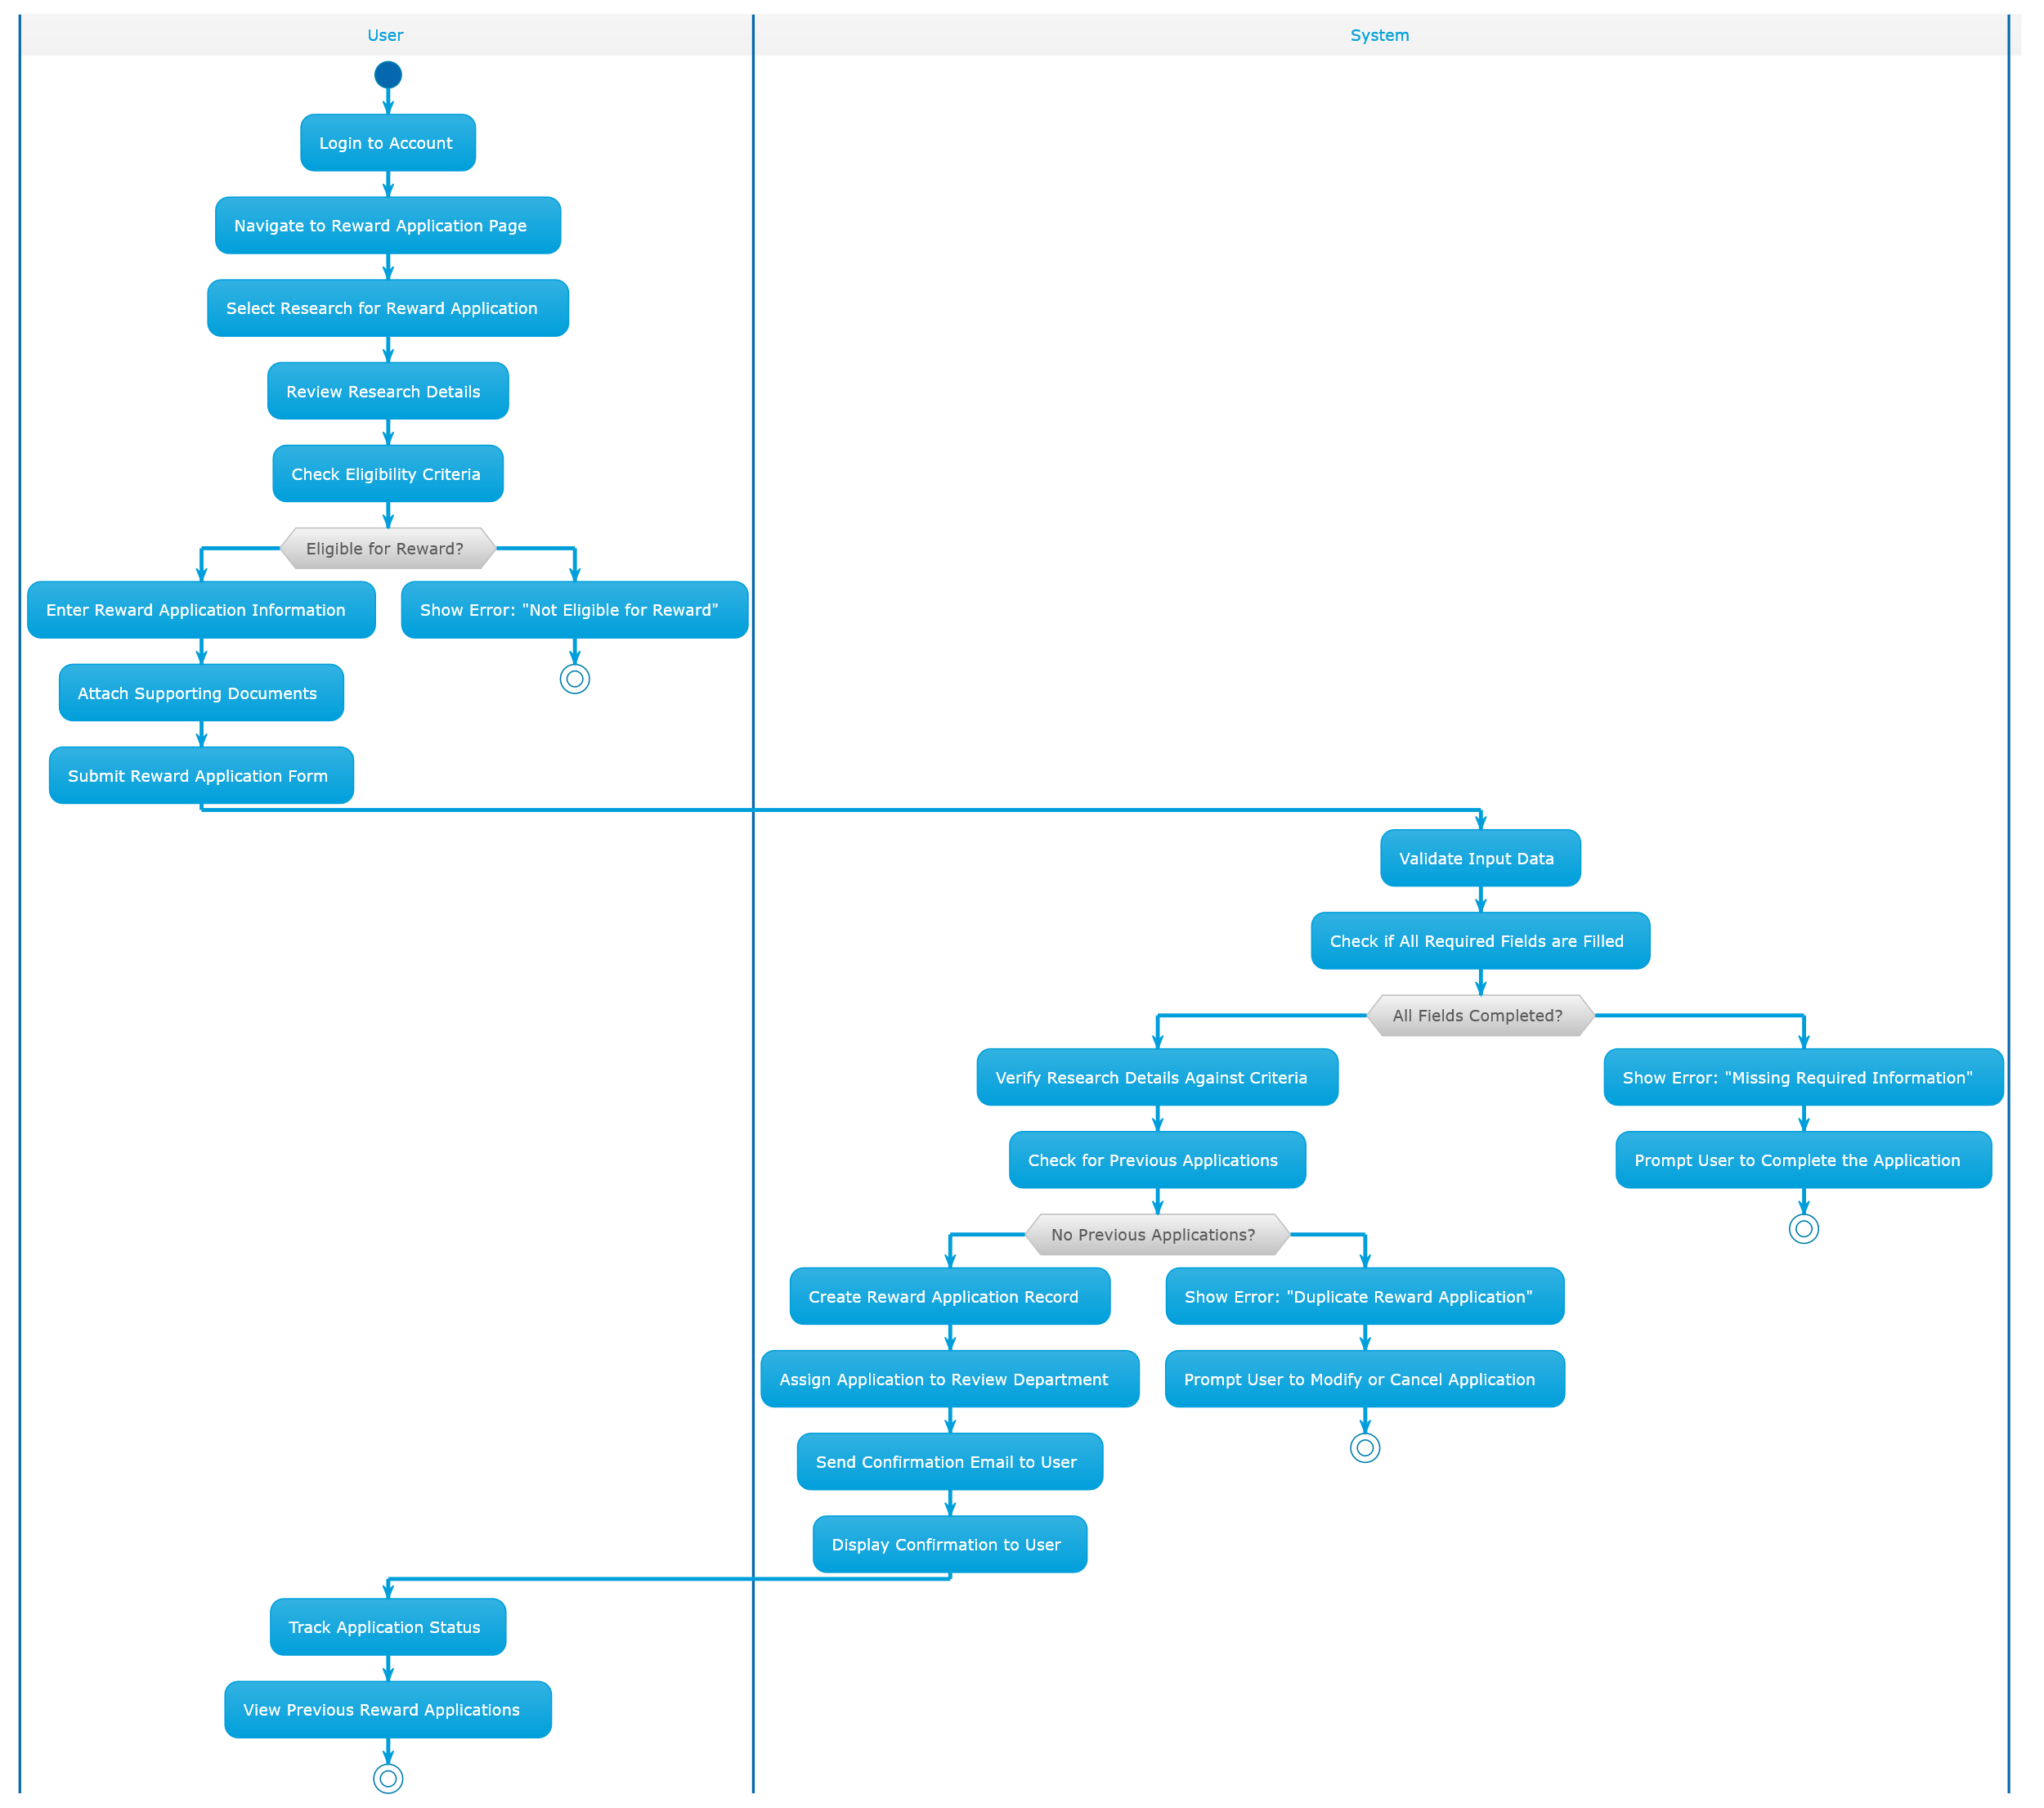
Figure 19. Reward Application Activity Diagram

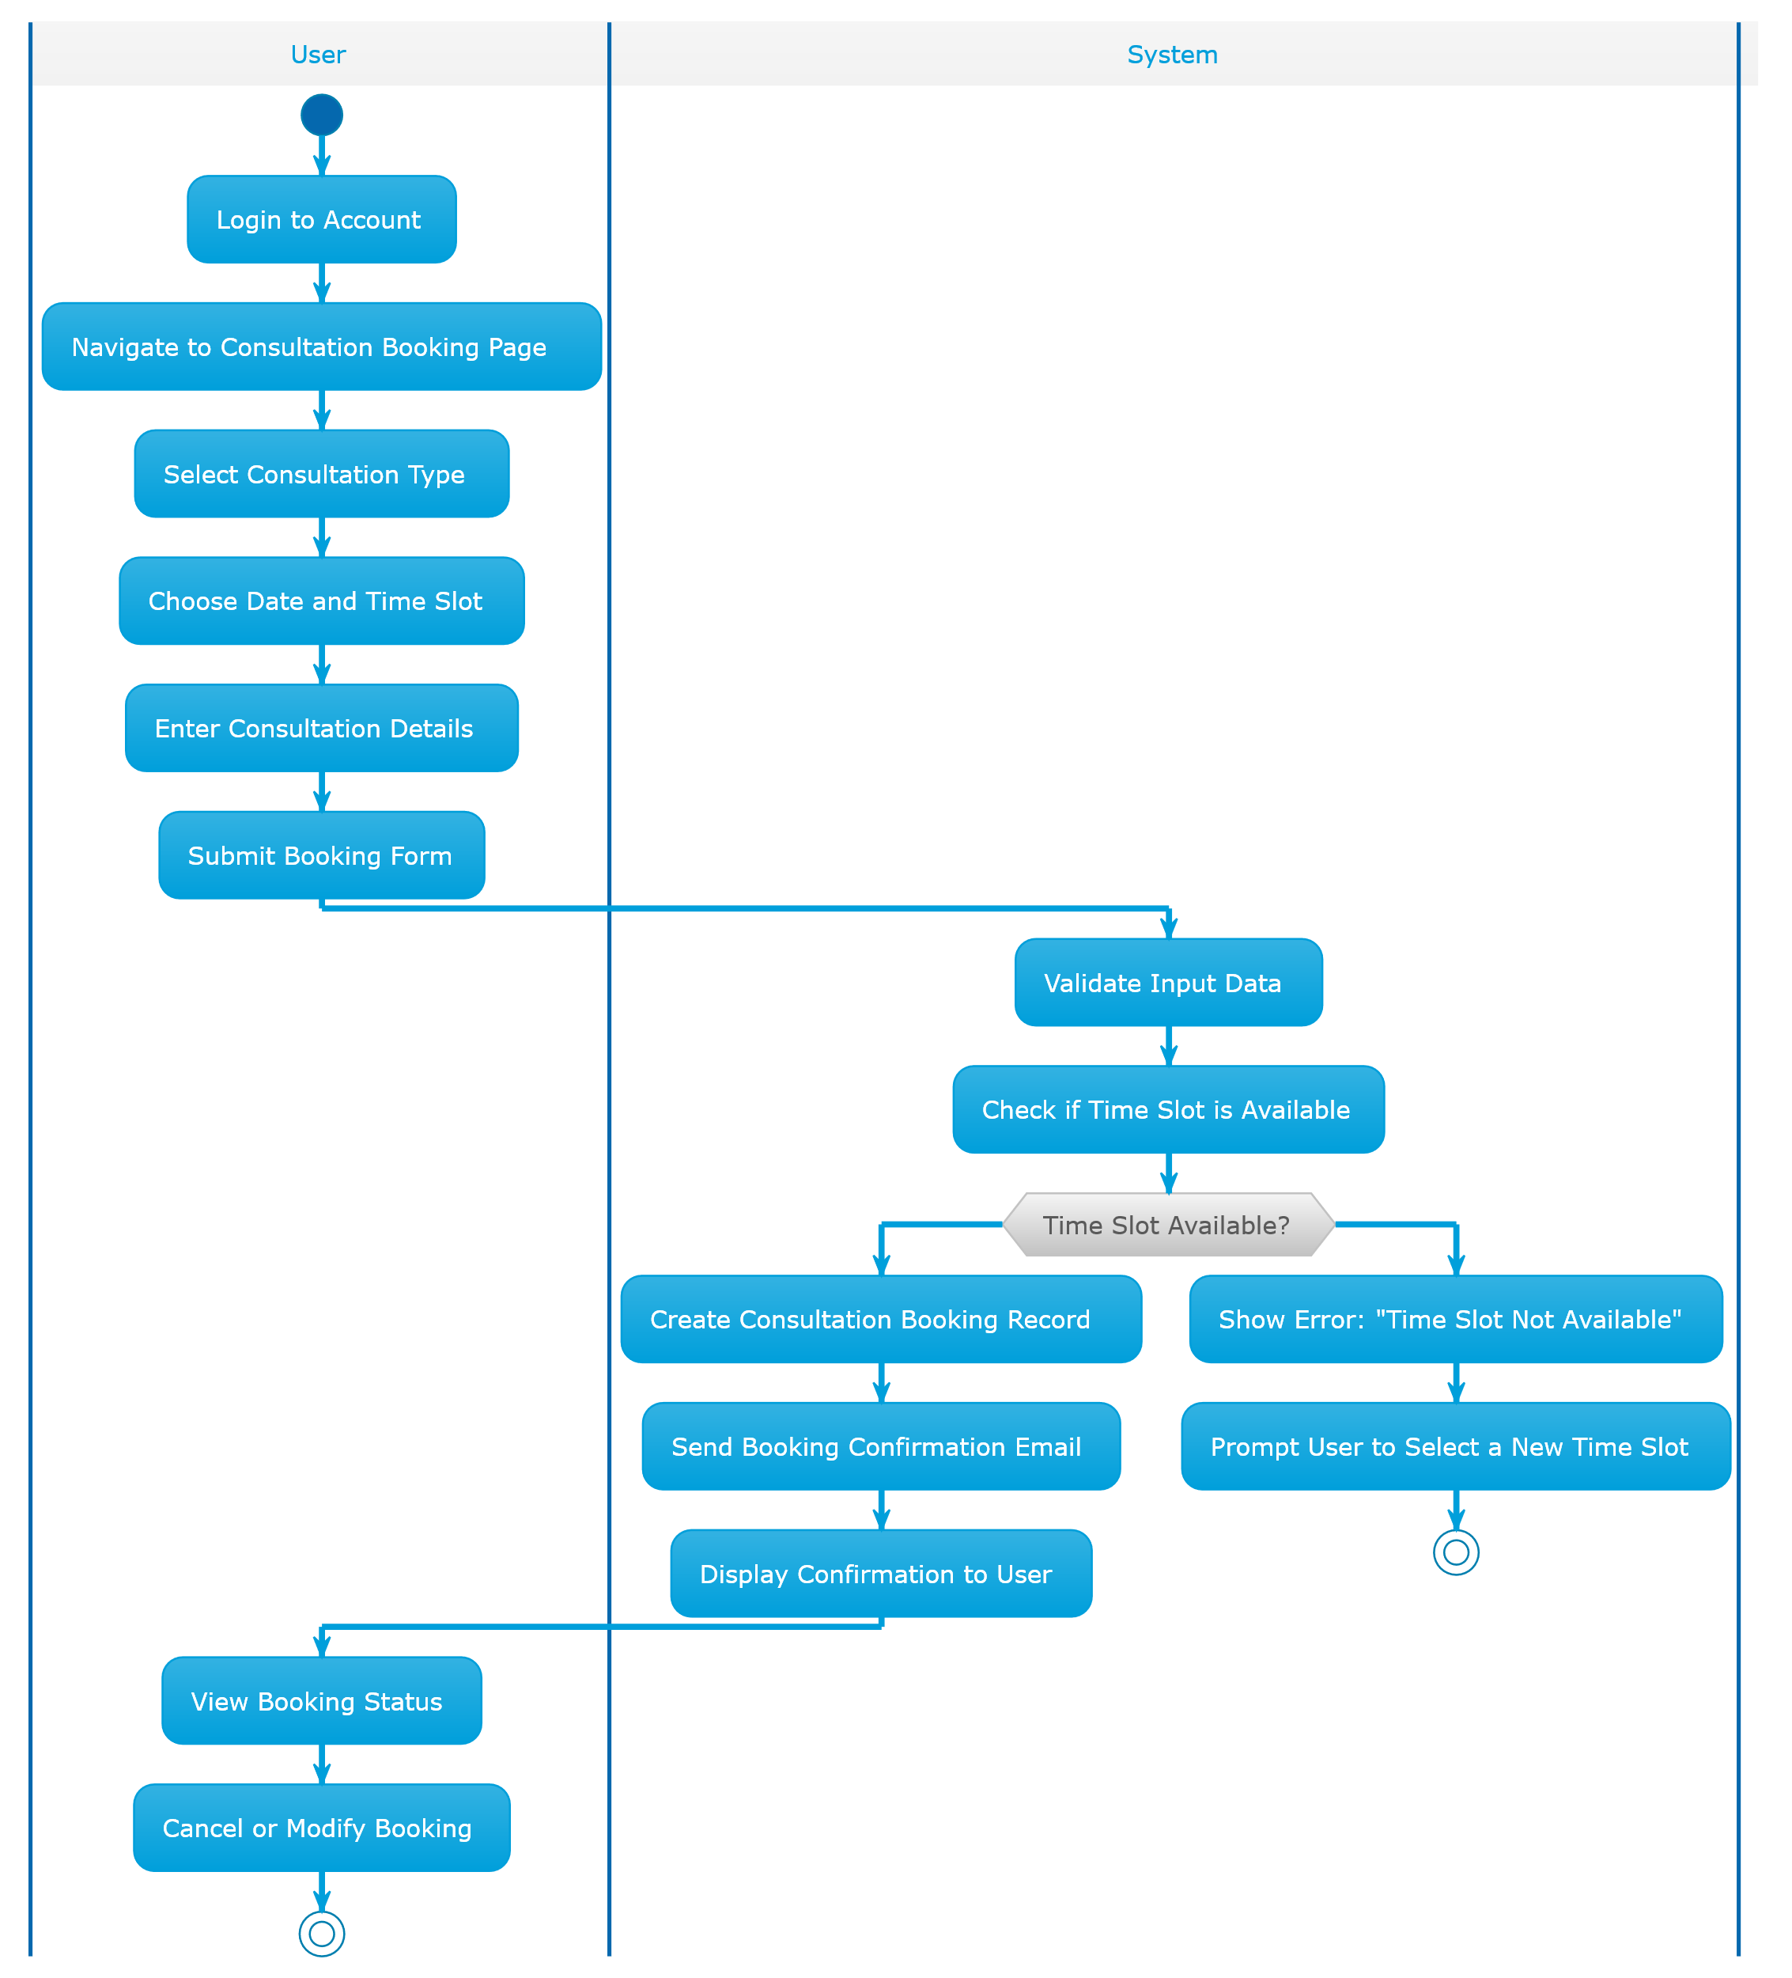
Figure 20. Consultation Booking Activity Diagram

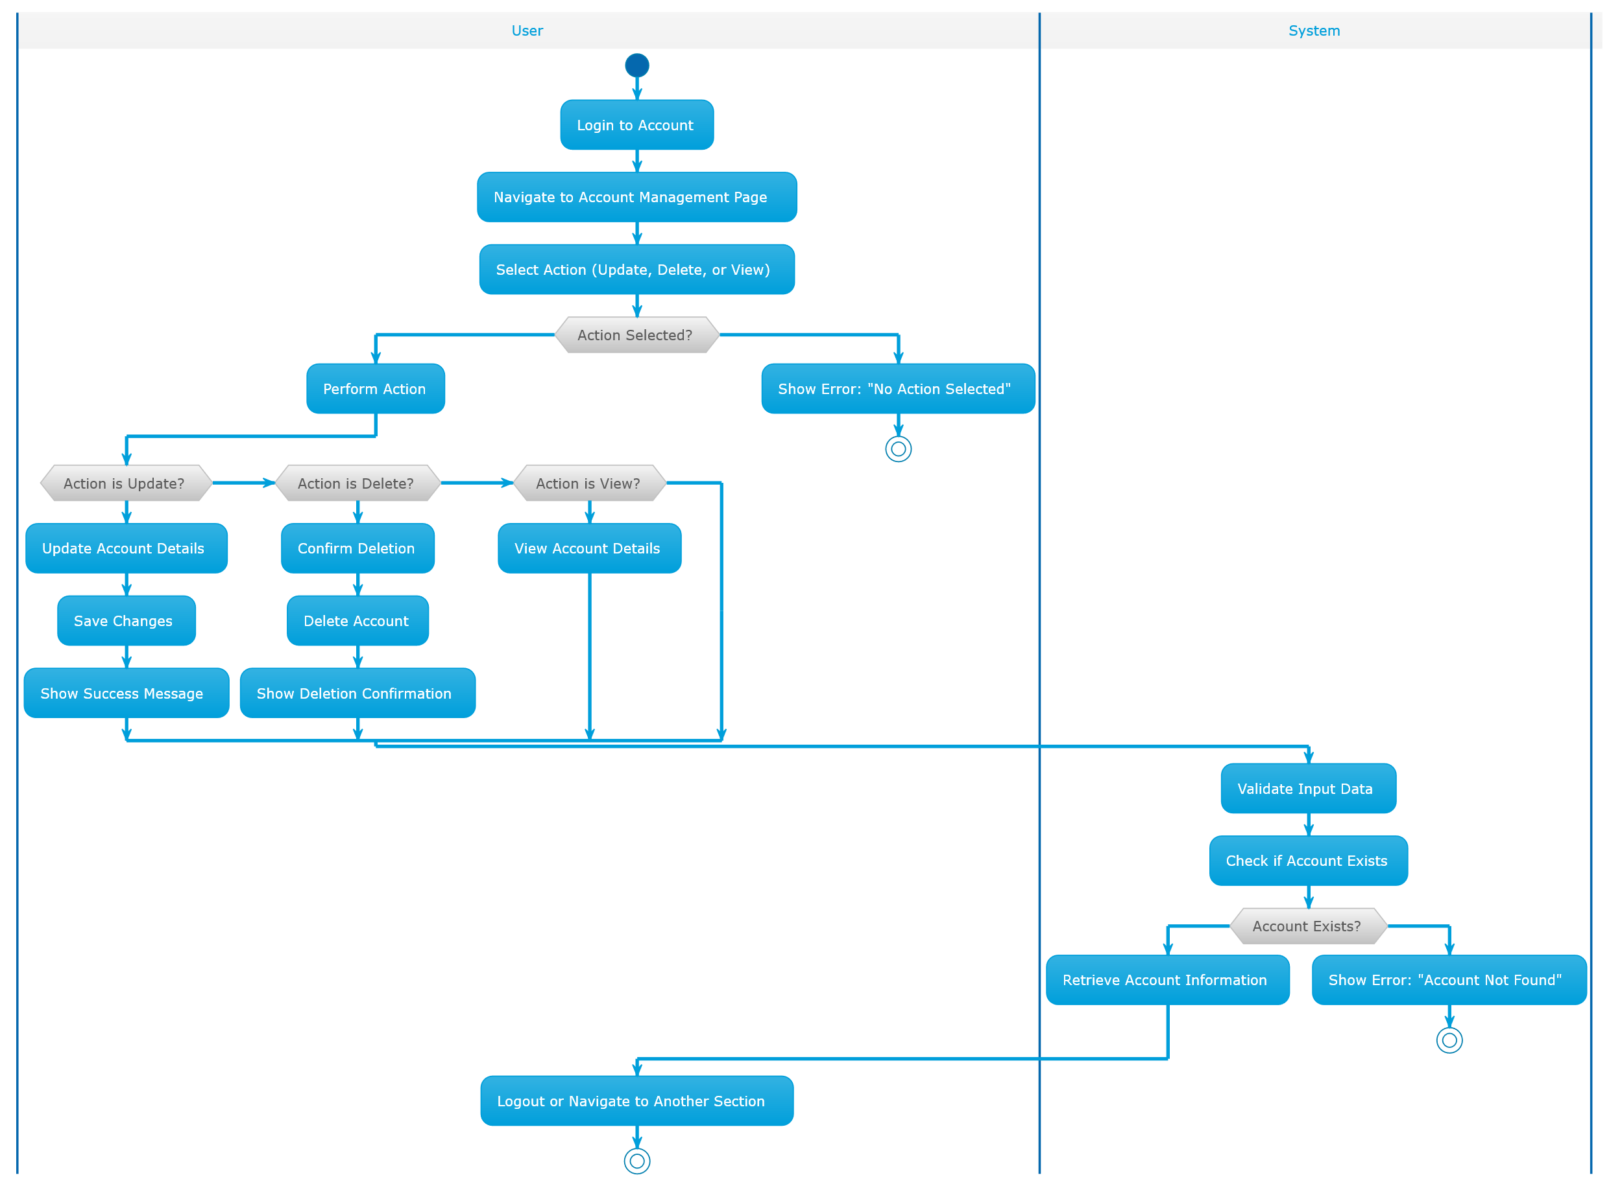
Figure 21. Account Management Activity Diagram

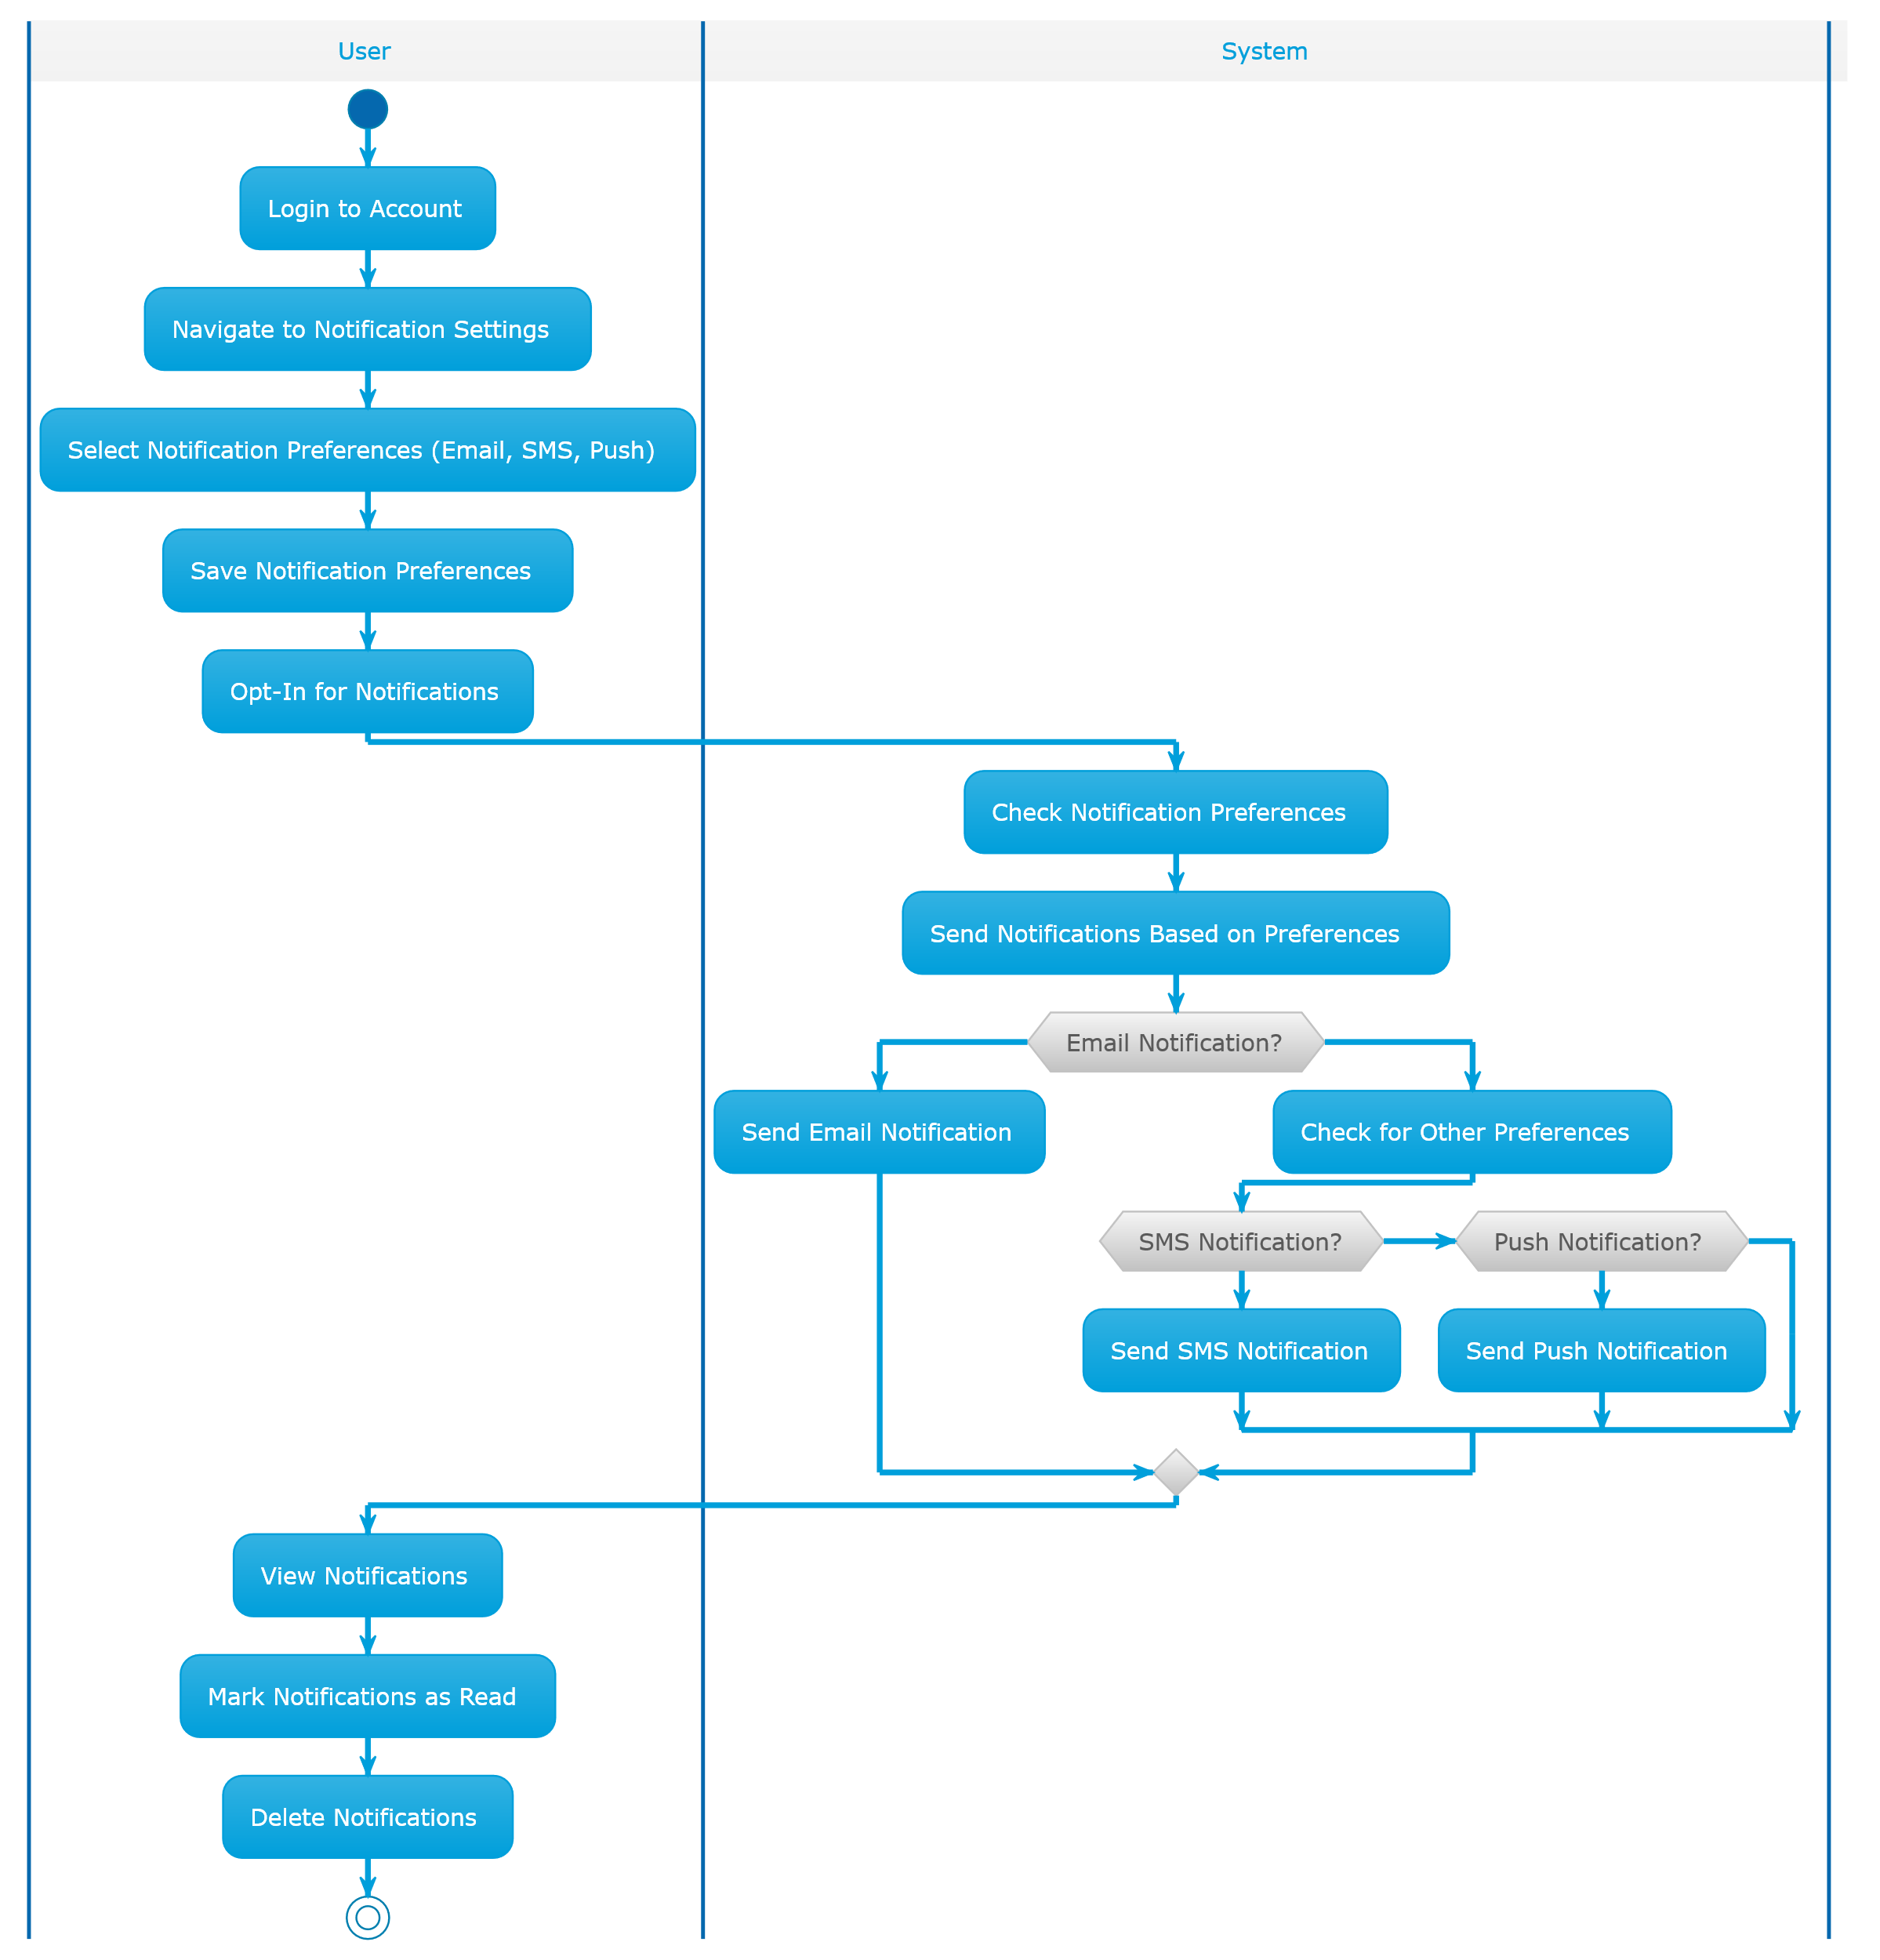
Figure 22. Notification System Activity Diagram

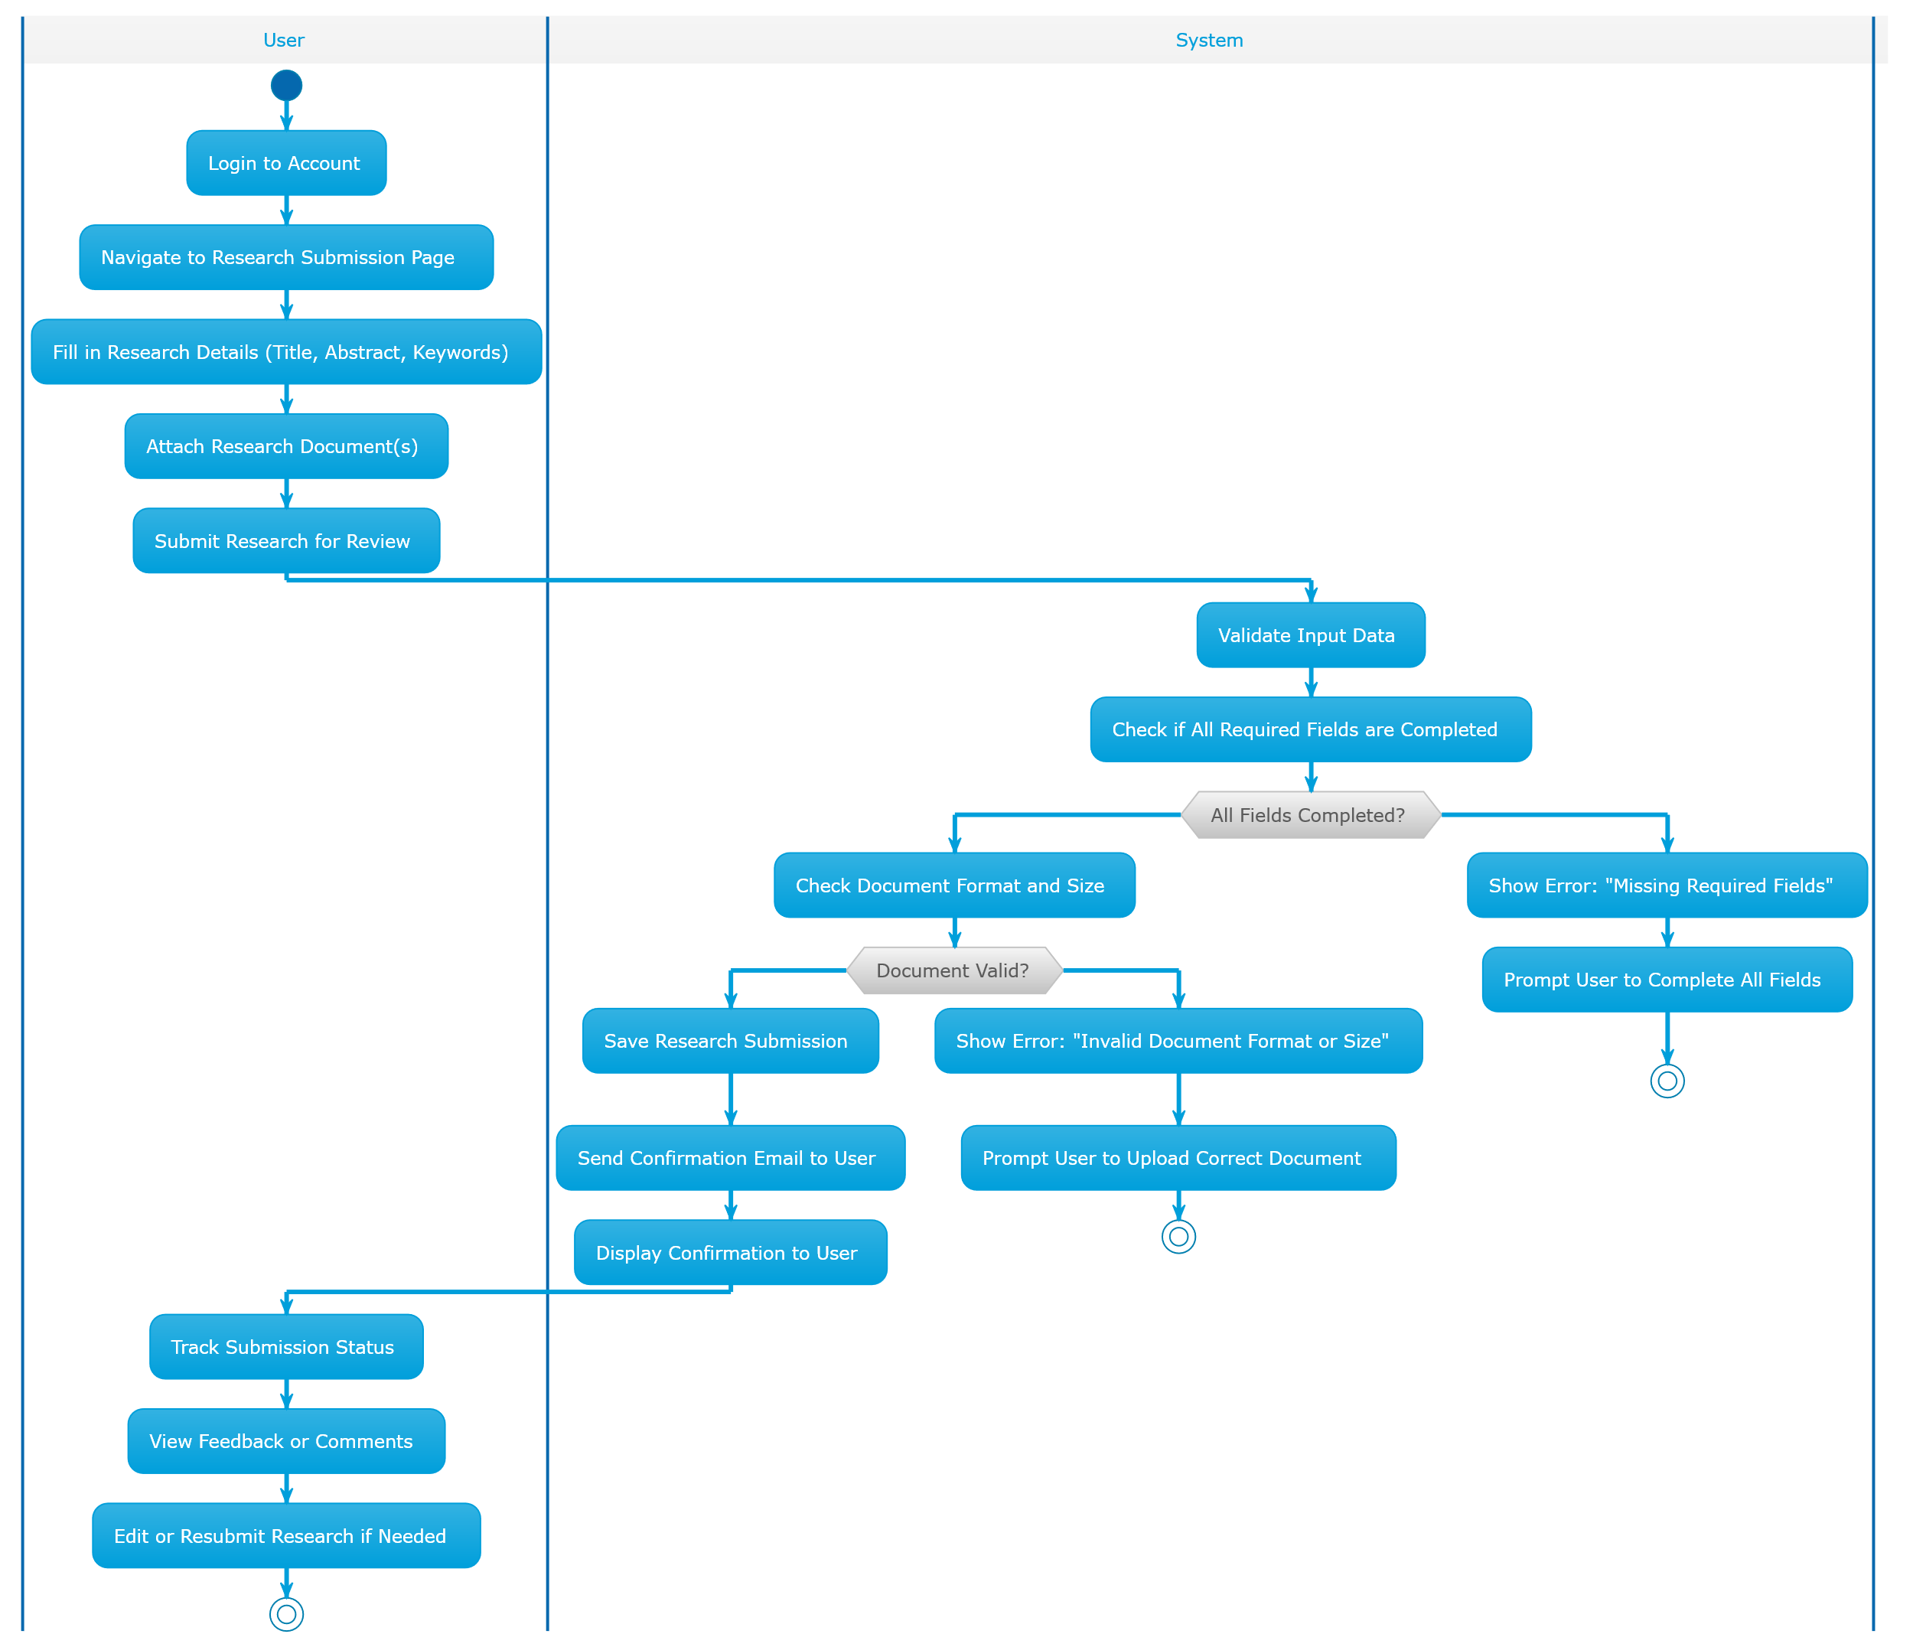
Figure 23. Research Submission Activity Diagram

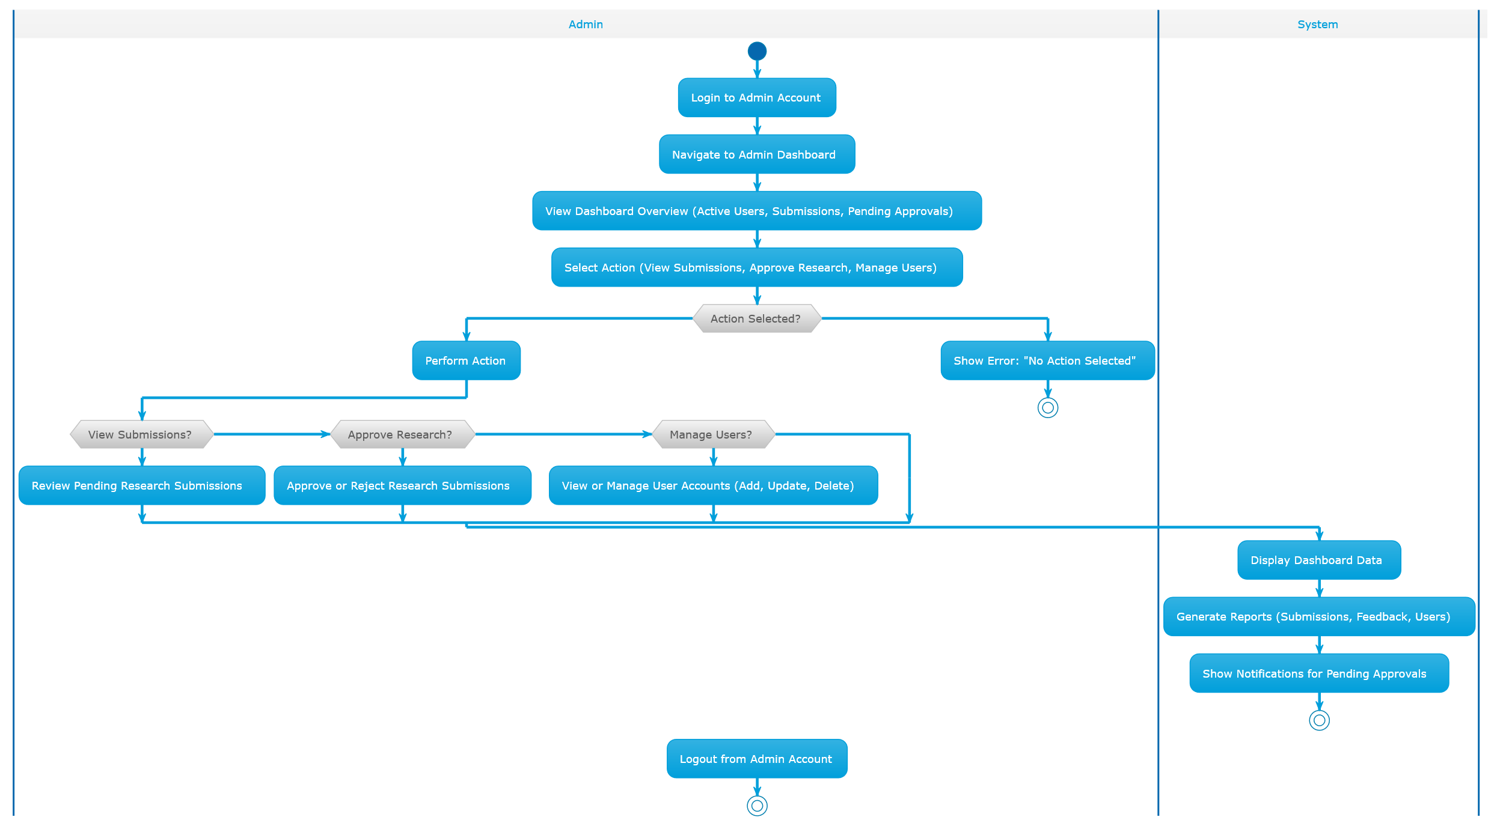
Figure 24. Admin Dashboard Activity Diagram

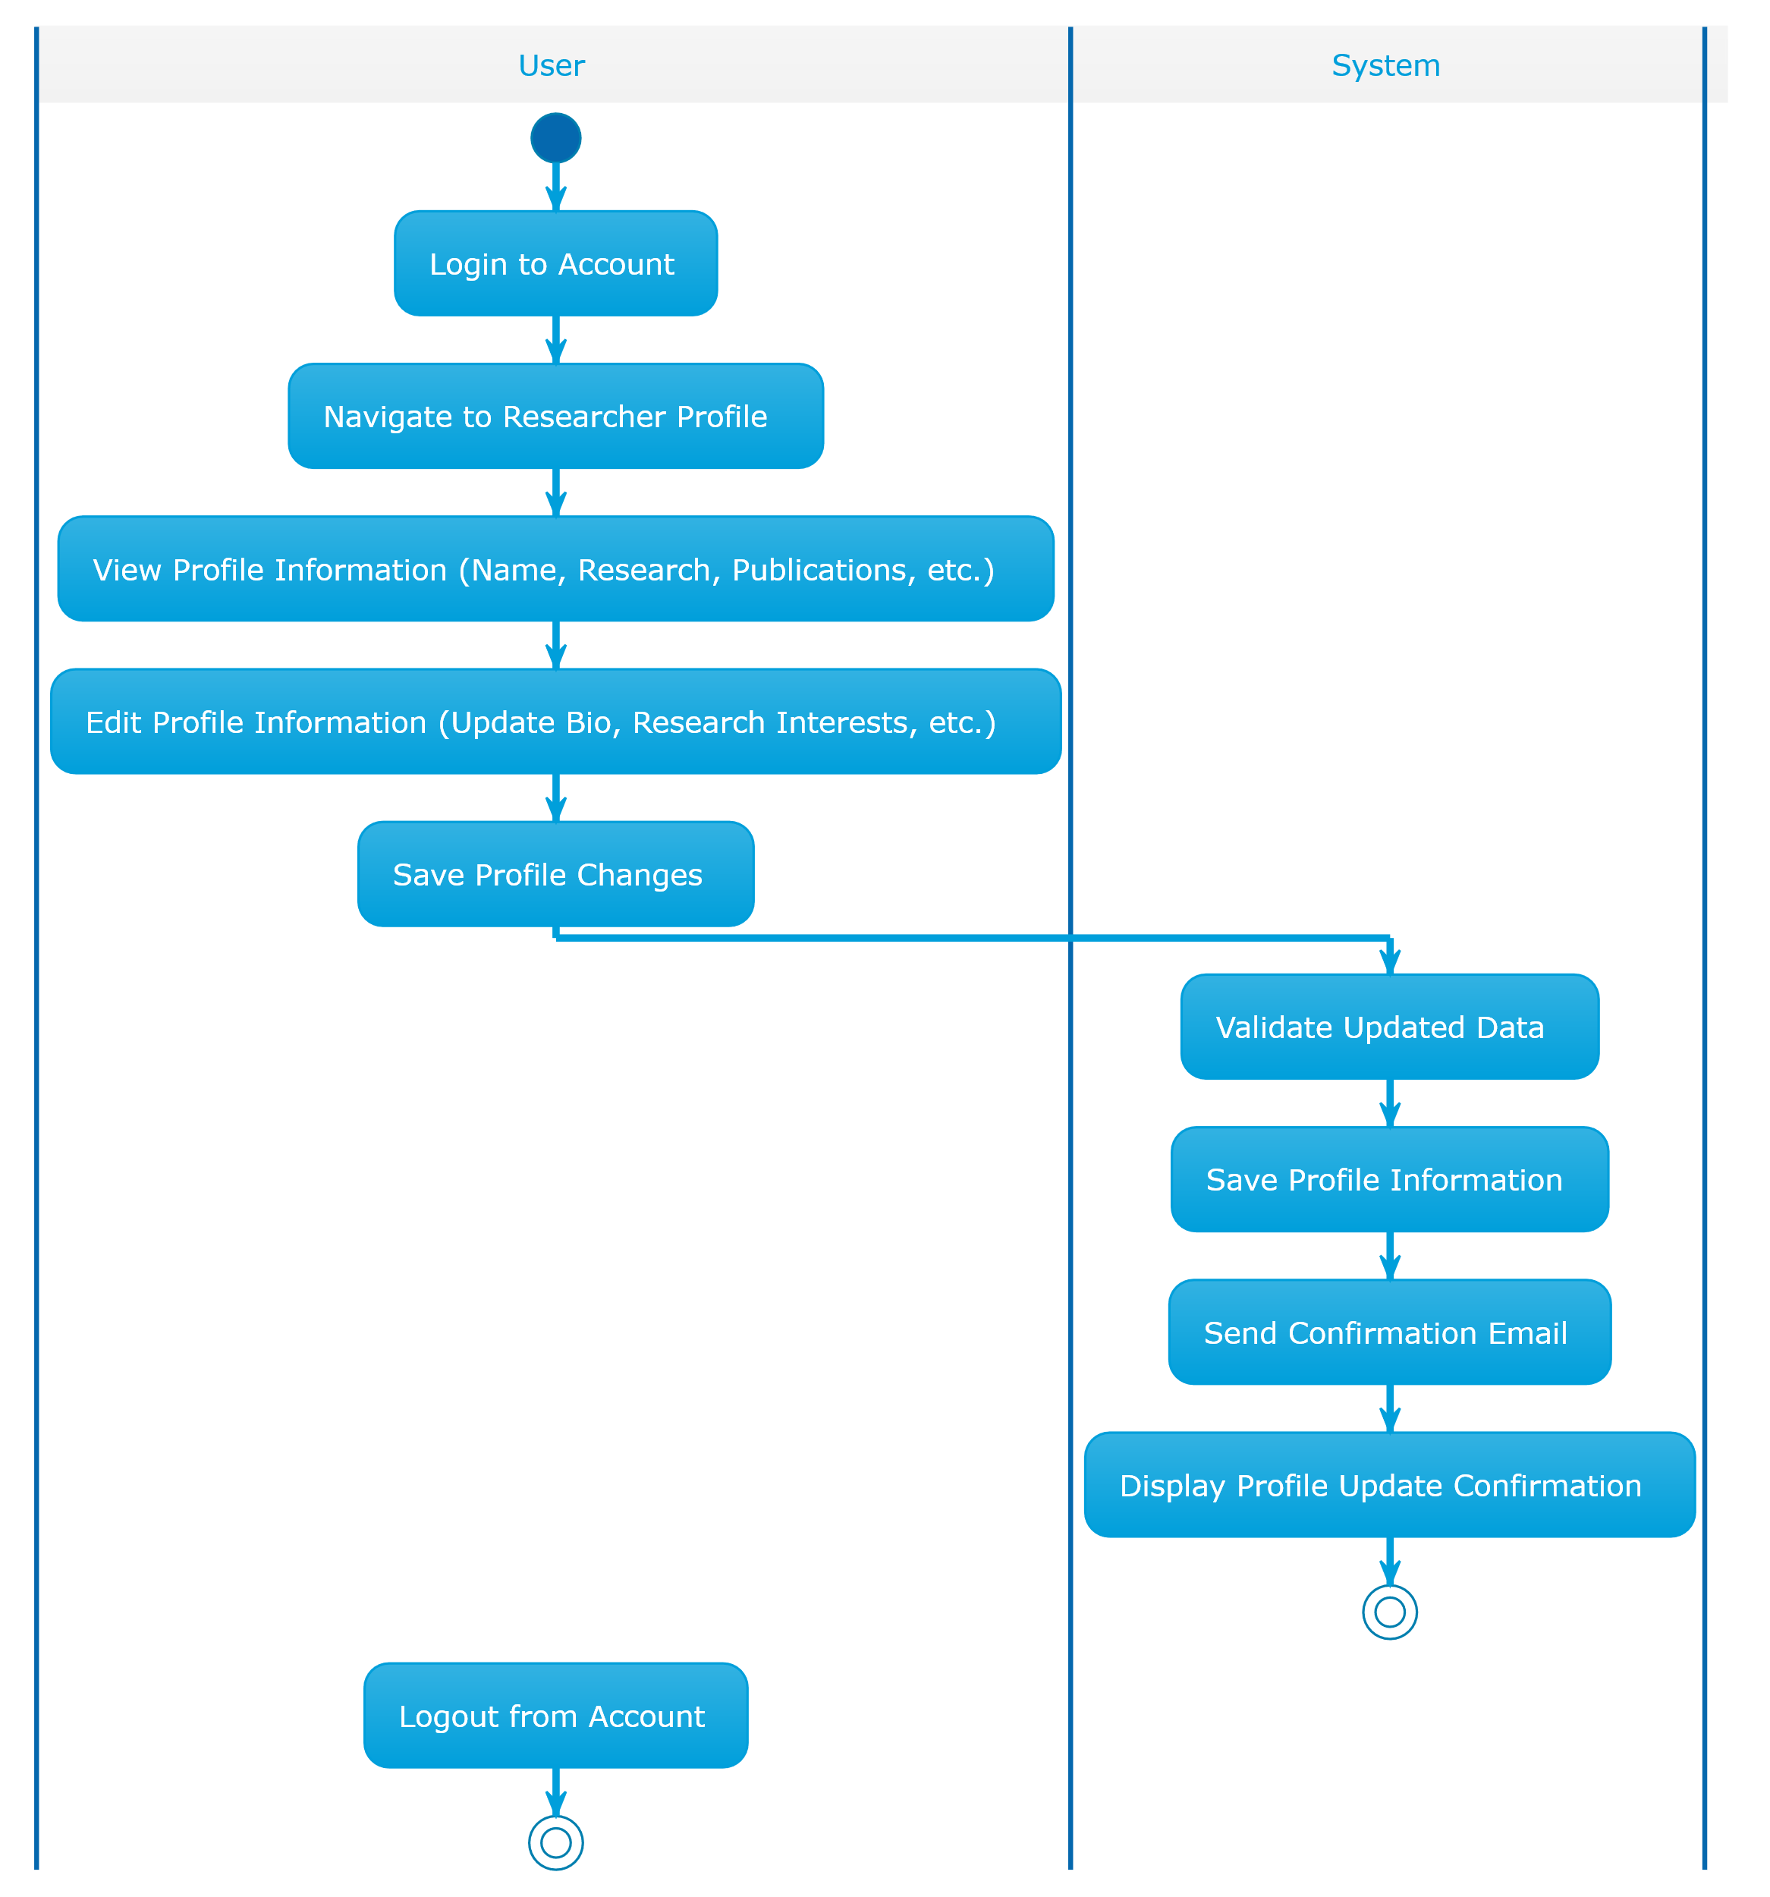
Figure 25. Researcher Profile Activity Diagram

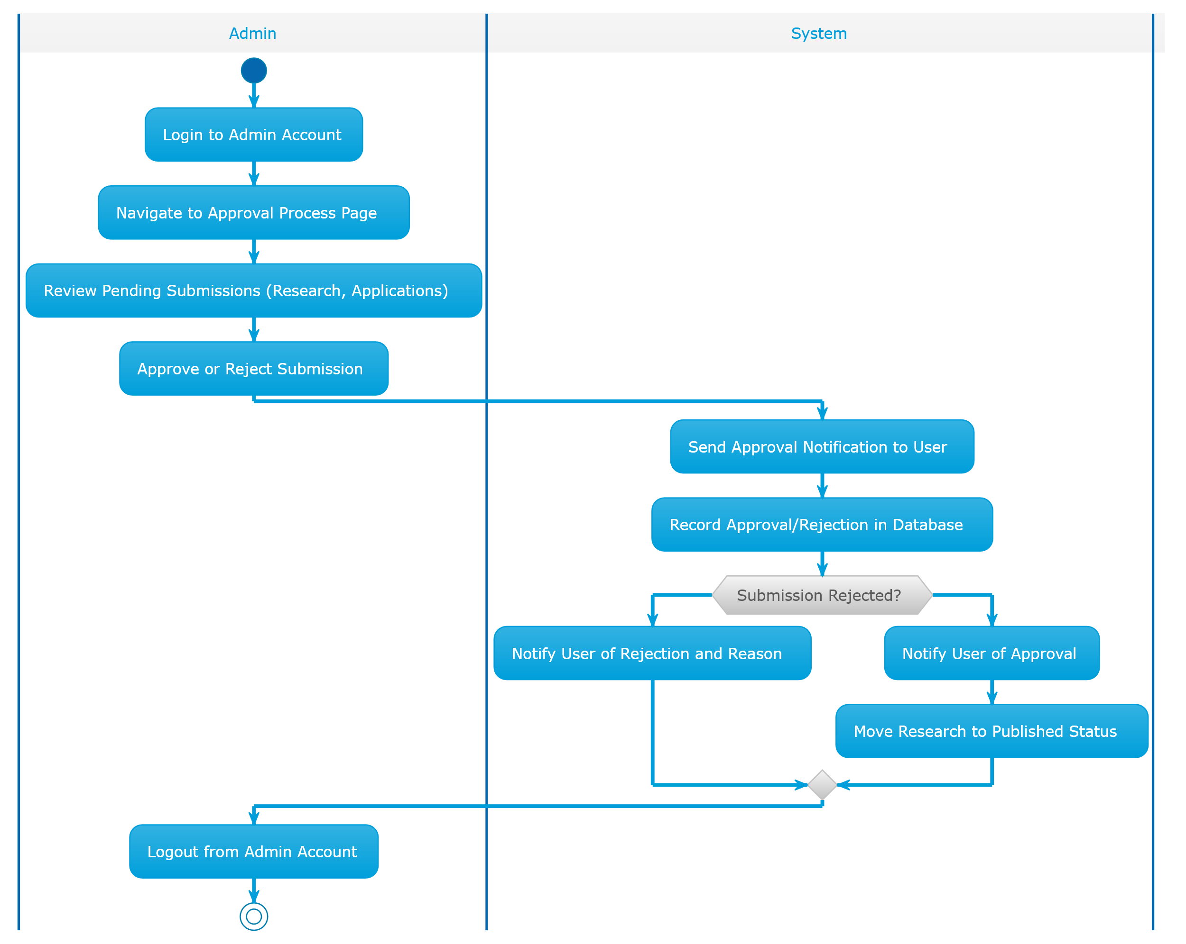
Figure 26. Approval Process Activity Diagram

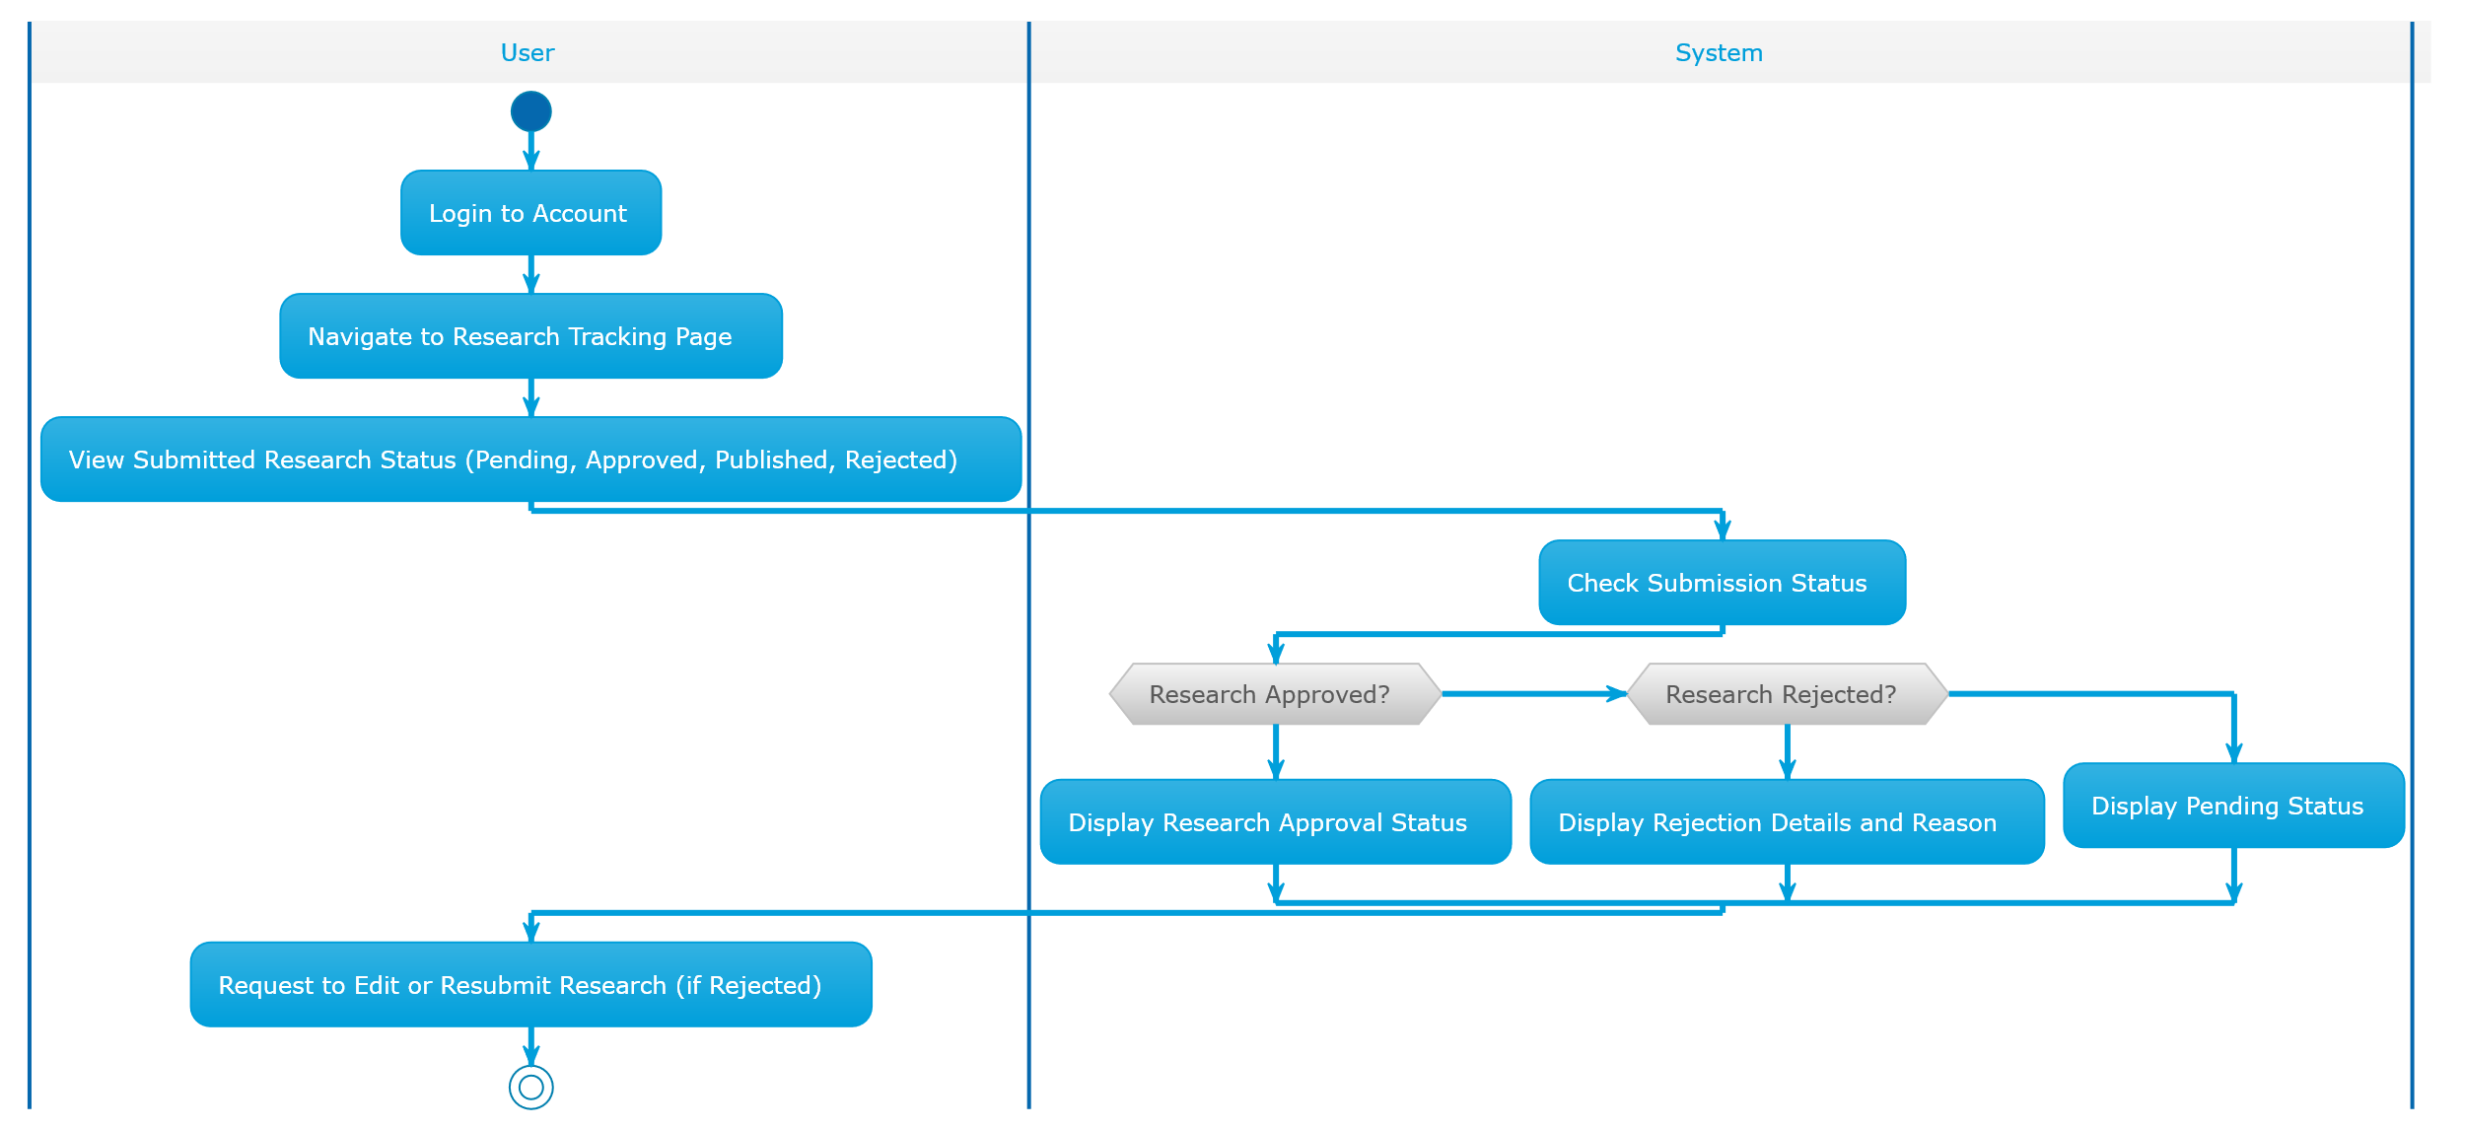
Figure 27. Research Tracking Activity Diagram

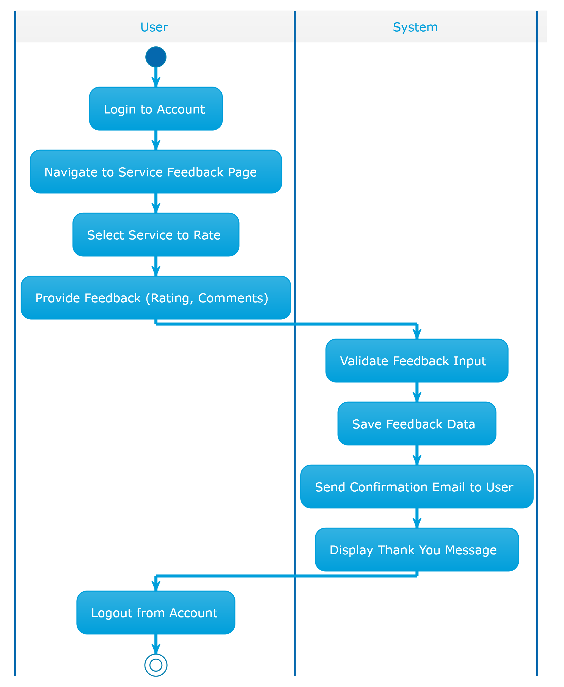
Figure 28. Service Feedback Activity Diagram

4.6 Input/Output Design:

Input:
- User Registration:
  - User information (name, email, password, contact details)
- User Login:
  - Login credentials (email/username, password)
- Research Submission:
  - Research details (title, abstract, keywords, document files)
- Service Feedback:
  - Rating (1-5 stars), feedback comments
- Admin Dashboard Actions:
  - Admin selections (view submissions, approve research, manage users)
- Researcher Profile:
  - Profile details (bio, research interests, publications)
- Reward Application:
  - Research details for reward (research title, details, eligibility criteria)
- Consultation Booking:
  - Consultation request details (research topic, preferred time, user info)
- Service Request:
  - Service details (type of service, requested consultation time, user details)

Output:
- User Registration:
  - Registration status (success or fail)
  - Error message if email already exists
- User Login:
  - Login status (success or fail)
- Research Submission:
  - Submission status (approved, pending, rejected)
  - Confirmation email upon successful submission
- Service Feedback:
  - Thank you message upon feedback submission
  - Confirmation email to the user
- Admin Dashboard Actions:
  - Dashboard overview (active users, pending research, etc.)
  - Reports generated based on data (submissions, feedback, etc.)
  - Notifications for pending approvals
- Researcher Profile:
  - Profile view with updated information
  - Success or failure message for profile updates
- Reward Application:
  - Application status (approved, rejected, pending)
  - Confirmation email for submitted applications
- Consultation Booking:
  - Booking confirmation (approved, pending, or rejected)
  - Consultation details sent to user
- Service Request:
  - Request status (approved, pending, or rejected)
  - Confirmation of booked service or consultation

4.7 Summary

Chapter four focus design proposed system, detailing structure component. begin introduction overall system architecture present key design diagram class diagram, break user, role, core component like research & service management, account & user management, finance & budgeting, technical support, notification & approval process. sequence diagram illustrates interaction system component user various function, entity relationship diagram (ERD) outline relationship entity, defining data structured managed. additionally, chapter cover function design & activity diagram, explaining workflow functionality key system process, focusing system handle input, output, operation; concludes detailed input / output design, ensuring efficiency user interface interaction; chapter establishes foundation system ’s development implementation.

CHAPTER FIVE: SYSTEM DEVELOPMENT

5.1 Introduction
The website of the Department of Scientific Research is a site that solves many problems in terms of time, effort and money, as the services provided by the department have been made available through the website. Through this chapter, the technical aspects of this site will be reviewed.

5.2 User Interface

Login Page:

Figure 29. Login Page

Sign Up Page:

Figure 30. Sign Up Page
User Home Page:

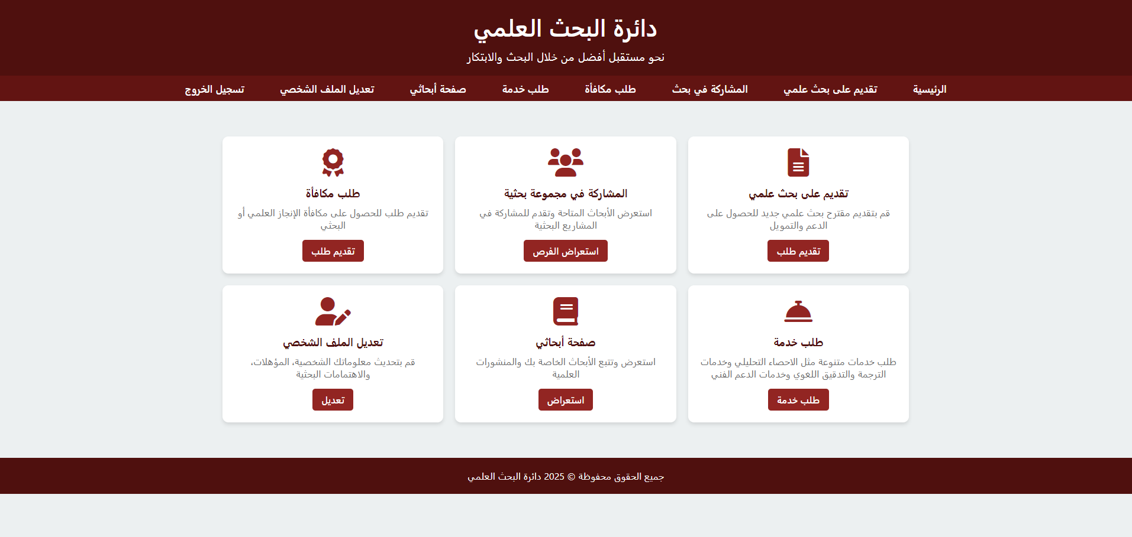
Figure 31. User Home Page

Edit Profile Page:

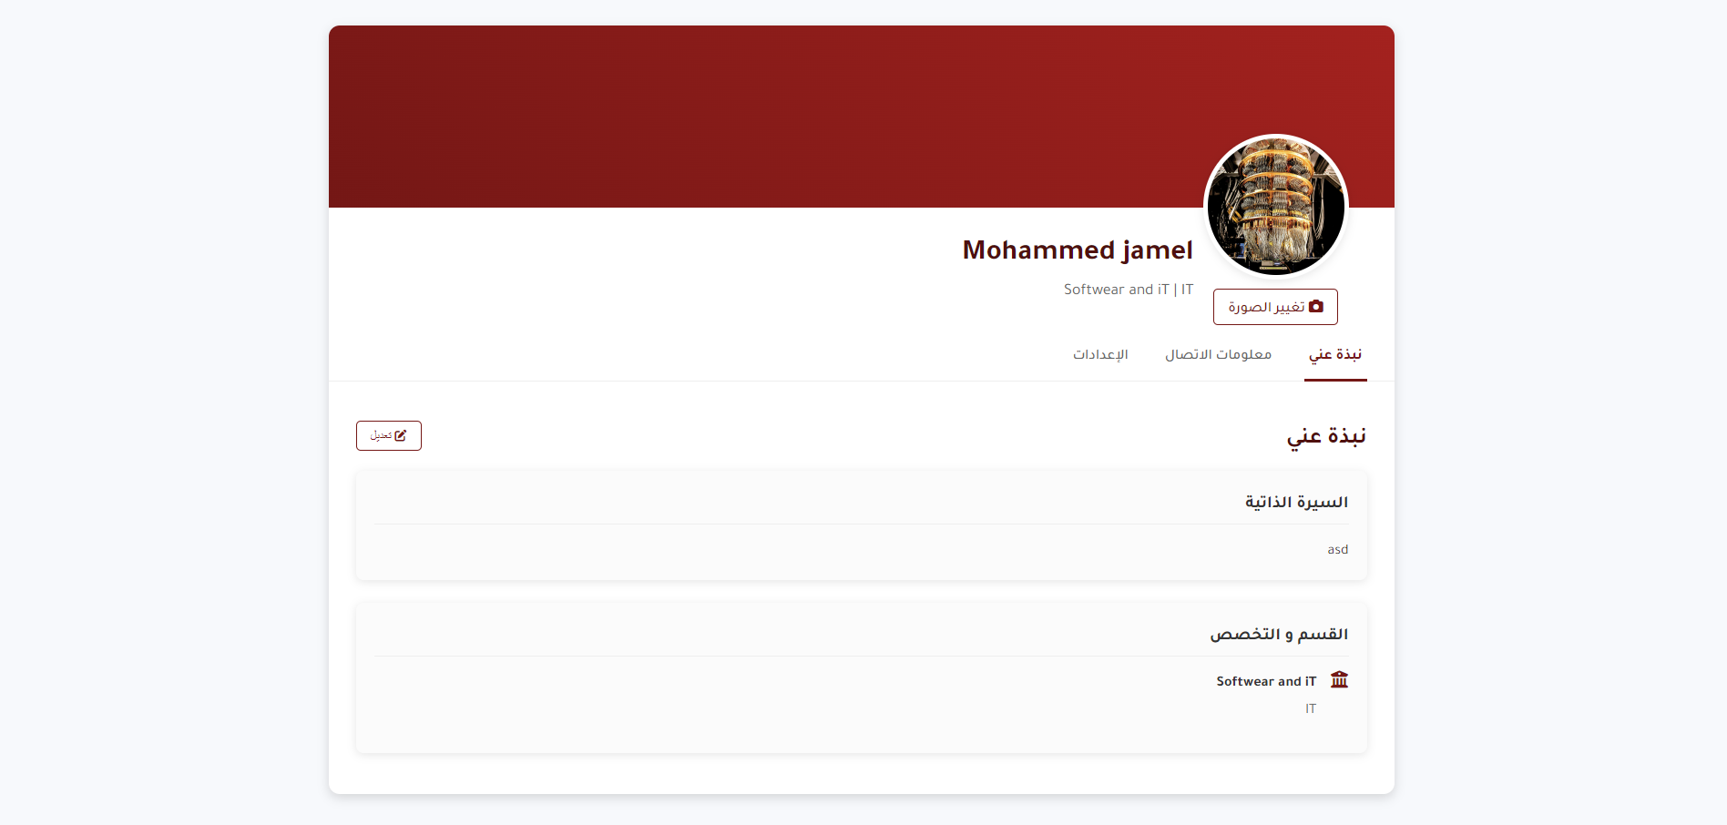
Figure 32. Edit Profile Page(1)

Figure 33. Edit Profile Page(2)

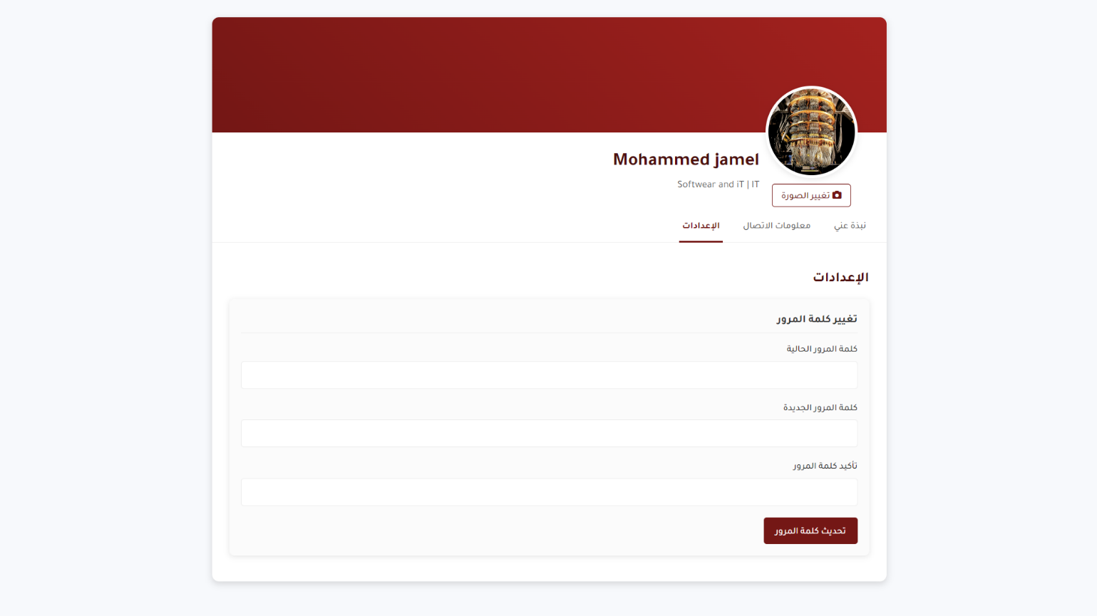
Figure 34. Edit Profile Page(3)
Reward User Page:
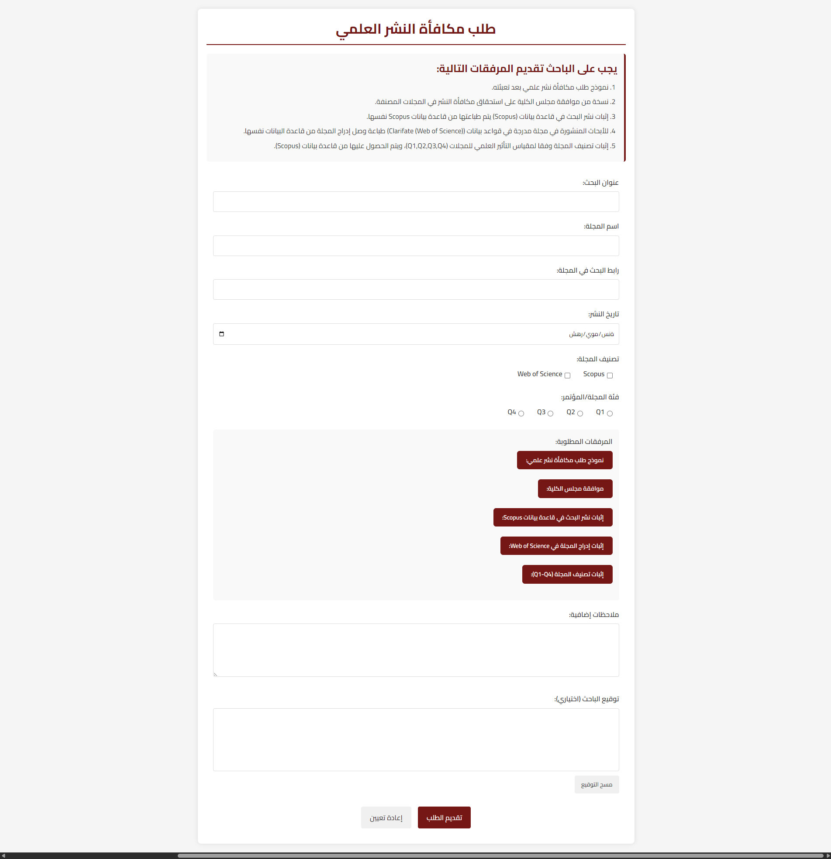
Figure 35. Reward User Page

Participate in a research group Page:

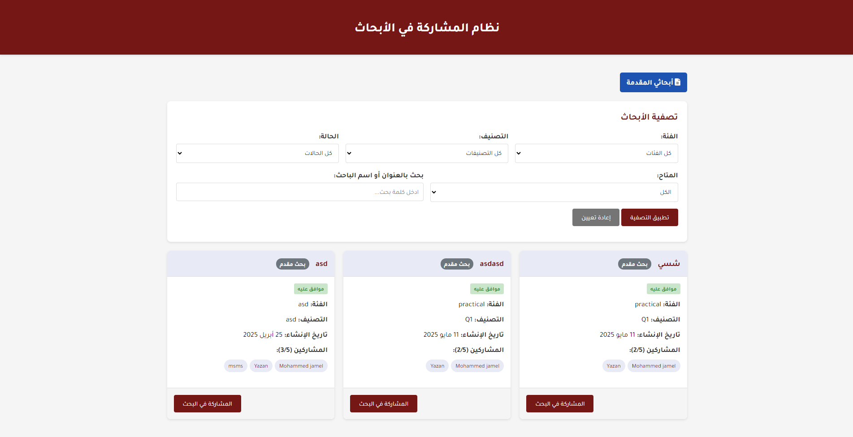
Figure 36. Participate in a research group Page(1)
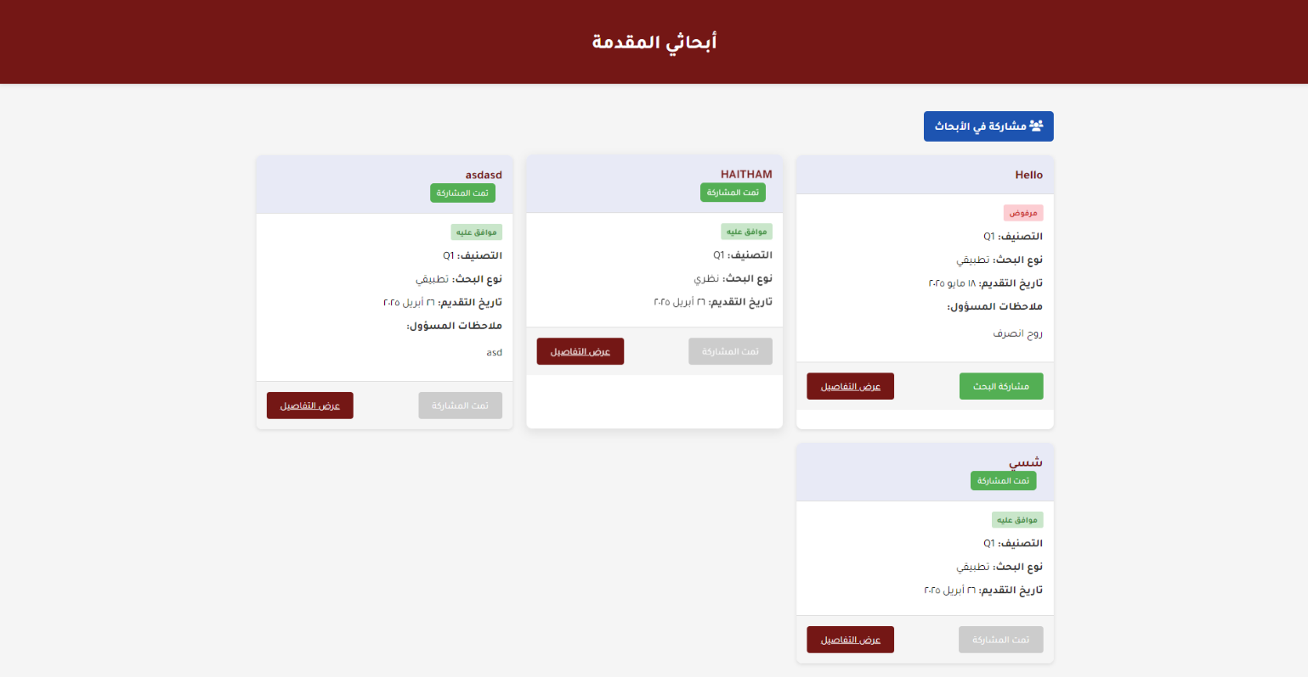
Figure 37. Participate in a research group Page(2)

Submit Research Page:
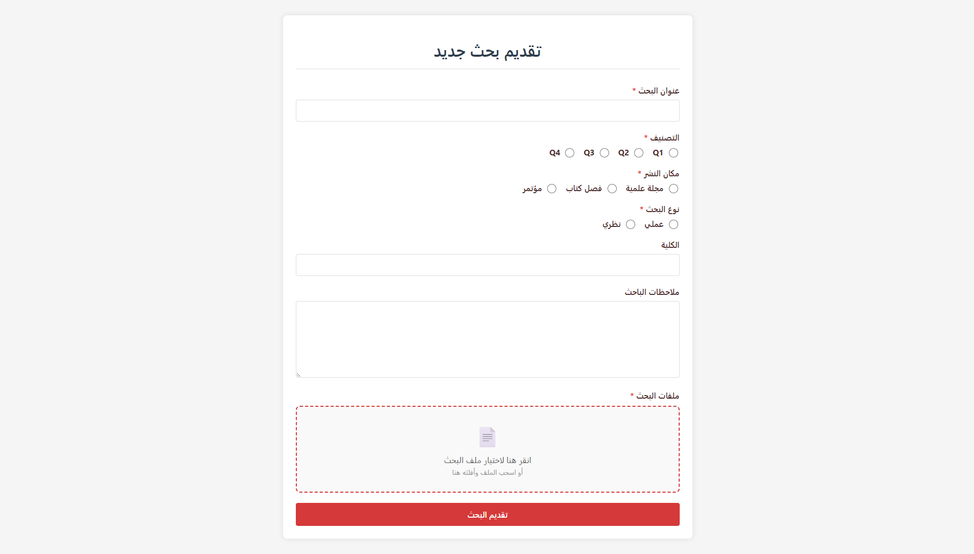
Figure 38. Submit Research Page

Submit Service Request Page:
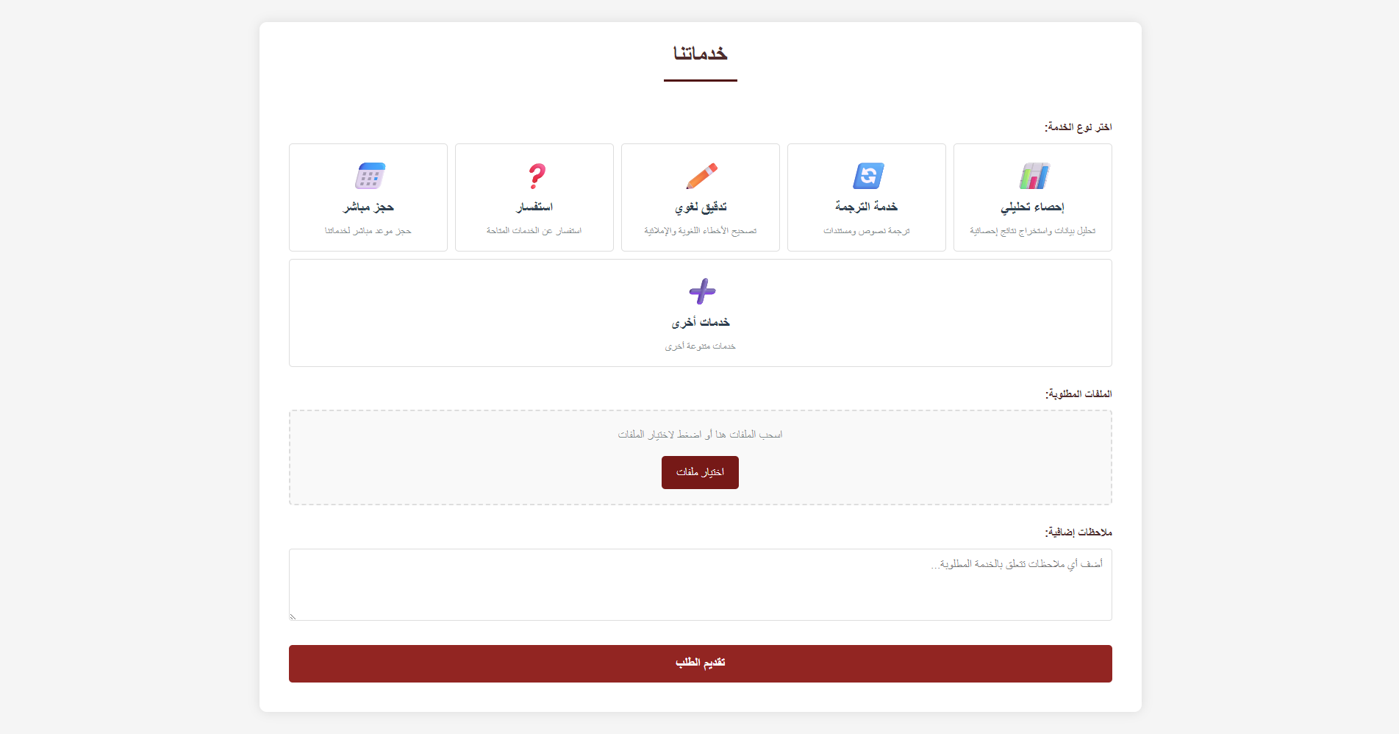
Figure 39. Submit Service Request Page
User Research Page:

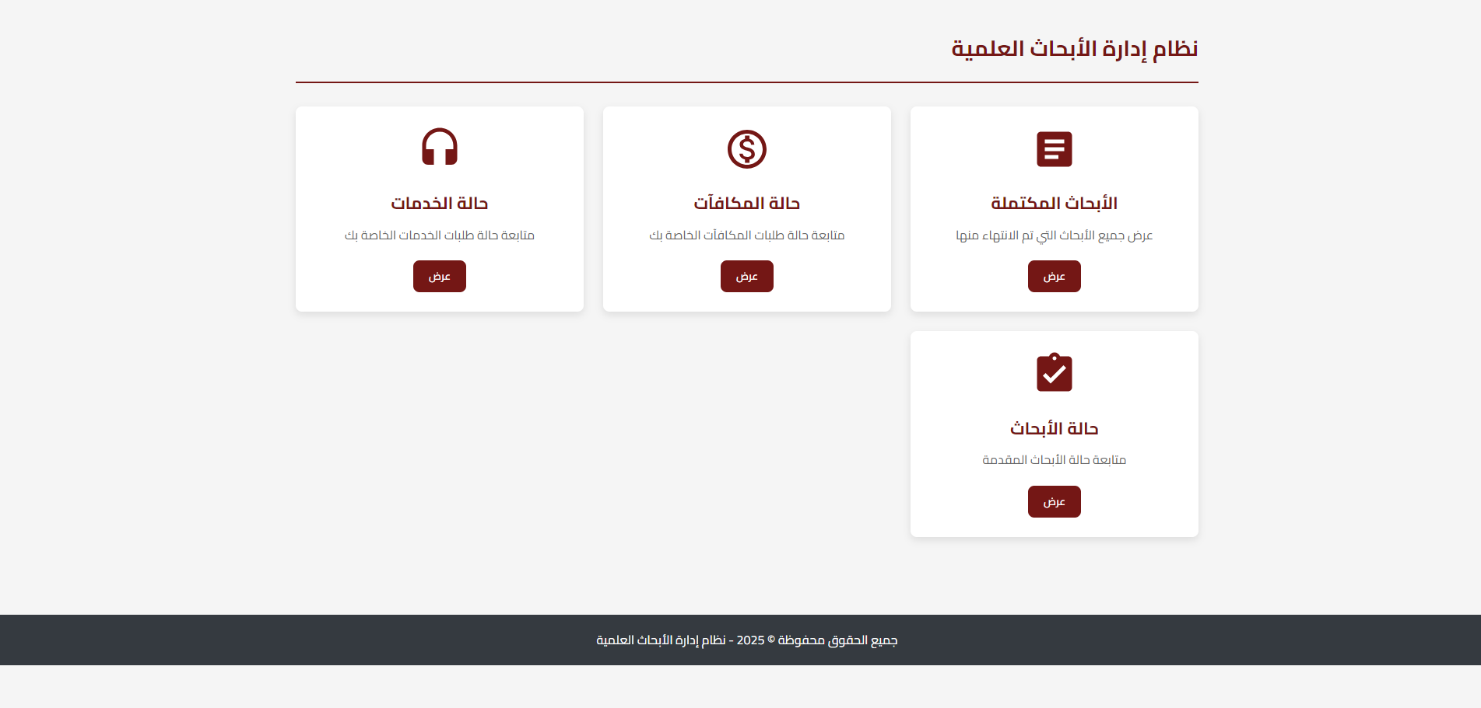
Figure 40. User Research Page (1)

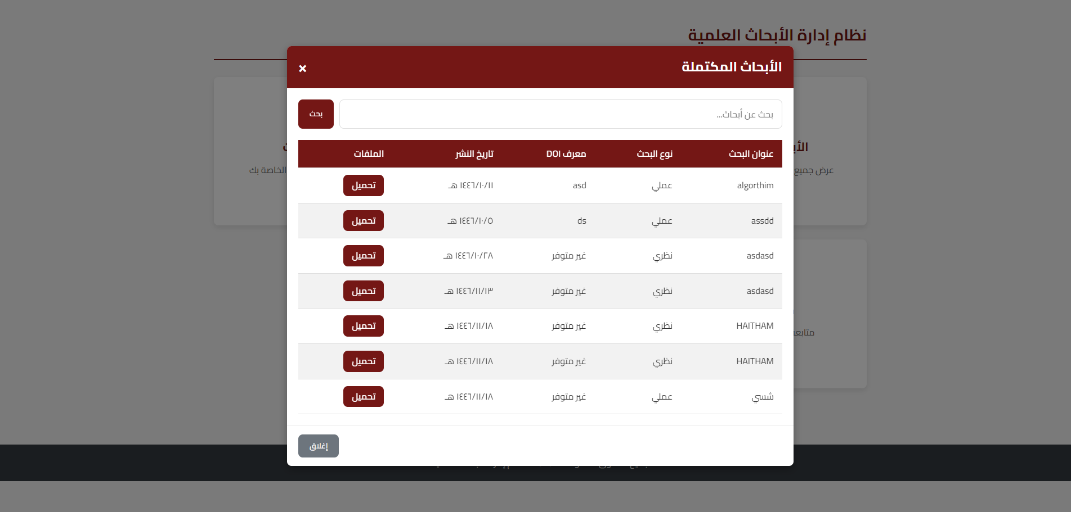
Figure 41. User Research Page (2)

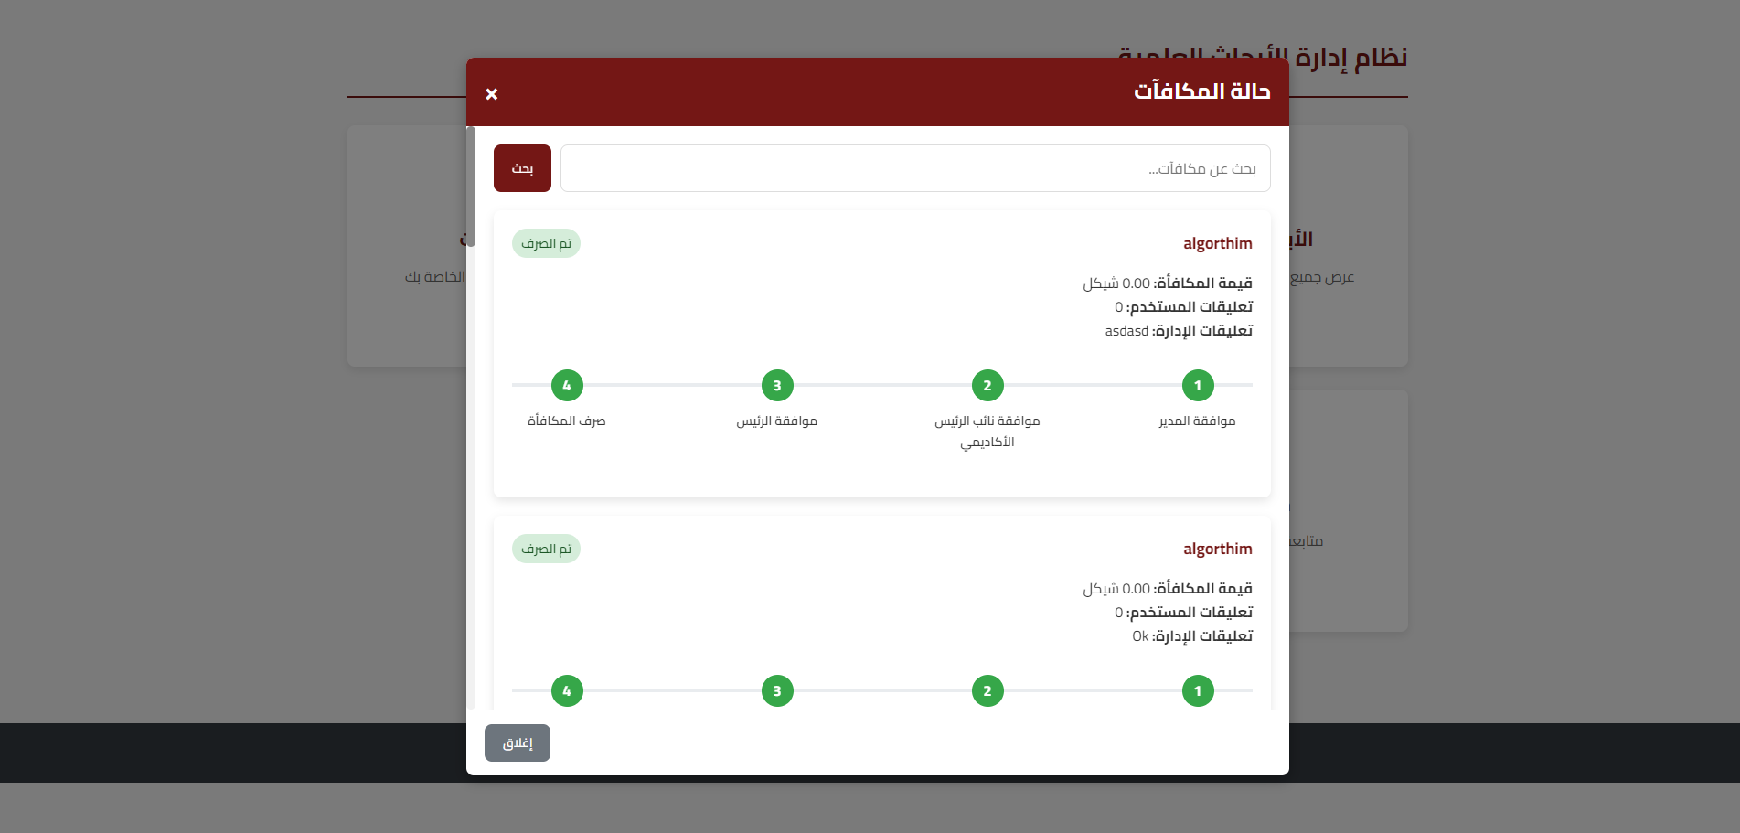
Figure 42. User Research Page (3)

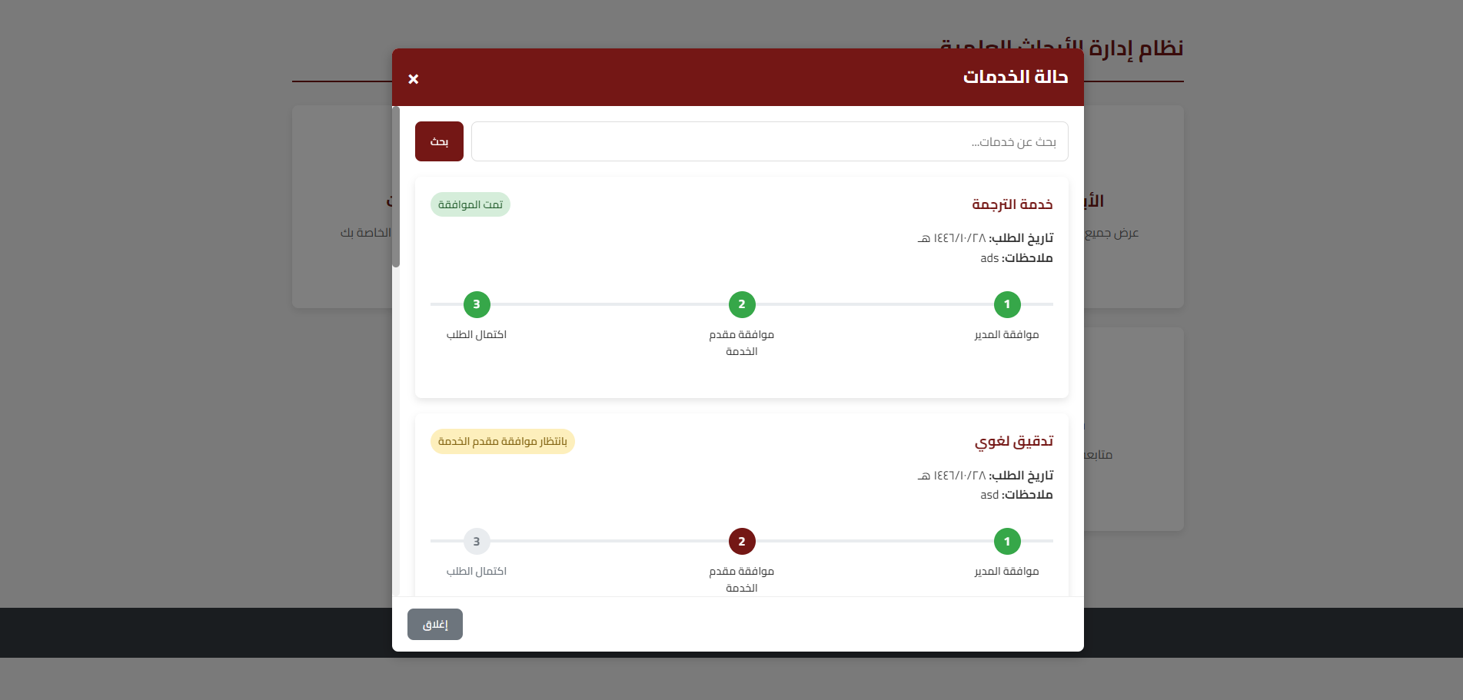
Figure 43. User Research Page (4)

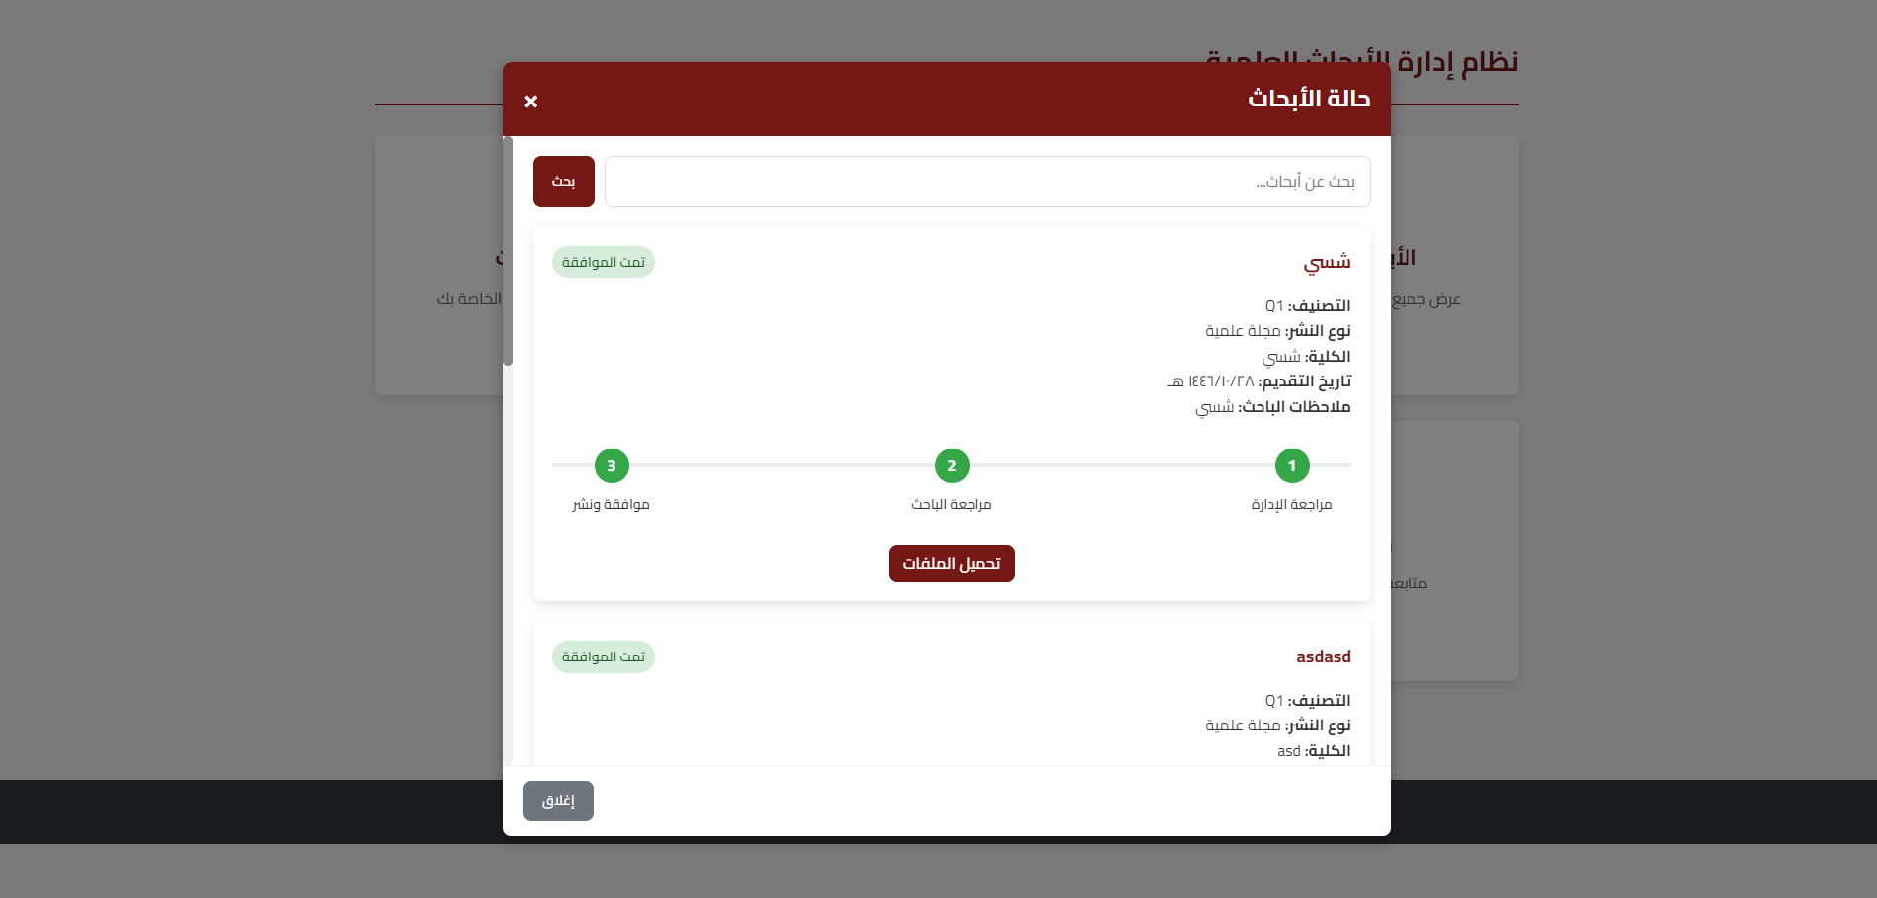
Figure 44. User Research Page (5)

Staff Home Page:

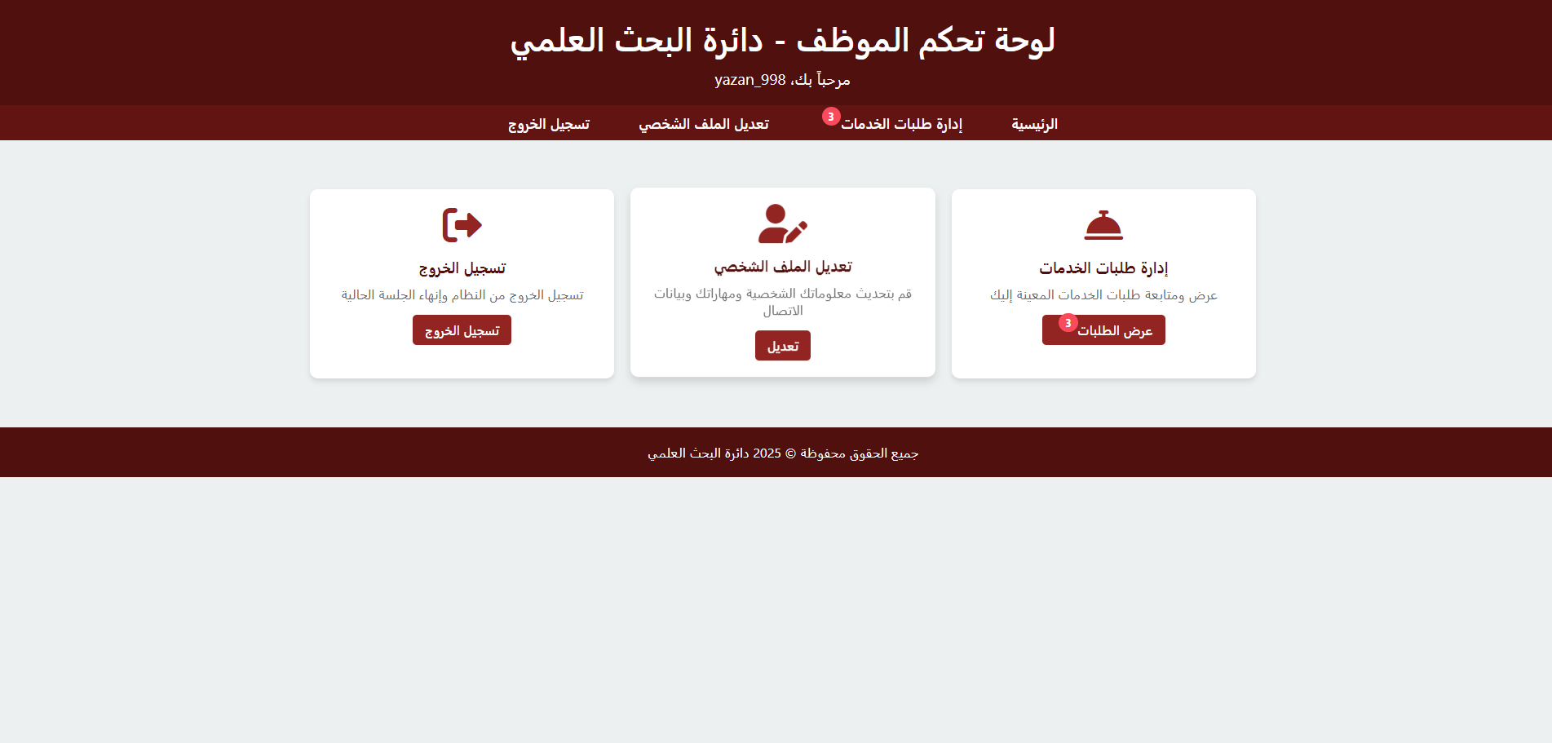
Figure 45. Staff Home Page

Staff Services Management Page:

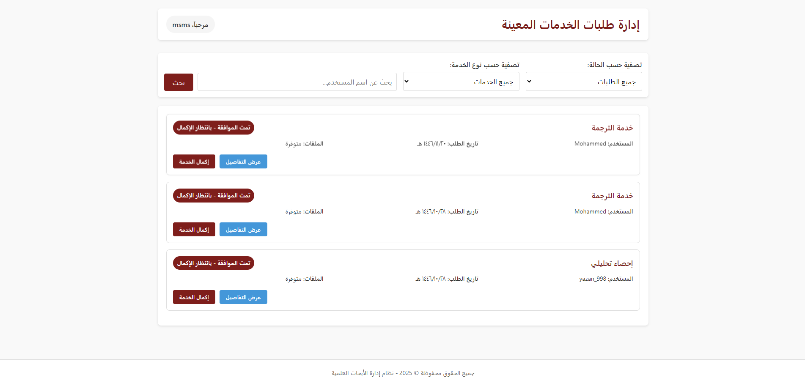
Figure 46. Staff Services Management Page
Admin Home Page:

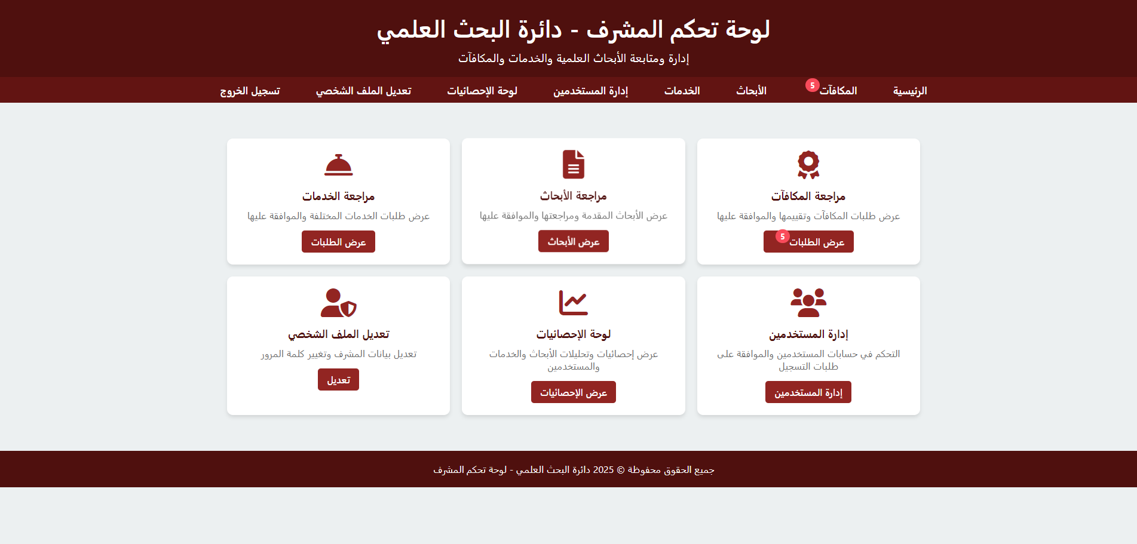
Figure 47. Admin Home Page

Admin Reward Management Page:

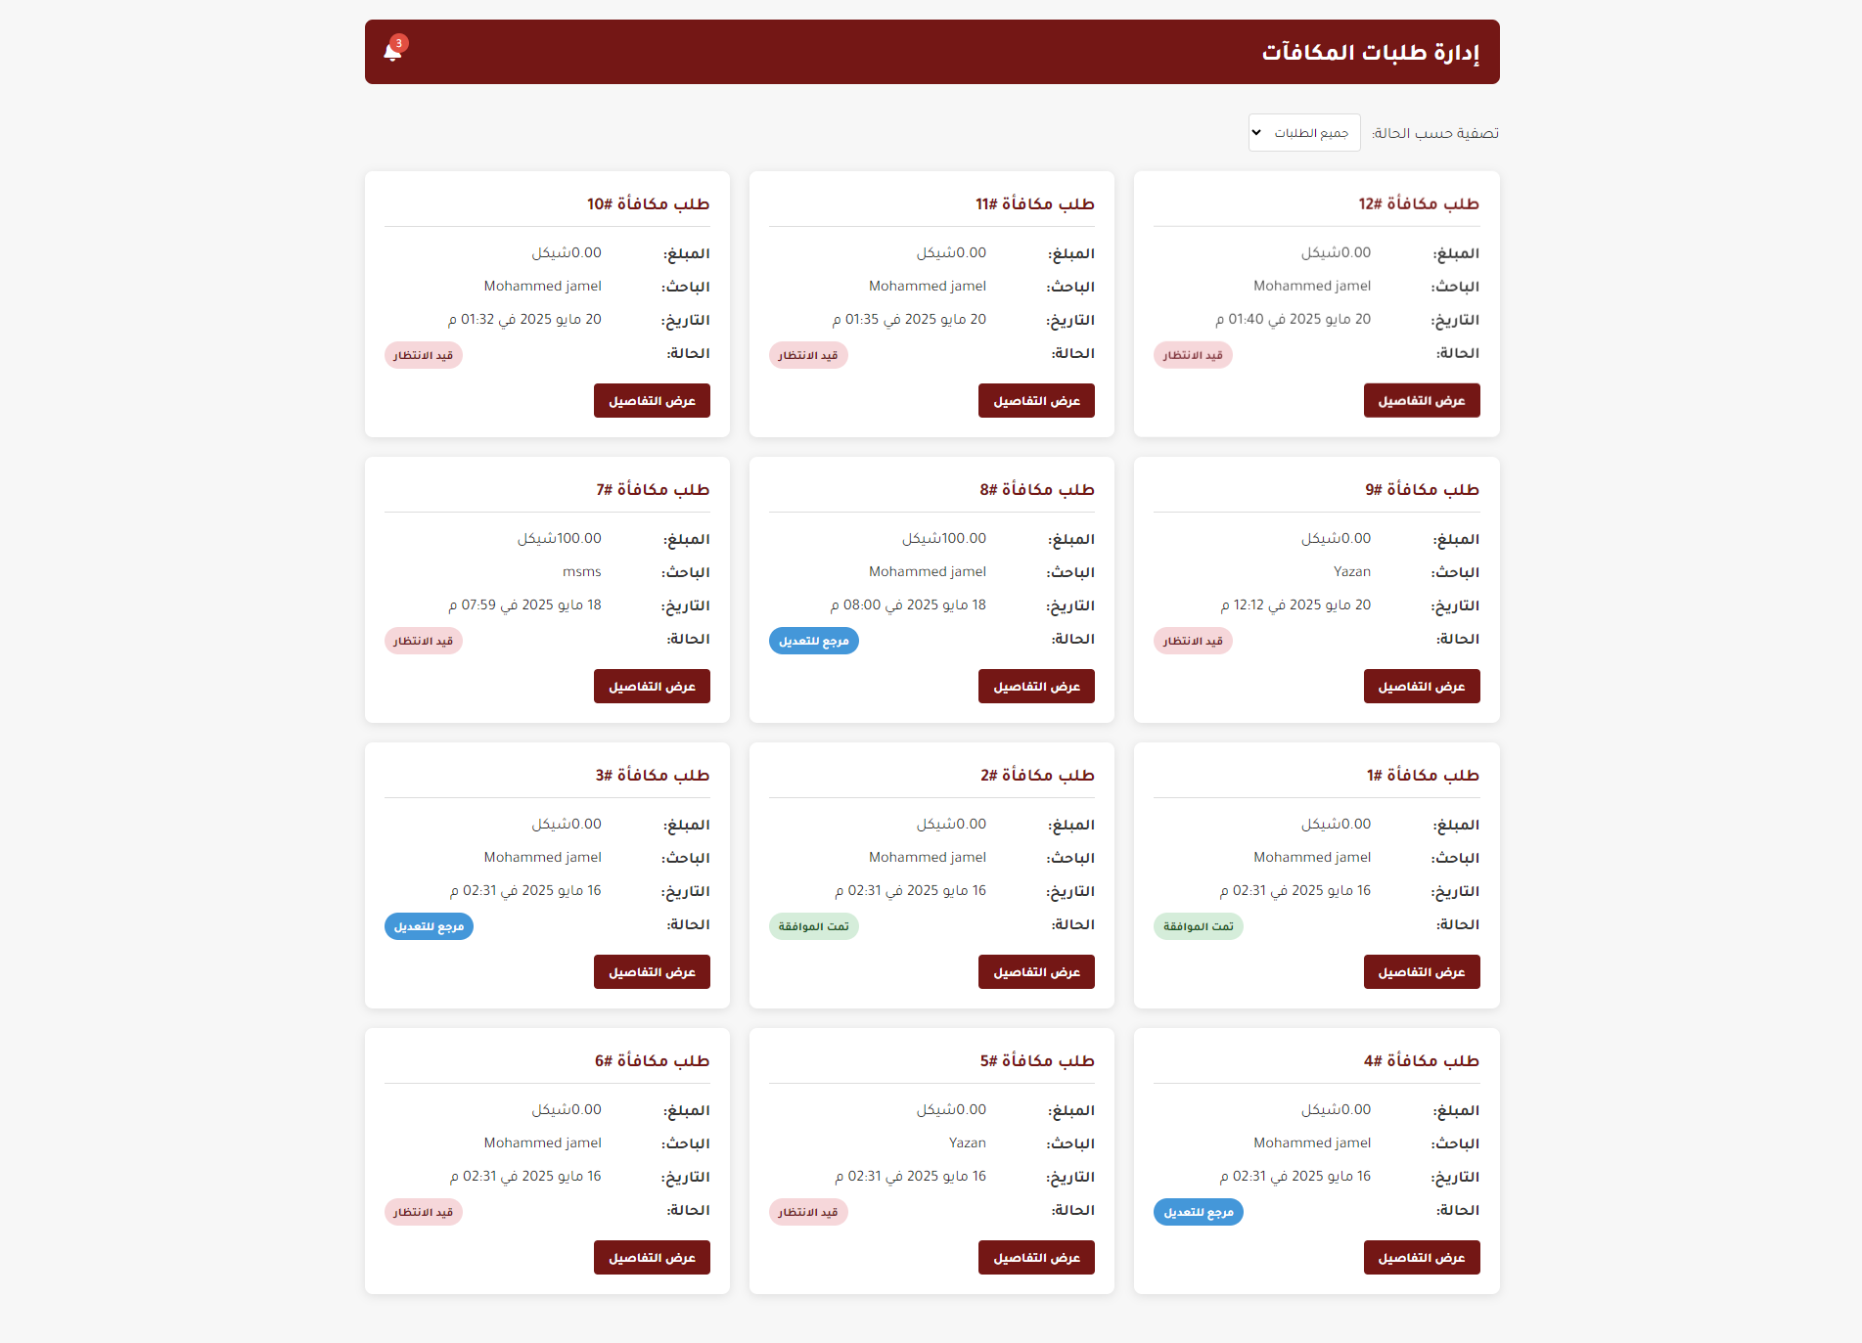
Figure 48. Admin Reward Management Page (1)

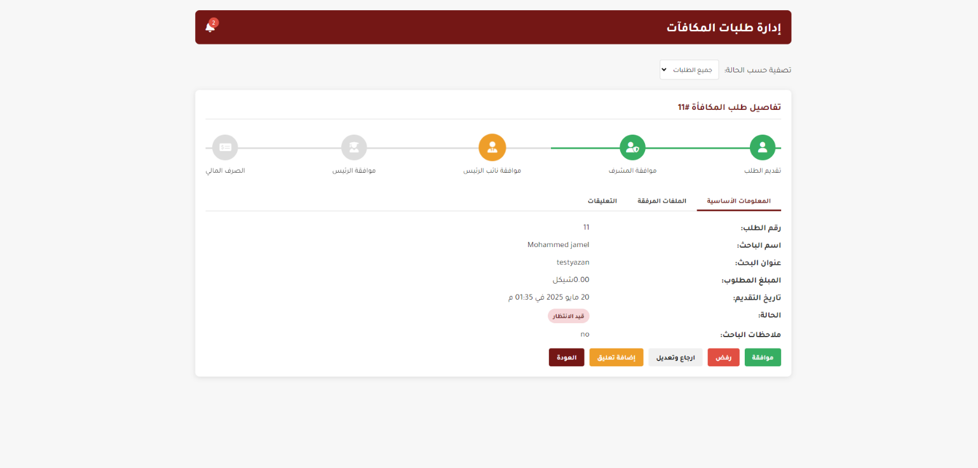
Figure 49. Admin Reward Management Page (2)
Admin Research Management Page:

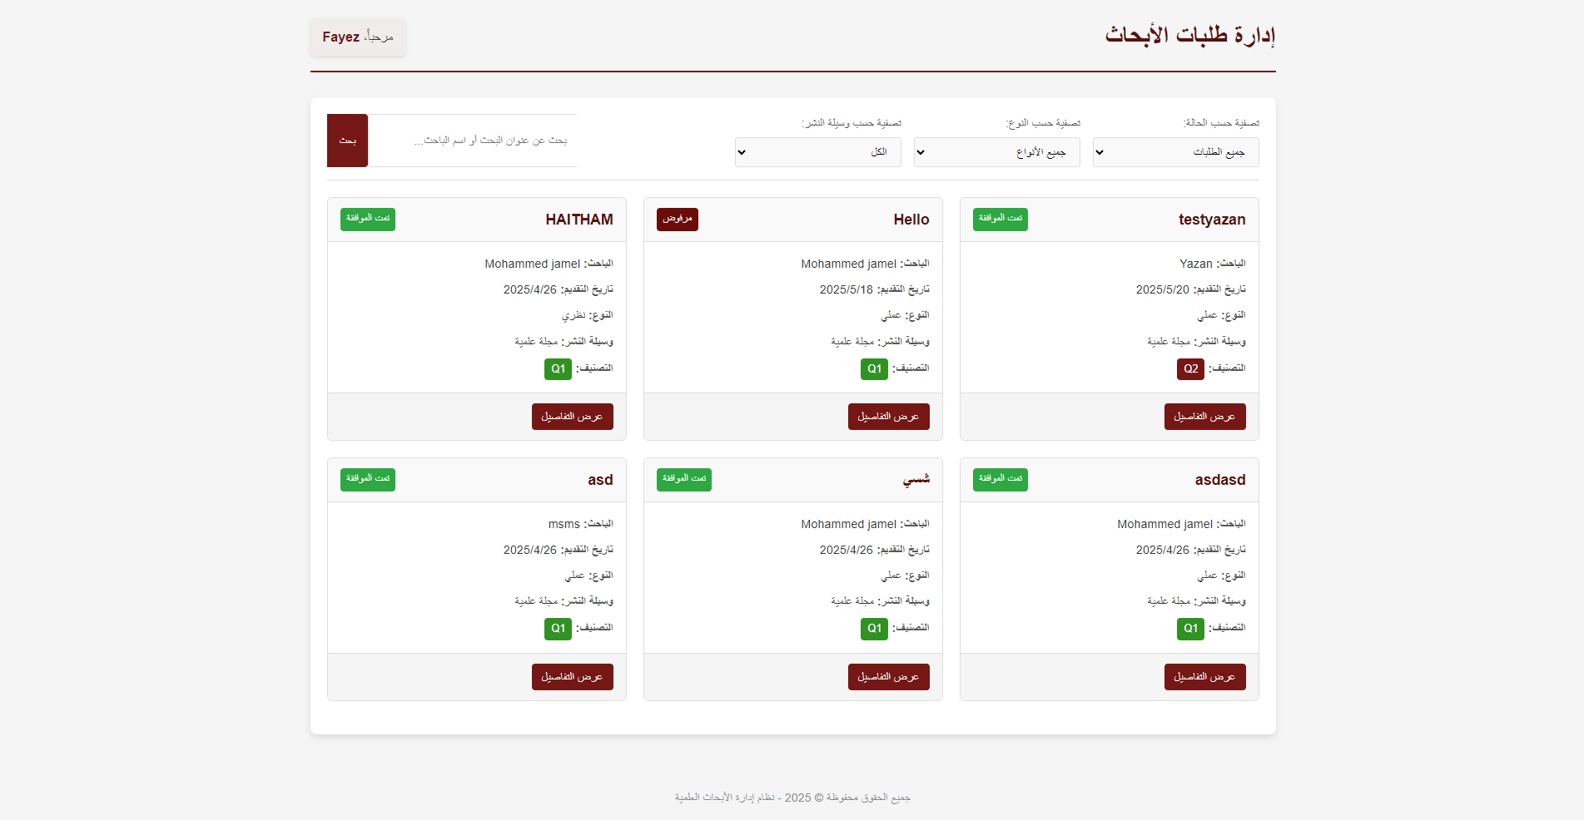
Figure 50. Admin Research Management Page
Admin Services Management Page:

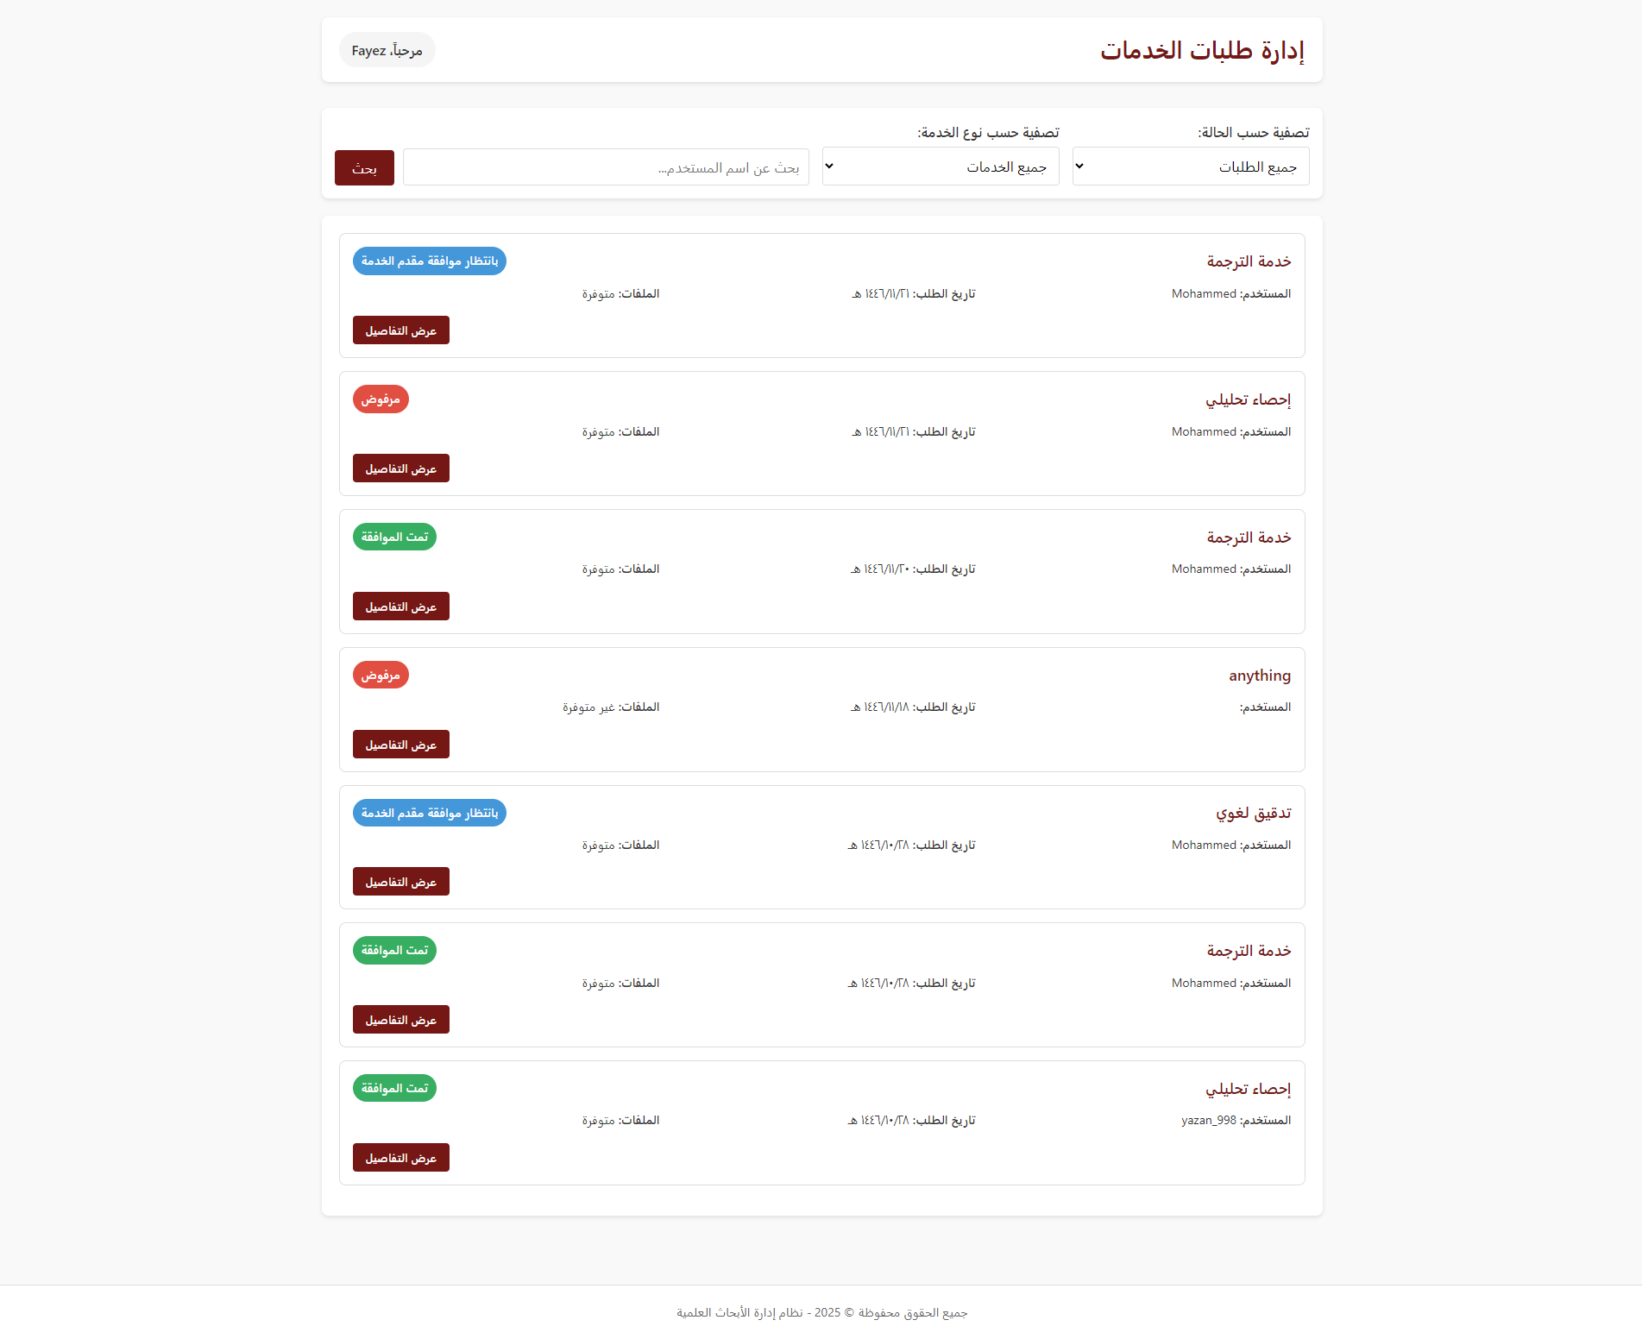
Figure 51. Admin Services Management Page

Admin User Management Page:

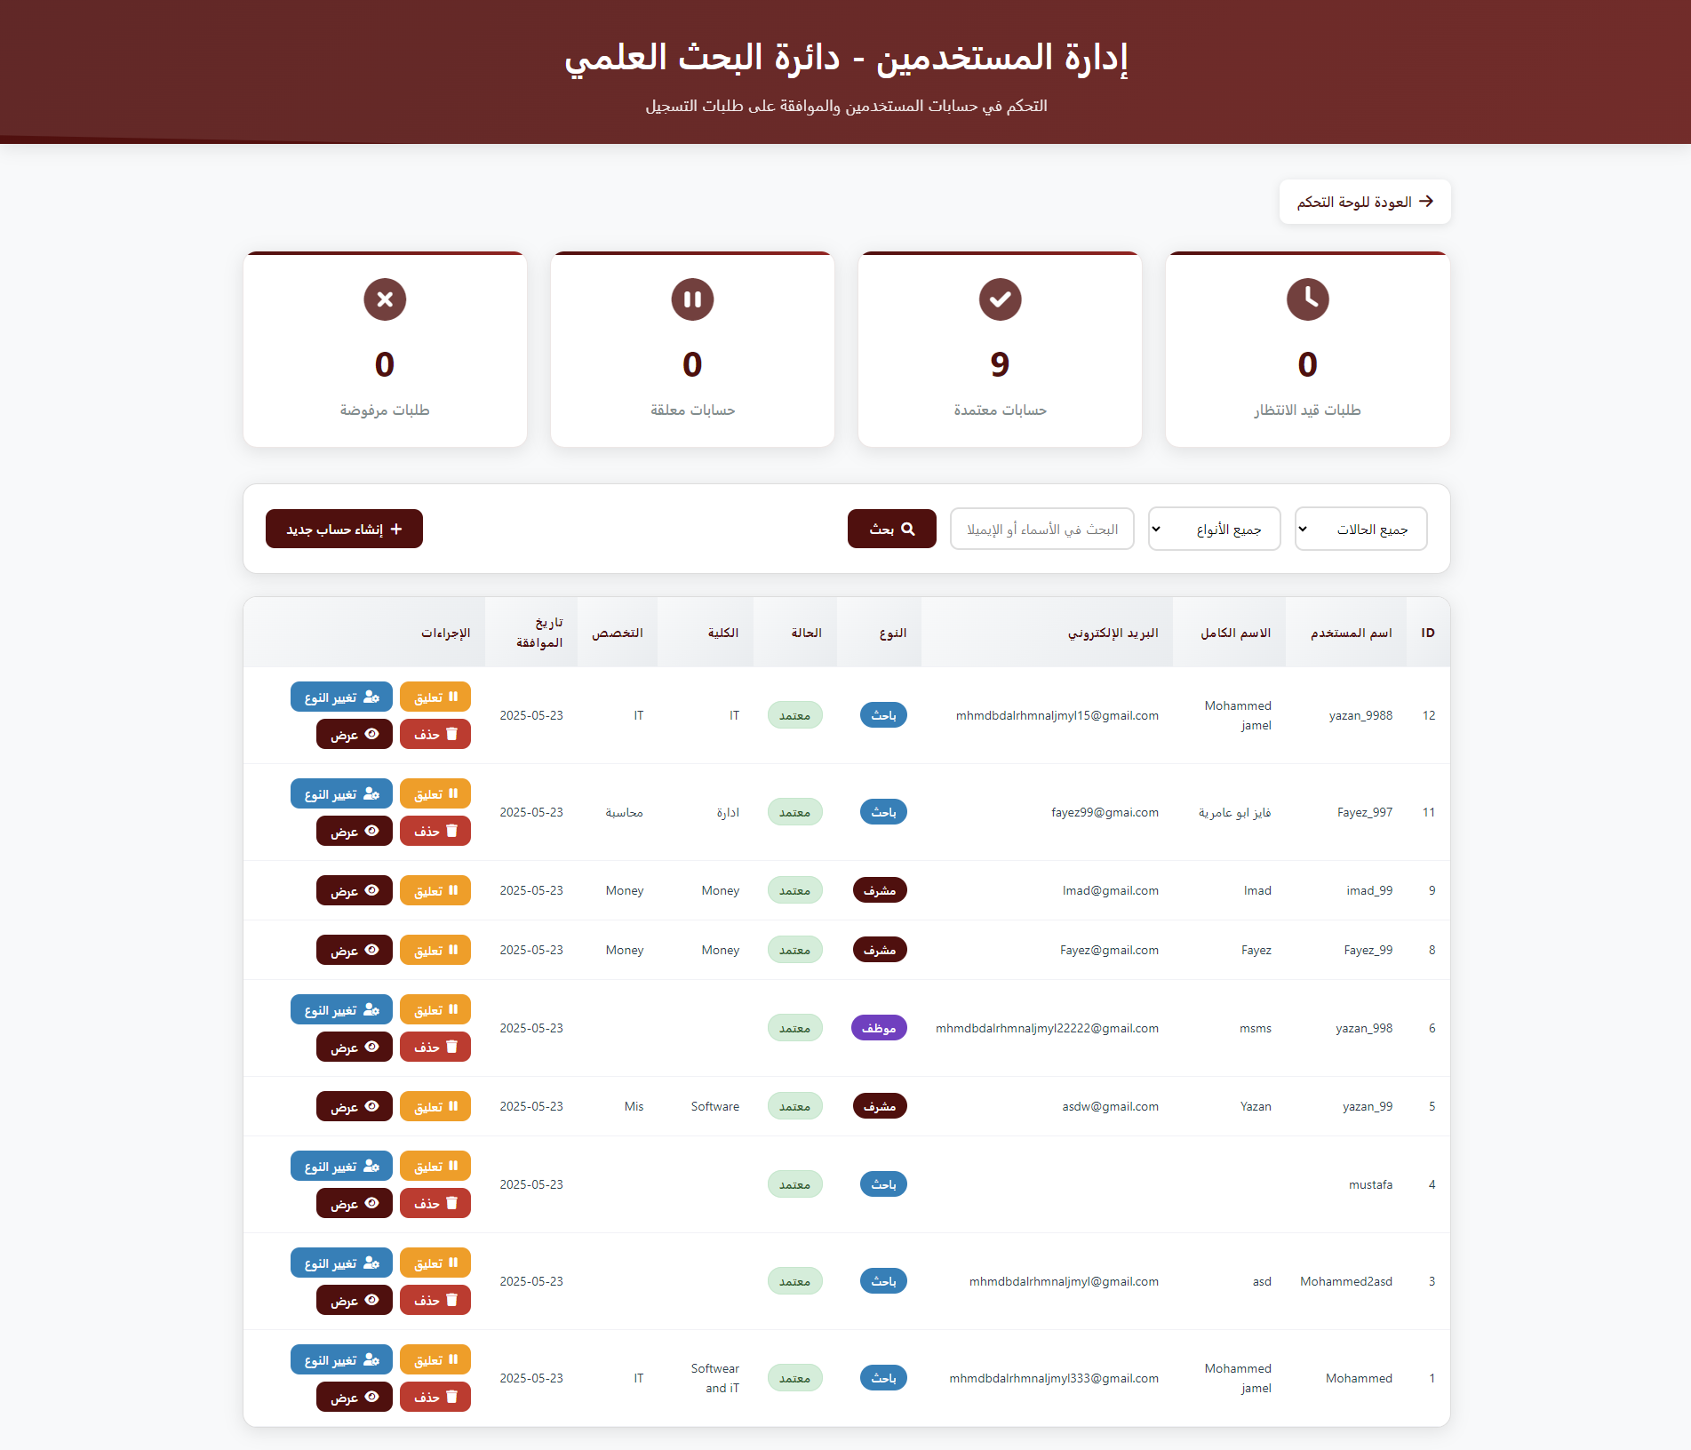
Figure 52. Admin User Management Page

Admin Statistics Page:

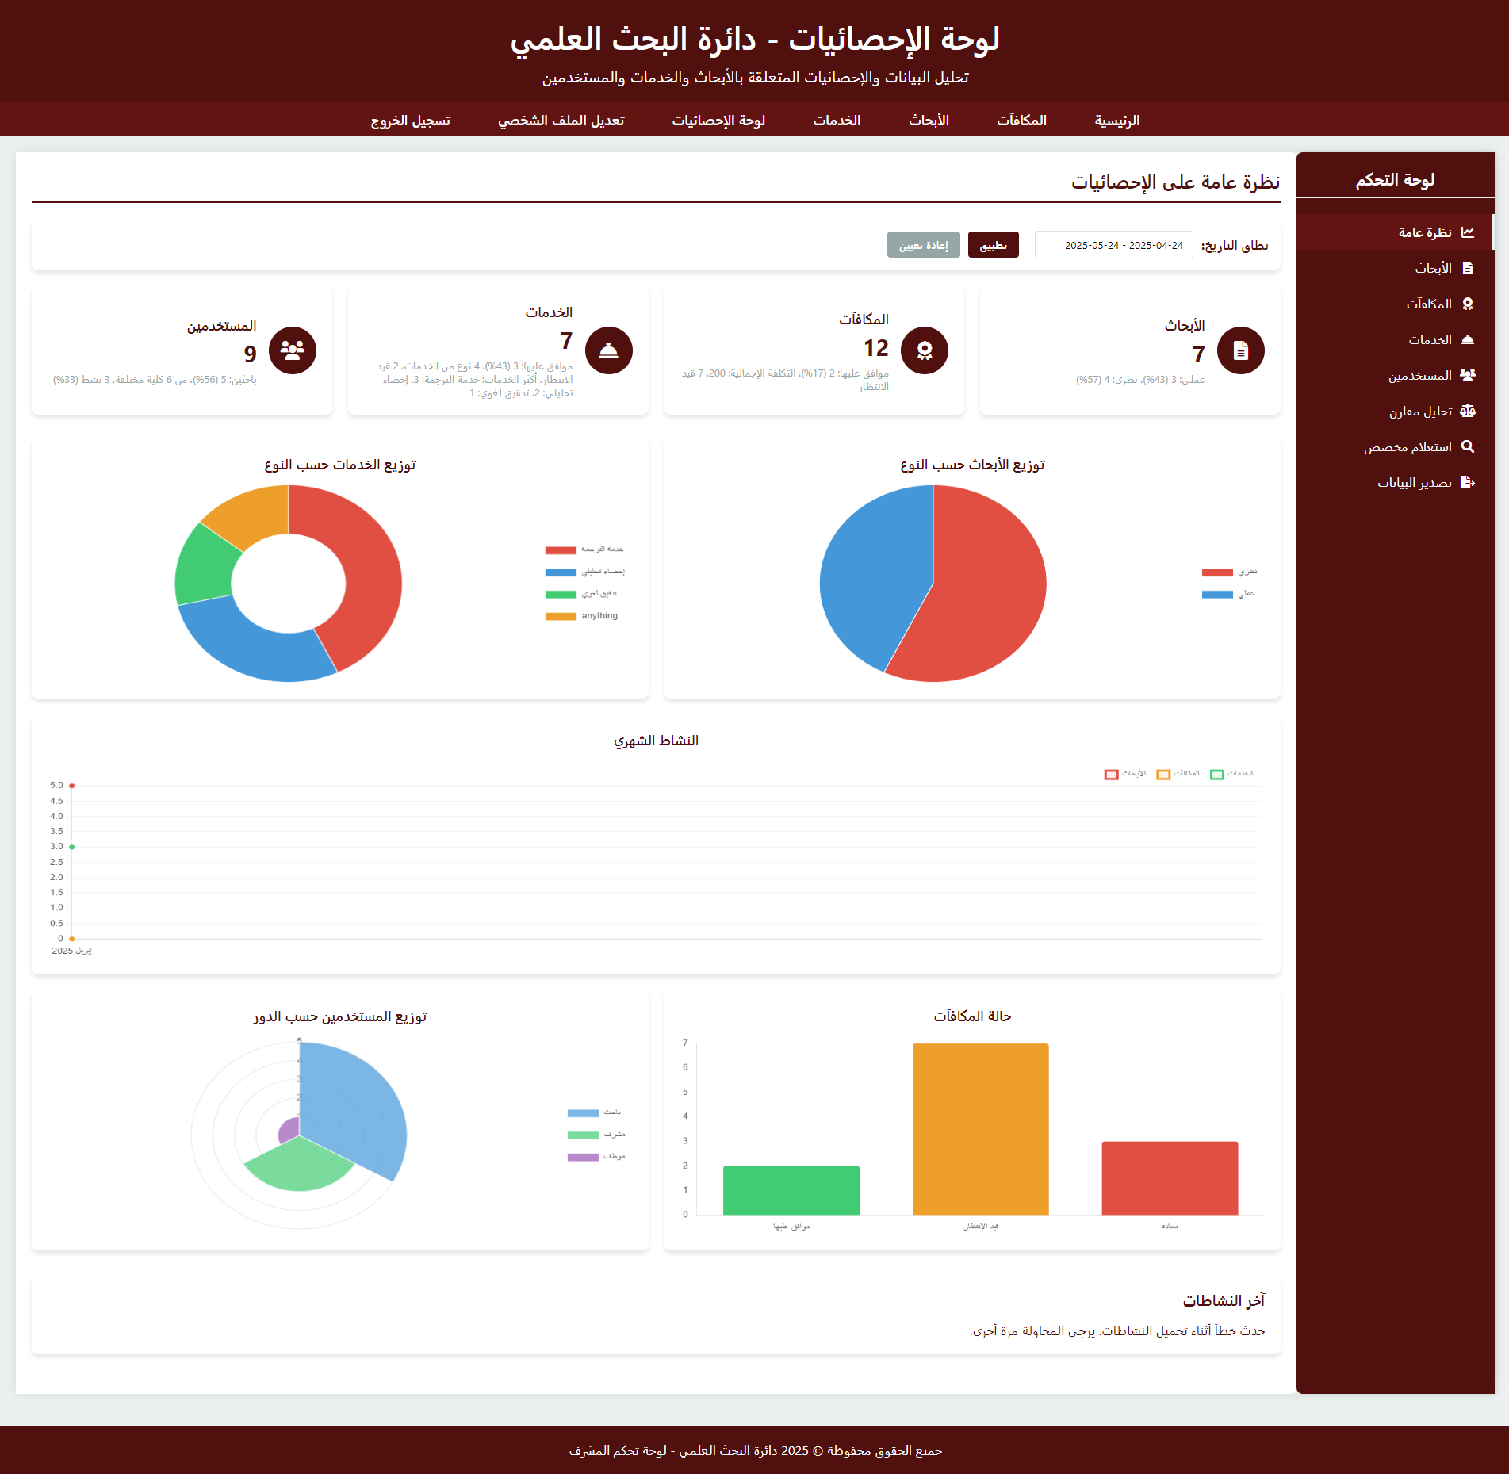
Figure 53. Admin Statistics Page (1)
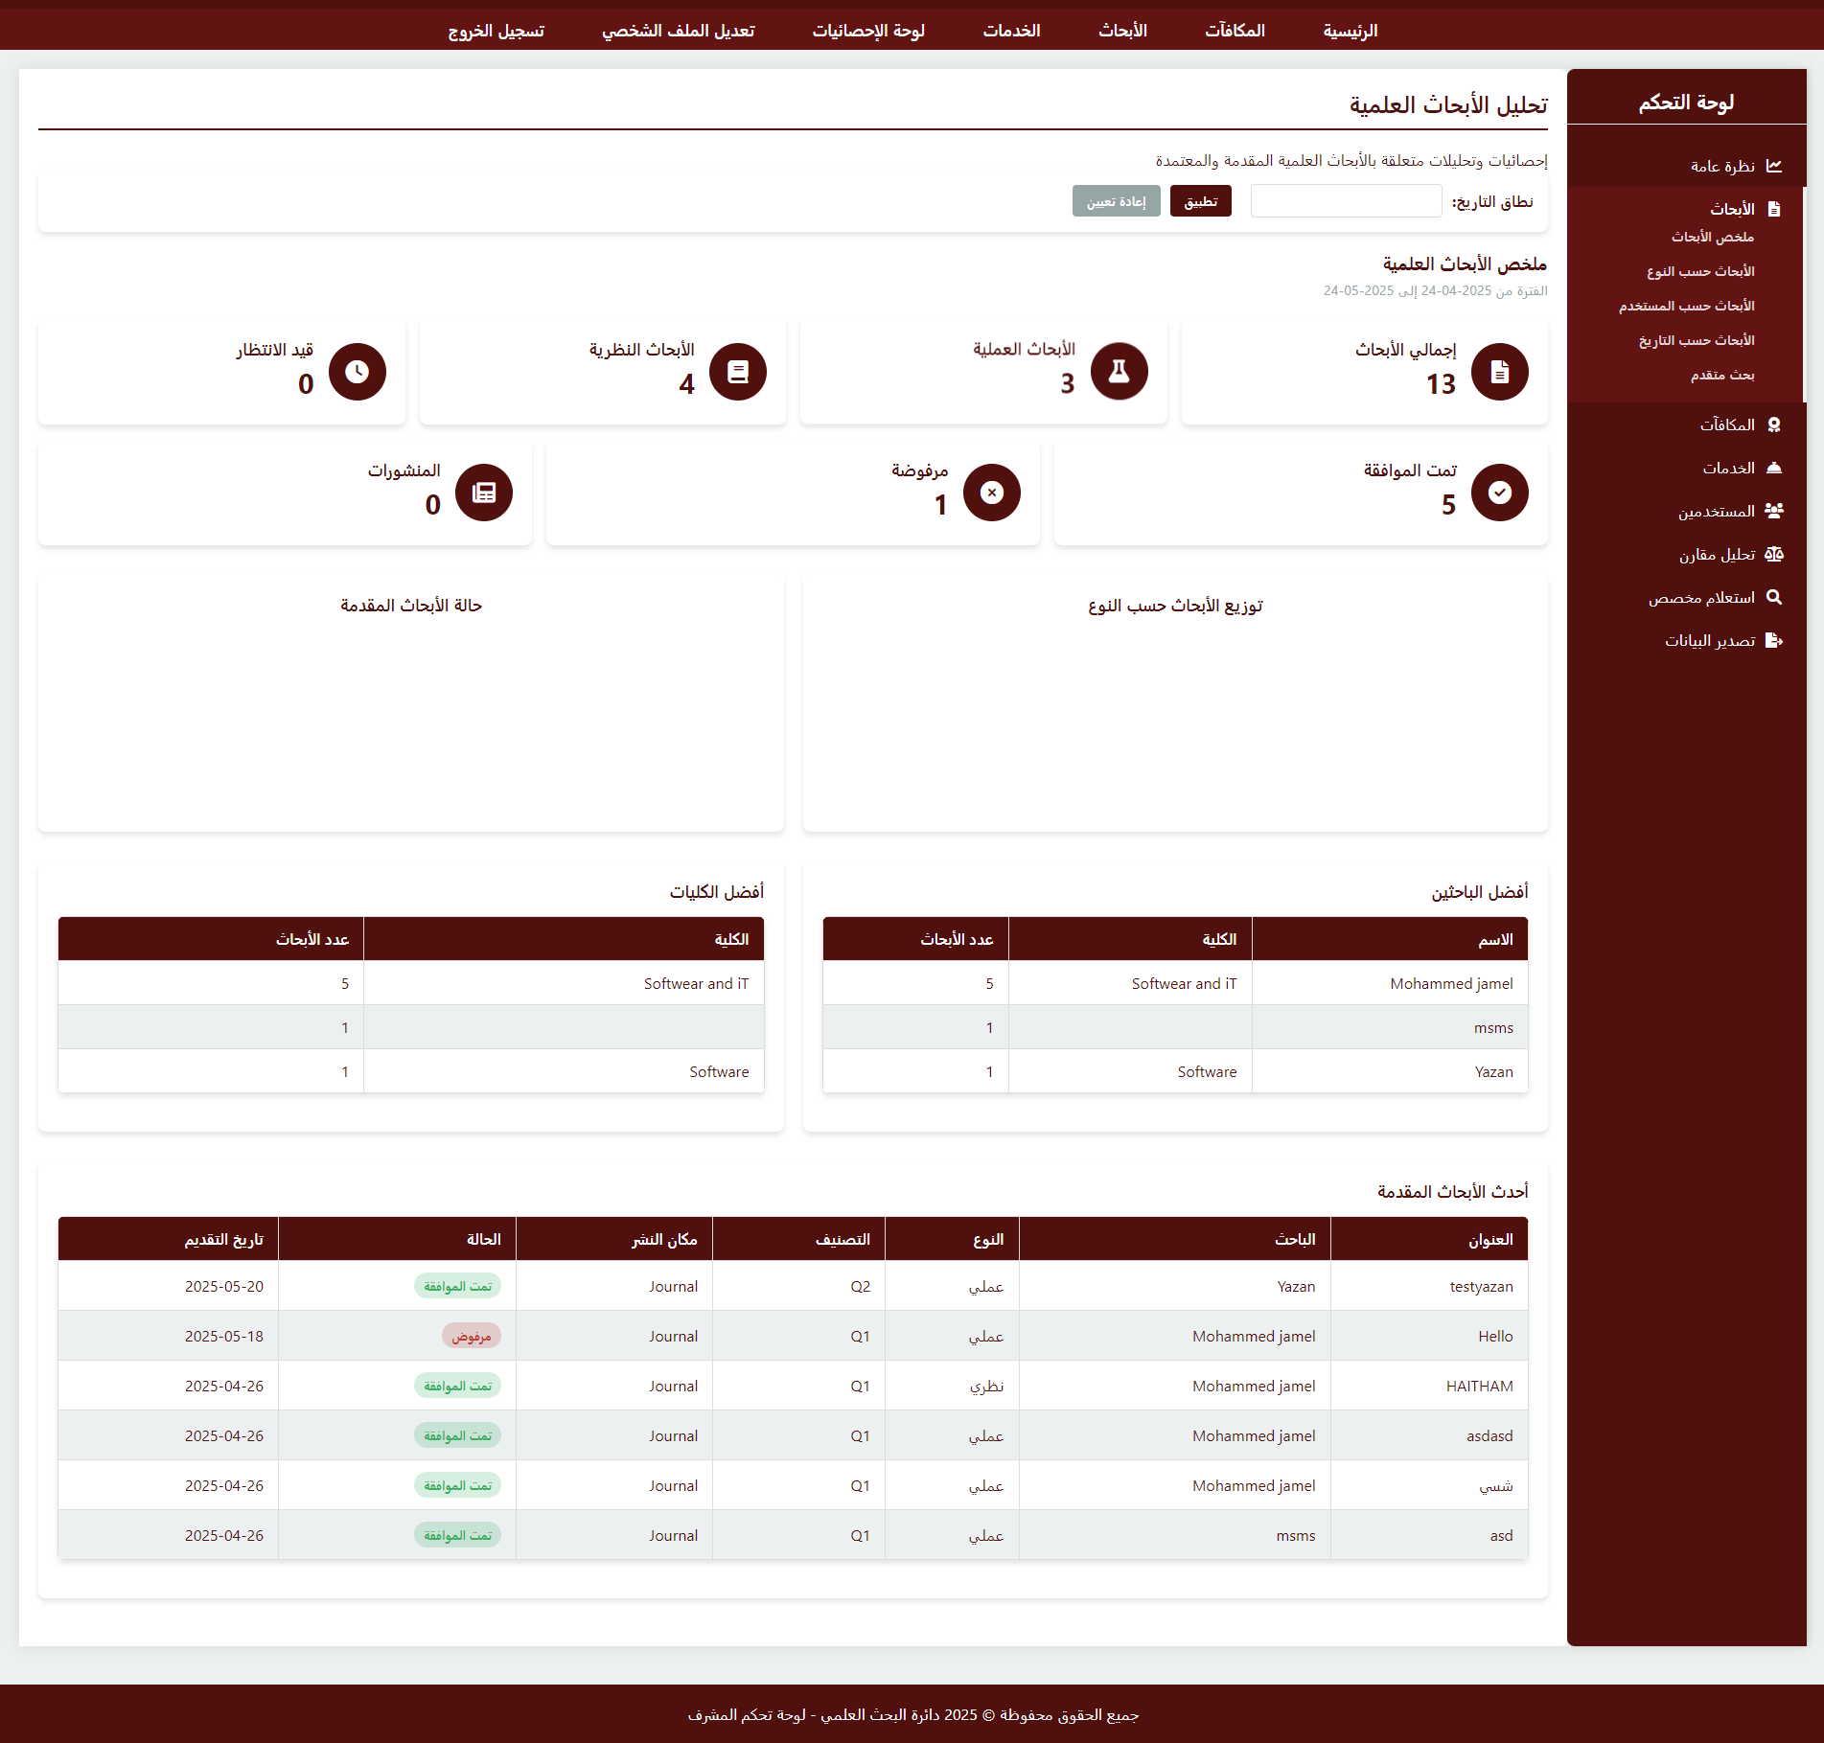
Figure 54. Admin Statistics Page (2)
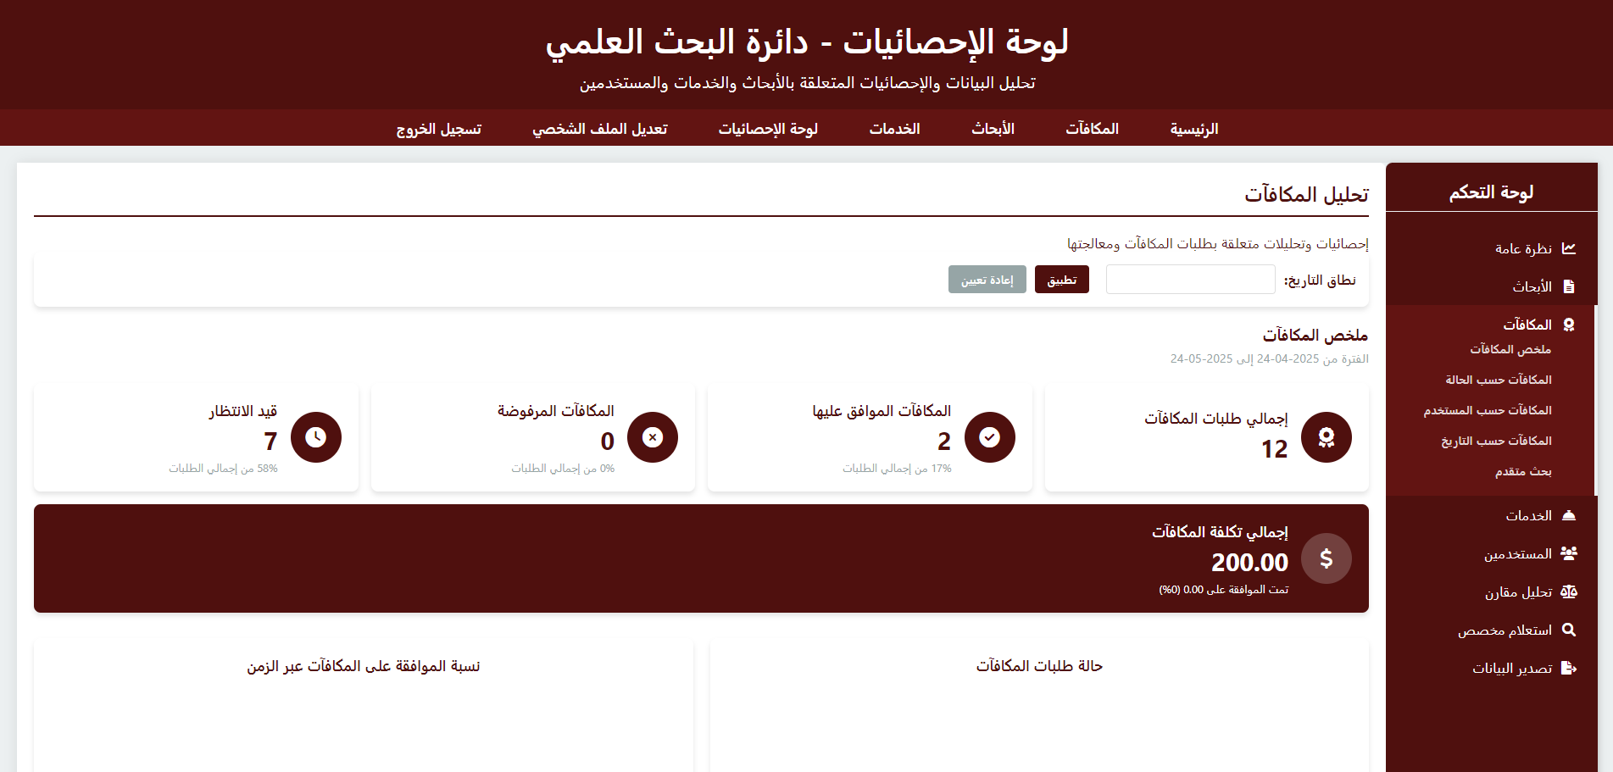
Figure 55. Admin Statistics Page (3)
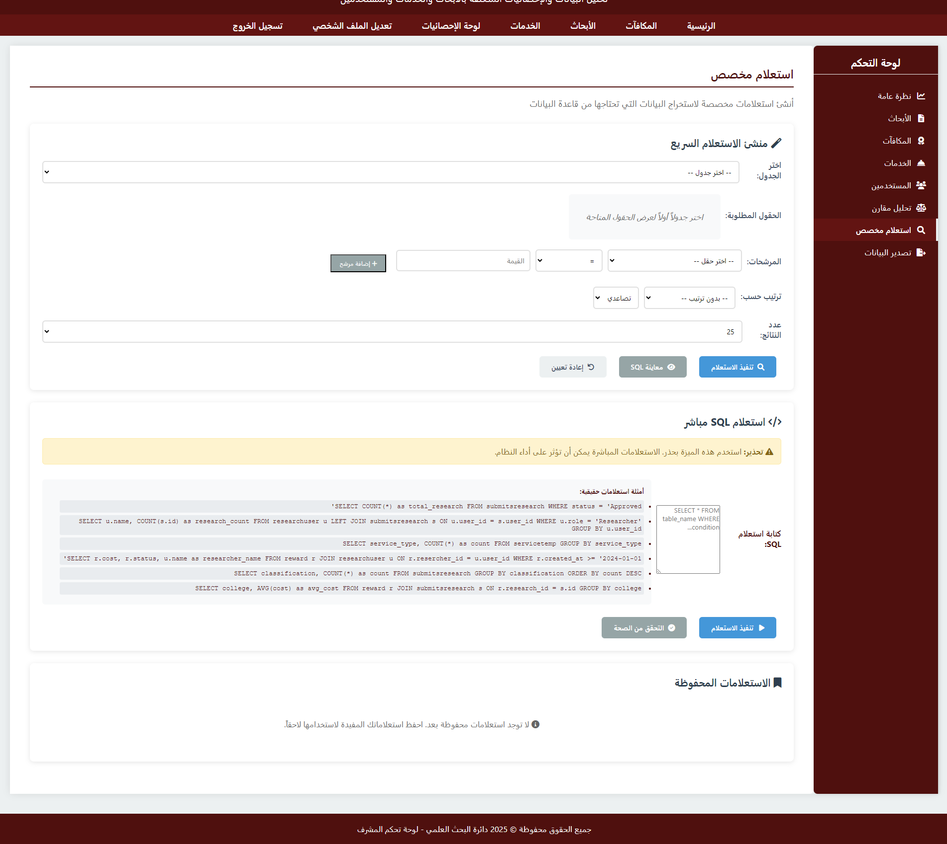
Figure 56. Admin Statistics Page (4)
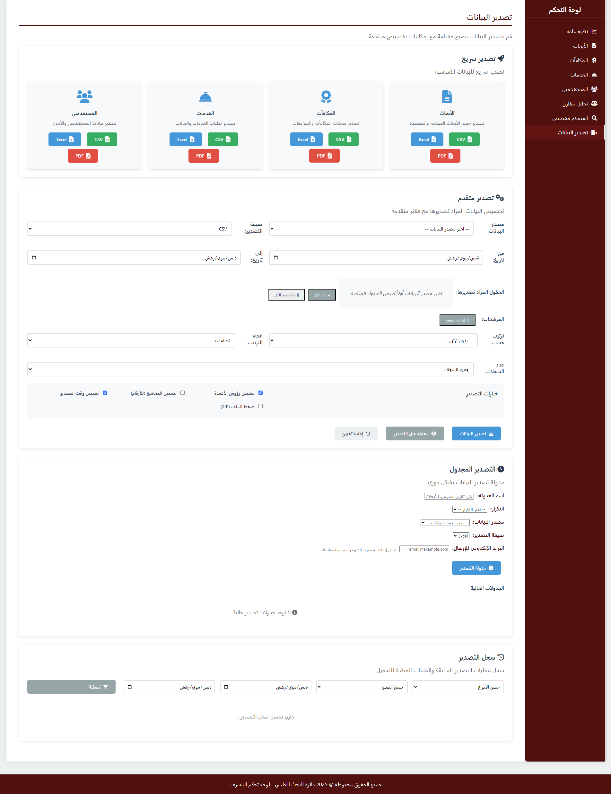
Figure 57. Admin Statistics Page (5)

5.3 Summary

In summary, these were the most important pages for the project to automate the Scientific Research Department at Palestine Ahliya University from paper to a website, as the pages expand and expand, but these were the most important things that met the project’s requirements.

CHAPTER SIX: TESTING

6.1 Introduction

This chapter will discuss the testing process for the project to ensure that the inputs and outputs were correct or in terms of security for the website of the Department of Scientific Research at Palestine Ahliya University.

6.2 System testing

System Testing built the very core for the development of software, assuring that the PAU Research Automation System is tested completely against a set of requirements and to work efficiently. Within this frame, many types of system testing were required to maintain quality, reliability, and integrity in the digital conversion from paper-based to web-based research management.
The types of system testing that were carried out on the system developed are as follows:
Frontend Testing
The frontend testing of the PAU Research System involved a comprehensive analysis of the user-facing elements to ensure the best possible user experience, security for the researchers, and coordination for faculty and administrators. The testing ensured that all research submission forms were loaded correctly under responsive design principles on different devices or validations as per academic requirements. The main attention was on commonly used attacks and vulnerabilities commonly found in frontend development, Cross-Site Scripting being a severe threat. The present-day JavaScript frameworks offer various mechanisms against XSS, yet some risks remain about research document uploads and rendering dynamic content. The team put the HTML, CSS, and JavaScript components through a vigorous test to ensure that the application stands against possible attacks that would expose sensitive academic data.

Backend Testing
Backend testing focused on the reliability and functionality of API routes of the PAU Research System and authorization mechanisms implemented using PHP. All API routes were tested for proper operation, and authorization per route was checked to confirm that they comply with the access control policies specified for the various user roles (researchers, reviewers, administrators). The prime aim was to detect the presence of weaknesses that are common in the scenario of SQL injection (SQLi) assault, which threaten the integrity and security of a research database. The vulnerable PHP backend components were made secure against exploits to assure the confidentiality and integrity of sensitive research data, publication records, and academic information, thereby culminating into security enhancement of the entire system.
Database Testing
Another vital area of system testing involves database testing for the PAU Research System. In this testing, integrity and constraint checks are done against the MySQL database architecture, which is managed through the phpMyAdmin interface running on the XAMPP environment. It was made sure that all the constraints were enforced for research papers, author details, review processes, and publication tracking in such a way that no operations could damage data consistency and integrity. Through strict database constraints and wise testing procedures, the PAU Research System was shielded from data inconsistencies so that the academic database architecture remained reliable.
Testing Methodologies
Both manual and automated testing methods were used to ensure the application works correctly and consistently and securely in the academic research environment.
Manual Testing
Manual testing was hitched to human assessment of some aspects of the research system's functionality and the user experience. Manual testing procedures were:

1.User Interface Testing: Research submission pages were manually verified to ensure they load and display academic UI elements properly and comply with responsive design across different devices and screen sizes used by researchers and faculty members.
2.Input Validation Testing: Entering data into forms and fields to verify that input validation rules are correctly applied per academic standards, ensuring that invalid or malicious input will not degrade research integrity.
3.Exploratory Testing: Through ad-hoc testing of various research workflow paths and scenarios within the application, identifying issues overlooked by scripted tests, including multiple research submission processes and review workflows.
4.Security Testing: Identification of common security flaws by manual testing means such as XSS or SQL injection attempts meant to exploit weakness in either frontend or backend components to protect sensitive academic and research data.

Manual testing gave flexibility and adaptability to ever-changing academic requirements and research workflows to enable testers to use domain knowledge to find issues that automated testing may not have spotted, especially with complex research processes in academic settings.

Automated Testing
Automated testing used tools and scripts to autonomously run predefined test cases and verify system behavior. Automated testing approaches included
1.Regression Testing: Repeat test cases were executed by automation to ensure new changes or features did not introduce regressions or unintended side effects in submission for research and review processes. This testing was performed using Selenium WebDriver.
2.Integration Testing: Automated checking of interactions between system components, including API endpoints for research submissions, database integrations for publication tracking, and connections to academic databases. This testing was done using Postman for API testing.
3.Load and Performance Testing: Automated and simulated concurrent users during peak research submission periods to characterize performance of the system under different loads typical of academic environments. This testing was performed using Apache JMeter.
4.Security Scanning: Automated security scanning identified potential vulnerabilities and exposures in the research system's codebase and infrastructure to ensure confidential research data and academic information were safe. This testing was performed using Nikto web vulnerability scanner.
Automated testing was all about speed and scale, insisting on rapid test execution and quick onboarding of changes into the testing regime. Thus, this approach made the testing procedures more efficient and gave quicker feedback on the research system's quality and stability.

Testing Environment
The testing environment was realized through XAMPP. It installed Apache web server, MySQL database, and PHP runtime environment. The phpMyAdmin interface was used for managing the database and for carrying out testing procedures. Such a local development environment ensured equal levels of testing and proper evaluation for all system components.
By combining manual and automated testing techniques, the PAU Research System achieves optimum test coverage and risk mitigation. It guarantees high-quality plus reliable digital research management that, in turn, successfully transfers the traditional paper-based processes into worthy web-based processes for the Palestine Ahliya University Research community.

6.3 System Integration
The system integrity of the PAU Research Automation System entails safeguarding the confidentiality, availability, and accuracy of research data, user information, and academic records. Preventing unauthorized access to sensitive research data via strict security measures also elevates the chance of security breaches within the academic setup.
Besides, the mechanism must have allowed determining such data loss, need of corruption, unauthorized modification that could have, in reality, liquefied [diminished] the integrity of research publication data, author data, and academic records stored in the MySQL database through phpMyAdmin onto the XAMPP environment. High reliability and availability are intended for the system to serve all continuous research activities and academic workflows. System integrity is, therefore, an important aspect of the PAU Research System, ensuring safe storage of researchers' data and adequately ensuring the operation of research submission and management processes developed through the use of HTML, CSS, JavaScript, and PHP technologies.
Being one of the most helpful tools deployed within the PAU Research System, automated tests safeguard data integrity by spotting bugs or errors that could potentially threaten data security and accuracy within academic workflows. System testing would be performed periodically to verify that the application worked as expected and that research data entered and output from the web-based interface had been processed correctly and not considered to have changed in any way throughout the cycle. Once risks were identified and resolved through the timely identification of problems, automated testing minimized the possibilities of risk escalation and enabled developers to maintain application integrity and ensure it functioned properly as intended. Moreover, it reduced human errors, which are terribly important in retaining data integrity, and by extension, maintain the reliability of the systems within the academic research environment.

6.4 System Testing Result

Table 14 System Testing Result
Expected Result | Test Description | Test Objective | Test ID
User is registered successfully | Verify the ability to register as a new researcher/faculty member | Functionality – User Registration | 1
User is logged in successfully | Verify the ability to login as an existing user (researcher/faculty/admin) | Functionality - Login | 2
Analytics viewed successfully | Verify the ability for researchers to view dashboard analytics (Total Publications, Submitted Papers, Under Review, Published, Citations Count, Research Areas) | Functionality – View Research Dashboard | 3
Profile created successfully | Verify the ability to create researcher profile (Name, Department, Bio, Research Interests) | Functionality – Create Research Profile | 4
Profile edited successfully | Verify the ability to edit researcher profile (Name, Department, Bio, Research Interests) | Functionality – Edit Profile Details | 5
Analytics viewed successfully | Verify the ability for faculty to view dashboard analytics (Supervised Research, Published Papers, Review Tasks, Student Researchers) | Functionality – View Faculty Analytics | 6
Analytics viewed successfully | Verify the ability for admins to view dashboard analytics (Total Users, Research Papers, Publications, System Reports) | Functionality – View Admin Analytics | 7
Monitor successful | Verify the ability for admins to access Research tab to see papers (title, author name, ID, submission date, status) | Functionality – Research Monitoring | 8
Monitor successful | Verify the ability for admins to access Users tab to see users (name, username, ID, role, department, registration date) | Functionality – Users Monitoring | 9
Paper submitted successfully | Verify the ability to submit research papers to the system | Functionality – Submit Research Paper | 10
Category created successfully | Verify the ability to create categories for research areas | Functionality – Create Research Categories | 11
Paper assigned to category successfully | Verify the ability to assign research papers to specific categories | Functionality – Assign Papers to Categories | 12
Review request sent successfully | Verify the ability for researchers to request paper reviews from faculty | Functionality – Create Review Request | 13
Review response sent successfully | Verify the ability for faculty to respond to review requests | Functionality – Respond to Review Request | 14
Feedback added successfully | Verify the ability for faculty to leave feedback on research papers | Functionality – Leave Research Feedback | 15
Edit made successfully | Verify the ability for researchers to edit papers (Title, Abstract, Content, Keywords) | Functionality – Edit Research Papers | 16
Paper deleted successfully | Verify the ability for researchers to delete papers | Functionality – Delete Research Papers | 17
Edit made successfully | Verify the ability for admins to edit research categories | Functionality – Edit Research Category | 18
Category deleted successfully | Verify the ability for admins to delete categories | Functionality – Delete Research Category | 19
Publication request created successfully | Verify the ability for researchers to submit papers for publication | Functionality – Submit for Publication | 20
Publication status updated successfully | Verify the ability for admins to update publication status | Functionality – Update Publication Status | 21
Template created successfully | Verify the ability for faculty to create paper templates (Format, Structure, Guidelines) | Functionality – Create Research Templates | 22
Template edited successfully | Verify the ability for faculty to edit templates (Format, Structure, Guidelines) | Functionality – Edit Research Templates | 23
Template deleted successfully | Verify the ability for faculty to delete templates | Functionality – Delete Research Template | 24
Template used successfully | Verify the ability for researchers to use templates when writing papers | Functionality – Use Research Template | 25
User profile updated successfully | Verify the ability for users to edit their info (First name, Last name, Phone, Email, Department, Office, Research Areas) | Functionality – Update User Profile | 26
User password updated successfully | Verify the ability for users to change their password | Functionality – Change Password | 27
System responds quickly to user actions | Measure the responsiveness and performance of the research system | Performance – System Responsiveness | 28
System functions correctly on various devices and browsers | Verify compatibility with different devices and web browsers | Compatibility - Device and Browser Compatibility | 29
System gracefully handles errors and exceptions | Evaluate the system's ability to handle exceptions and errors | Error Handling - Exception Handling | 30
Research group joined successfully | Verify the ability for researchers to join existing research groups | Functionality – Join Research Group | 31
Research group created successfully | Verify the ability for faculty to create new research groups | Functionality – Create Research Group | 32
Research group managed successfully | Verify the ability for group leaders to manage group members and activities | Functionality – Manage Research Group | 33
Reward request submitted successfully | Verify the ability for researchers to submit reward/incentive requests | Functionality – Submit Reward Request | 34
Reward request reviewed successfully | Verify the ability for admins to review submitted reward requests | Functionality – Review Reward Request | 35
Reward request processed successfully | Verify the ability for admins to approve or reject reward requests | Functionality – Approve/Reject Reward | 36
Research proposal submitted successfully | Verify the ability for researchers to submit research proposals | Functionality – Submit Research Proposal | 37
Research proposal reviewed successfully | Verify the ability for faculty to review research proposals | Functionality – Review Research Proposal | 38
Research proposal processed successfully | Verify the ability for admins to approve or reject research proposals | Functionality – Approve/Reject Research | 39
Service request submitted successfully | Verify the ability for users to submit service requests (technical support, equipment, etc.) | Functionality – Submit Service Request | 40
Service request reviewed successfully | Verify the ability for staff to review service requests | Functionality – Review Service Request | 41
Service request processed successfully | Verify the ability for admins to approve or reject service requests | Functionality – Approve/Reject Service | 42

6.5 Summary

By a careful system testing that includes frontend testing, backend testing, and database testing, PAU Department of Scientific Research Web is sure that it meets the requirements, functionality, and security standards that have been set by dealing with the possible weaknesses and checking the system integrity at every level, PAU Department of Scientific Research Web provides a System that Saves time and effort for all parties

CHAPTER SEVEN: CONCLUSION AND FUTURE WORKS

7.1 Conclusion

PAU Research Automation System is the integration of quantitative development of tools used to apply scientific research management at Palestine Ahliya University. Developing the system means the team placed importance on providing interrelated features such as research paper management, publication tracking, review processes, reward administration, research group coordination, and service request handling on a single interface in an intuitive web application.

Much time and effort went into the Research System's development at PAU, including planning, analyzing, and testing phases to make sure that the offered platform responds adequately to meet the expectations of the players in action-researchers, faculty members, and administrative staff. The team successfully converted a platform from scratch that would take the complexity out of the traditional methods of paper-based research management, aided by modern development concepts, thereby giving the user meaningful insights through analytics and reporting tools.

The system successfully digitized much of the research workflow, including paper submission, the automated process of assigning reviewers, publication tracking, and bridging communications between the researchers and faculty members. Through these processes, the system retained the record-keeping integrity of the academic records all the way through their metamorphosis from paper to web-based research management.

7.2 Future Works

As we look into the future, there are several areas we can improve and expand upon. The PAU Research Automation System remains a cutting-edge and robust platform, therefore to continue being that, the following points outline the future works planned:
Artificial Intelligence Integration: Implement advanced AI algorithms for automated research analysis and data processing. This will include developing AI models for research classification, quality assessment, and trend analysis to enhance the decision-making process for research management.

Advanced Data Analytics AI: Integrate sophisticated AI-powered analytics to provide deeper insights into research patterns, publication trends, and academic performance metrics, enabling more informed strategic planning for the university's research initiatives.

Scopus API Integration: Establish seamless integration with Scopus API to automatically verify and validate research publications, ensuring accurate tracking of citations, impact factors, and journal rankings for more precise reward calculations and research assessment.

Enhanced Notification System: Develop a comprehensive multi-channel notification system including email, SMS, and in-app notifications to keep researchers, faculty, and administrators informed about submission status, review progress, and important deadlines.

Research Sustainability Module: Introduce a dedicated sustainability assessment module that evaluates research projects based on environmental impact, social responsibility, and sustainable development goals (SDGs) alignment, promoting environmentally conscious research practices.
Mobile Application Development: Transform the web-based platform into a fully functional mobile application for iOS and Android devices, enabling researchers to submit papers, track progress, and receive notifications on-the-go.

Classified and Unclassified Research Management: Implement advanced categorization system for classified and unclassified research projects to generate specialized reports as requested by university administration, ensuring proper handling of sensitive research materials.

Blockchain Security Implementation: Integrate blockchain technology to ensure research confidentiality and detect any unauthorized modifications or tampering with submitted research documents, providing immutable proof of research integrity and intellectual property protection.
Research Weight and Classification System: Develop a comprehensive research weight assessment system that evaluates different types of research (theoretical, experimental, applied, etc.) and assigns appropriate weightings for fair comparison and reward distribution.

Performance Matrix and Goal Setting: Implement a dynamic performance matrix system that tracks research achievements and automatically updates goals based on performance metrics, enabling continuous improvement and strategic planning for individual researchers and departments.

Enhanced Statistics Dashboard: Complete the development of comprehensive statistical dashboards with advanced visualization tools, predictive analytics, and customizable reporting features for detailed research performance analysis.
External Collaboration Platform: Expand collaboration capabilities to facilitate partnerships with external researchers, international institutions, and industry partners, including features for joint research projects and cross-institutional publication tracking.

Advanced Search and Filtering: Develop sophisticated search algorithms and filtering mechanisms to help users quickly locate specific research papers, publications, or researchers based on multiple criteria including research area, publication date, and impact metrics.

Multi-language Support: Implement multi-language support to accommodate international researchers and facilitate global collaboration, making the platform accessible to Arabic, English, and other relevant languages.

Automated Plagiarism Detection: Integrate advanced plagiarism detection tools to ensure research originality and maintain academic integrity throughout the submission and review process.
Research Funding Management: Add comprehensive funding tracking and management features to monitor research grants, budget allocation, and expenditure tracking for better financial oversight of research projects.
Publication Timeline Tracking: Implement detailed timeline tracking for the entire publication process, from initial submission to final publication, providing researchers with clear visibility of their research journey.

Peer Review Management System: Develop an integrated peer review system that automatically matches submissions with appropriate reviewers based on expertise, availability, and conflict of interest considerations.

Research Impact Assessment: Create tools for measuring and tracking the real-world impact of research projects, including citation analysis, media coverage, and practical applications in industry or society.

Data Backup and Recovery Enhancement: Implement advanced backup and disaster recovery systems to ensure research data security and system availability even in case of technical failures or emergencies.

By focusing on these improvements in the future, we aim to further enhance the functionality, security, and global reach of the PAU Research Automation System, ensuring it remains a valuable and innovative platform for the academic research community at Palestine Ahliya University and beyond.

References

[1] | B. University, "Scientific Research Research and Projects," 2015. [Online]. Available: https://www.birzeit.edu/en/research..
[2] | A.-N. N. University, "Deanship of Scientific Research," 2017. [Online]. Available: https://scresearch.najah.edu/en/.
[3] | P. T. University, "Deanship of Scientific Research," 2018. [Online].
[4] | K. S. University, "Deanship of Scientific Research," 2016. [Online]. Available: https://dsrs.ksu.edu.sa/en.
[5] | C. University, "Research Awards," 2014. [Online]. Available: https://cu.edu.eg/Research_Awards.
[6] | U. A. E. University, "Research and Innovation," 2019. [Online]. Available: https://www.uaeu.ac.ae/en/research/.
[7] | H. University, "Research Data Management," 2012. [Online]. Available: https://research.harvard.edu/research-policies-compliance/research-data-management/.
[8] | C. University, "Research," 2015. [Online]. Available: https://www.cam.ac.uk/research.
[9] | S. University, "Research Technology | Stanford Data Science Resources," 2014. [Online]. Available: https://med.stanford.edu/sdsr/research-technology.html.
[10] | O. S. J. R. J. W. Pekka Abrahamsson, "Agile Software Development Methods: Review and Analysis," VTT Publications, vol. 478, p. 107, 2002.
[11] | G. f. geeks, "Context Diagrams," 14 10 2024. [Online]. Available: https://www.geeksforgeeks.org/context-diagrams/#:~:text=Context%20diagrams%20serve,to%20create%20them..
[12] | G. f. geeks, "Unified Modeling Language (UML) Diagrams," 23 10 2024. [Online]. Available: https://www.geeksforgeeks.org/unified-modeling-language-uml-introduction/#:~:text=Unified%20Modeling%20Language%20(UML)%20is,is%20rather%20a%20visual%20language..
[13] | G. f. geeks, "Use Case Diagram," 11 10 2024. [Online]. Available: https://www.geeksforgeeks.org/use-case-diagram/#:~:text=A%20Use%20Case,scope%20and%20requirements..
[14] | G. Booch, The Unified Modeling Language User Guide, Reading, MA: Addison-Wesley, 1999.
[15] | Wkipedia, "Sequence diagram," 11 6 2024. [Online]. Available: https://en.wikipedia.org/wiki/Sequence_diagram#:~:text=In%20software%20engineering,or%20iteration%20area.
[16] | KBSI, Standard for Conceptual Modeling Language Syntax and Semantics for IDEF1X, New York: IEEE, 1998.
[17] | G. f. geeks, "Activity Diagrams," 12 10 2024. [Online]. Available: https://www.geeksforgeeks.org/unified-modeling-language-uml-activity-diagrams/#:~:text=Activity%20diagrams%20are%20an,interact%20in%20a%20system..

